Contemplation and Conversation
7th Sunday after Pentecost, July 27, 2025
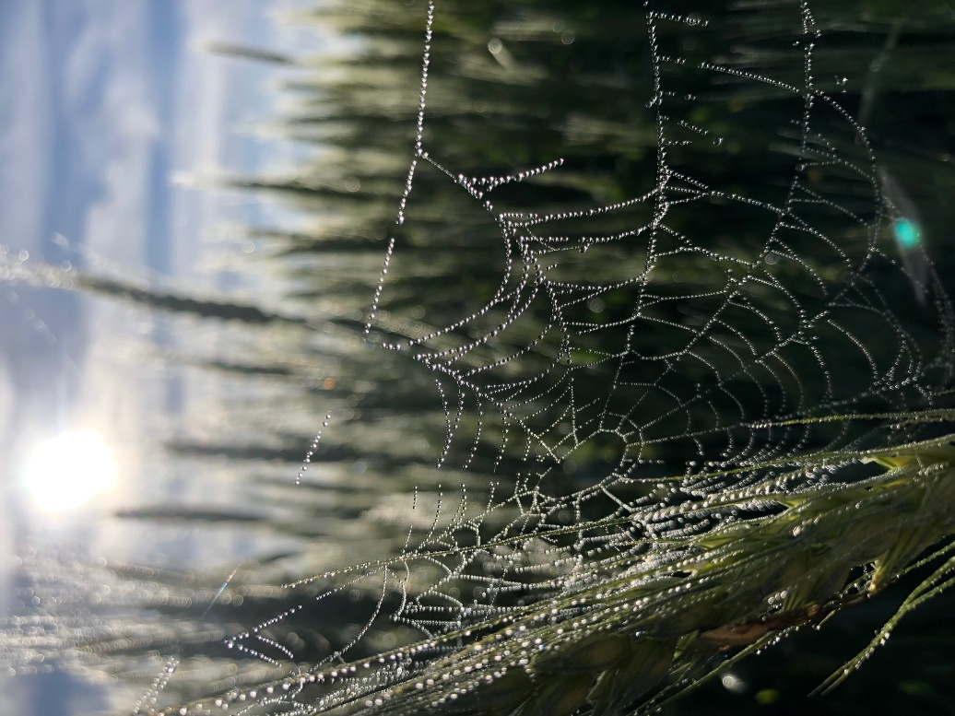
Scripture – Psalm 85 NRSVUE
Liz Guthrie
¹ Lord, you were favorable to your land;
you restored the fortunes of Jacob.
² You forgave the iniquity of your people;
you pardoned all their sin. Selah
³ You withdrew all your wrath;
you turned from your hot anger.
⁴ Restore us again, O God of our salvation,
and put away your indignation toward us.
⁵ Will you be angry with us forever?
Will you prolong your anger to all generations?
⁶ Will you not revive us again,
so that your people may rejoice in you?
⁷ Show us your steadfast love, O Lord,
and grant us your salvation.
⁸ Let me hear what God the Lord will speak,
for he will speak peace to his people, to his faithful,
to those who turn to him in their hearts.
⁹ Surely his salvation is at hand for those who fear him,
that his glory may dwell in our land.
¹⁰ Steadfast love and faithfulness will meet; righteousness and peace will kiss each other.
¹¹ Faithfulness will spring up from the ground, and righteousness will look down from the sky.
¹² The Lord will give what is good, and our land will yield its increase.
¹³ Righteousness will go before him and will make a path for his steps.
From Rev. Heather Leffler
Throughout the stories of the people of Israel, we see seasons of faithfulness and failure—times when the people walk closely with God, like in the days of Abraham, Moses, David, Solomon, Josiah, Ezra, and Nehemiah. And there are times when they turn away—grumbling in the wilderness, falling in battle, or enduring exile in Assyria and Babylon. Still, God never gives up on them. Again and again, the Holy One sends prophets—and, ultimately, Jesus—to call the people back into relationship.
When we face natural disasters, war, violence, and political upheaval, it can feel like God is angry or absent. But when we revisit these ancient stories and reflect on our own lives, we see that even in the darkest moments, goodness and love persist. People reach out in compassion, often at great cost to themselves. In these actions, we see love made visible—and we recognize God’s presence.
The psalmist reminds us that God's love is steadfast and faithful. This is our hope and our call. We are invited to pray and be faithful, so that God might use us to bring healing and hope to the world. As Paul writes, we are the hands and feet of Christ. When we stand with the oppressed, reach out to the vulnerable, and care for creation, others experience God's presence through us.
We are blessed to know God as Holy Mystery and Wholly Love—a God who forgives, renews, and restores. May that love continue to shape our lives.
Contemplation and Conversation
How have you experienced God’s love this week?
Prayer
Holy One, the Psalmist reminds us of your steadfast love and faithfulness.
We give thanks for your presence in our lives.
Help us to be faithful in sharing your love with the world. Amen.

Further Conversation … Would you like to talk more about today’s reflection? Email Heather at hleffler@rogers.com.

Our Rockwood Stone Family
If you missed today’s worship service, you can watch it here: https://youtu.be/be7QaZVrhO0.

United Church of Canada
In worship over the next weeks, we will share former United Church Moderators’ reflections on who Jesus is for them from the 44th General Council in 2022 online. Today we heard The Very Rev. Lois Wilson, 28th Moderator.
On Friday, August 8, The United Church of Canada will offer a somber and historic Apology to 2S and LGBTQIA+ communities. Join us at Stone at 11 am to watch it together from Knox United Church in Calgary or Register for the Zoom event to watch from home..
This formal apology reaffirms our commitment to radical hospitality and full inclusion of 2S and LGBTQIA+ people in all aspects of church life. It acknowledges past harm and shortcomings, while continuing to build towards a world of radical love and affirmation for all identities.
A gift of belonging to a church is that the practice of gathering together for worship … to pray, sing, listen to scripture and share how God touches our lives – helps us grow in deeper relationship with God and each other. We are offering this practice of sharing beyond Sunday morning to deepen our connection. Each week you are offered a picture, a scripture and a question for contemplation, as well as a short reflection for you to contemplate, have conversation with people in your life and/or join an online conversation on our Rockwood Stone Facebook page.

