Contemplation and Conversation
10th Sunday after Pentecost, August 17, 2025
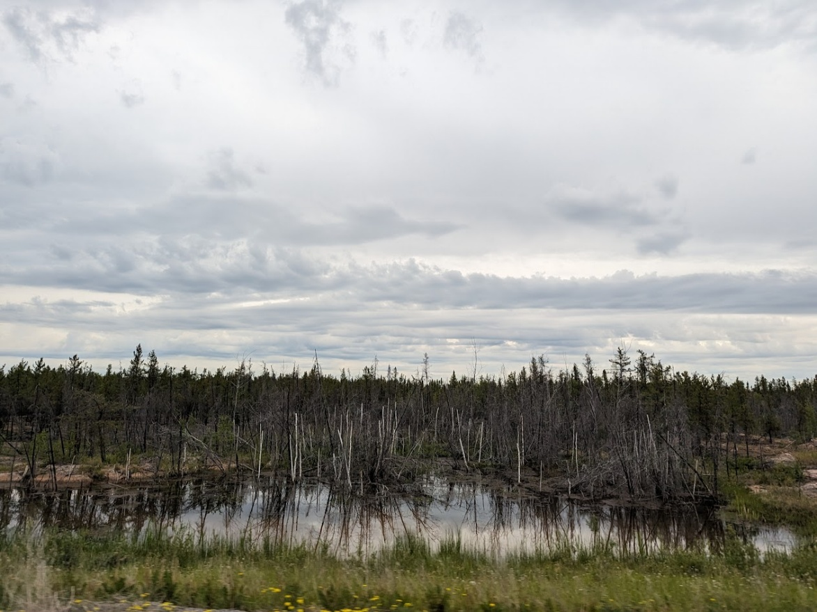
Scripture – Luke 12:49-56 NRSVUE
⁴⁹ “I have come to cast fire upon the earth, and how I wish it were already ablaze! ⁵⁰ I have a baptism with which to be baptized, and what constraint I am under until it is completed! ⁵¹ Do you think that I have come to bring peace to the earth? No, I tell you, but rather division! ⁵² From now on five in one household will be divided, three against two and two against three; ⁵³ they will be divided:
father against son
and son against father,
mother against daughter
and daughter against mother,
mother-in-law against her daughter-in-law
and daughter-in-law against mother-in-law.”
H Leffler
⁵⁴ He also said to the crowds, “When you see a cloud rising in the west, you immediately say, ‘It is going to rain,’ and so it happens. ⁵⁵ And when you see the south wind blowing, you say, ‘There will be scorching heat,’ and it happens. ⁵⁶ You hypocrites! You know how to interpret the appearance of earth and sky, but why do you not know how to interpret the present time?
From Rev. Heather Leffler
These words of Jesus are challenging. We want to join him in bringing God’s kingdom on earth as it is in heaven – feeding the hungry, healing the sick, loving God and our neighbours. We might even stretch ourselves toward loving our enemies. But Jesus setting the earth ablaze? Dividing families? That unsettles us.
Many of us have lived in relative peace – between wars or at least far from them – in Canada and other places where social systems provide some care and where we are free to speak about what matters to us. That was not the case for Jesus and the disciples, who lived under the iron rule of Rome. Religious leaders often cooperated with the empire to preserve wealth and power. Crosses lined the roads of Jerusalem as reminders of what happened to anyone who challenged Roman authority.
Even today, around the world – and sometimes even here in Canada – people face persecution for following Jesus. We also see political leaders who abuse power, stirring up fear and turning people against each other. In contrast, many of us have lived with the privilege of distance: able to offer help, but often from the safety of the sidelines.
Yet the kingdom of God is a place where everyone is loved. When individuals or systems oppress or marginalize others, Jesus’ words remind us that faithfulness will sometimes mean division. To follow Christ may require us to stand apart – even from family, friends, or neighbours – in order to stand with the vulnerable.
The fire Jesus speaks of is a fire of passion: a burning desire for justice, compassion, and the well-being of all. If God’s kingdom of peace and love is to come on earth, it must embrace every person. This is the ministry to which we are called.
Contemplation and Conversation
Who might the Spirit be calling us to stand with?
Prayer
Holy One, you call us to live with courage and compassion.
When the path of love leads to conflict, strengthen us.
When the fire of justice burns within us, guide our steps.
Keep our hearts fixed on your vision of peace,
where all are welcomed, valued, and loved.
Through Christ, our companion and our hope. Amen.
Further Conversation … Would you like to talk more about today’s reflection? Email Heather at hleffler@rogers.com.

Our Rockwood Stone Family
If you missed today’s worship service, visit our Rockwood Stone YouTube page.

United Church of Canada
In worship we heard our new Moderator, the Right Rev. Kimberley Heath speak before she was chosen about the future of our United Church.

A gift of belonging to a church is that the practice of gathering together for worship … to pray, sing, listen to scripture and share how God touches our lives – helps us grow in deeper relationship with God and each other. We are offering this practice of sharing beyond Sunday morning to deepen our connection. Each week you are offered a picture, a scripture and a question for contemplation, as well as a short reflection for you to contemplate, have conversation with people in your life and/or join an online conversation on our Rockwood Stone Facebook page.

