Contemplation and Conversation: 11th Sunday after Pentecost, August 24, 2025
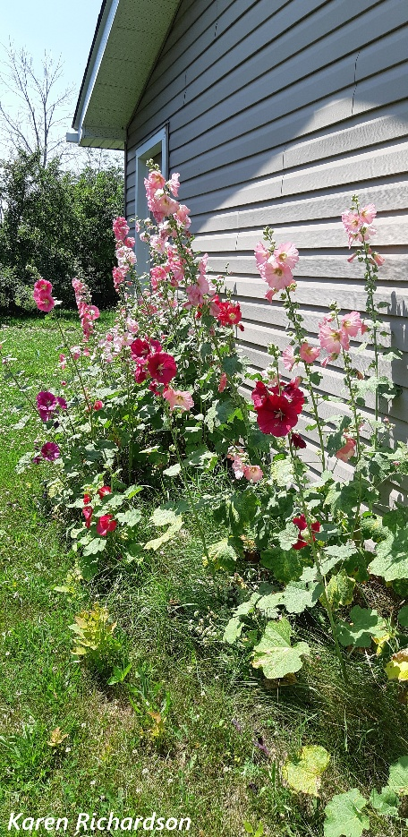
Scripture – Luke 13:10-17 NRSVUE
¹⁰ Now he was teaching in one of the synagogues on the Sabbath. ¹¹ And just then there appeared a woman with a spirit that had crippled her for eighteen years. She was bent over and was quite unable
to stand up straight. ¹² When Jesus saw her, he called her over and said, “Woman, you are set free from your ailment.” ¹³ When he laid his hands on her, immediately she stood up straight and began praising God. ¹⁴ But the leader of the synagogue, indignant because Jesus had cured on the Sabbath, kept saying to the crowd, “There are six days on which work ought to be done; come on those days and be cured and not on the Sabbath day.” ¹⁵ But the Lord answered him and said, “You hypocrites! Does not each of you on the Sabbath untie his ox or his donkey from the manger and lead it to water? ¹⁶ And ought not this woman, a daughter of Abraham whom Satan bound for eighteen long years, be set free from this bondage on the Sabbath day?” ¹⁷ When he said this, all his opponents were put to shame, and the entire crowd was rejoicing at all the wonderful things being done by him.
From Karen Richardson
I first became aware of this scripture in the summer of 1981. I was preparing summer services for when my colleague was on holidays, and I was reading an article in the Women’s Concerns Newsletter by David G. Owen. He talked about how this scripture had been neglected and didn’t make the top 10 or even the favourite forty like the Good Samaritan, the Prodigal Son, Blind Bartimaeus, the woman at the well or little Zacchaeus up in the sycamore tree. He went on to say he was reading along in Luke thinking he knew what was coming next when there she was the Bent Over Woman. I remember that I must have thought he was pulling a fast one on me, because I had to look up the scripture to see if she really was there. Since then, it has been one of my favourites.
I think it resonates with me because I can identify with times of being bent over. There is much in our humanness that can result in feeling weighed down - grief, guilt, sickness, loneliness; there is much in our world that can result in feeling weighed down - war, violence, food insecurity, climate catastrophes and there is much in the church that can result in feeling weighed down - our tainted history of residential schools, the loss of members, the dwindling volunteers and financial support and I could go on and on.
Even though it was the sabbath Jesus had compassion for the Bent Over Woman and touched her and set her free of her infirmity and she straightened up. The veil of hopelessness, sadness, and infirmity was lifted by God’s grace. While the religious leaders were more concerned about the fact that Jesus healed on the sabbath, the woman rejoiced in her new-found freedom and praised God, that same Higher Power that I believe wants us all to be strong and well and healed of those things that weigh us down.
Contemplation and Conversation
How does our community of faith help you to stand tall when you are weighed down? How can you help someone to feel God’s love and grace and be healed of whatever is weighing on their bodies, minds or souls?
Prayer
Holy mystery, universal energy,
help us to feel your healing power in our lives
and offer that love and grace to those who are burdened. Amen.
Further Conversation … Would you like to talk more about today’s reflection? Email Heather at hleffler@rogers.com.

Our Rockwood Stone Family
If you missed today’s worship service, you can watch it here: https://youtu.be/2a2TJWrvSrM.
For the spoon theory video shared in worship can be found here: https://www.pbs.org/video/spoon-theory-and-autoimmune-disease-d8pv4m/

United Church of Canada
100 Words of Hope - More Peace in Us, More Peace in the World:
Instead of brooding over threats and mirroring demeaning insults, let’s focus on reflecting the kin-dom values of love, forgiveness and grace.
Jewish writer Etty Hillesum consoled other Jews enroute to Auschwitz. In the midst of these terrorizing times, she helped those around her not lose their humanity and still find compassion. She wrote, “Ultimately, we have just one moral duty: to reclaim large areas of peace in ourselves, more and more peace, and to reflect it toward others. And the more peace there is in us, the more peace there will also be in our troubled world.”
—Loraine MacKenzie Shepherd, Winnipeg, MB
Read a selection of reader-submitted 100 Words of Hope reflections: https://united-church.ca/.../100-words-hope-more-peace-us....
We encourage you to share your own "100 Words of Hope" (prayers, poems, or reflections) through the online submission form: https://ow.ly/4lqn50VsQSP
[Image: The United Church of Canada]
#UCCan #100WordsofHope #DeepBoldDaring #DeepSpirituality
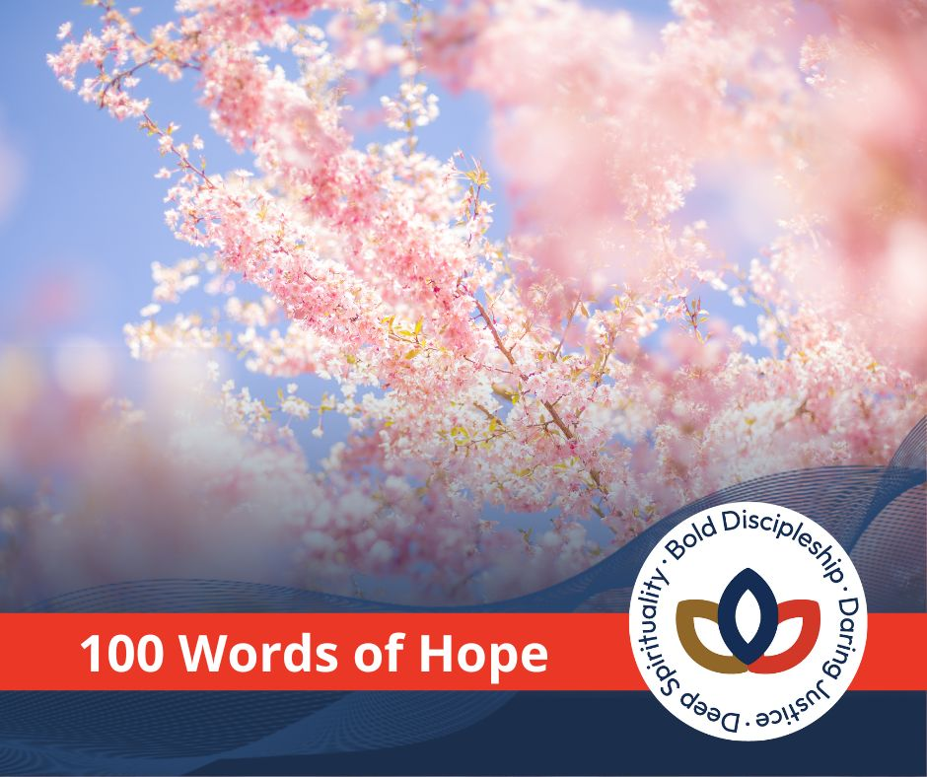

A gift of belonging to a church is that the practice of gathering together for worship … to pray, sing, listen to scripture and share how God touches our lives – helps us grow in deeper relationship with God and each other. We are offering this practice of sharing beyond Sunday morning to deepen our connection. Each week you are offered a picture, a scripture and a question for contemplation, as well as a short reflection for you to contemplate, have conversation with people in your life and/or join an online conversation on our Rockwood Stone Facebook page.

