Contemplation and Conversation: 12th Sunday after Pentecost, August 31, 2025

Scripture – Luke 14:1, 7-14 NRSVUE
14 On one occasion when Jesus was going to the house of a leader of the Pharisees to eat a meal on the Sabbath, they were watching him closely.
⁷ When he noticed how the guests chose the places of honor, he told them a parable. ⁸ “When you are invited by someone to a wedding banquet, do not sit down at the place of honor, in case someone more distinguished than you has been invited by your host, ⁹ and the host who invited both of you may come and say to you, ‘Give this person your place,’ and then in disgrace you would start to take the lowest place. ¹⁰ But when you are invited, go and sit down at the lowest place, so that when your host comes, he may say to you, ‘Friend, move up higher’; then you will be honored in the presence of all who sit at the table with you. ¹¹ For all who exalt themselves will be humbled, and those who humble themselves will be exalted.”
¹² He said also to the one who had invited him, “When you give a luncheon or a dinner, do not invite your friends or your brothers and sisters or your relatives or rich neighbors, in case they may invite you in return, and you would be repaid. ¹³ But when you give a banquet, invite the poor, the crippled, the lame, and the blind. ¹⁴ And you will be blessed because they cannot repay you, for you will be repaid at the resurrection of the righteous.”
From Barb Eley
One Sabbath, Jesus was having dinner at the home of an important Pharisee ruler. He was being watched carefully, probably because the Pharisees, who valued strict adherence to religious laws and traditions, were looking for a chance to criticize him. Jesus noticed how the guests were manoeuvring to sit in places of honour. He used this opportunity to teach about humility and generosity.
Jesus warns us not to focus on our pride and selfish desires, for if we vie for a place of honour, we might be asked to move down. If we choose a lower place, we could be asked to move up. He also goes on to instruct us to care for the disadvantaged, ahead of friends and family.
It is easy to put ourselves and those in our social circle first, but Jesus asks us to practise humility, generosity and inclusivity.
Contemplation and Conversation
When have we found the opportunity to put others first, without looking for rewards or praise?
When have we failed to do so?
Prayer
Lord, you see into our hearts and know our desires.
You know how easy it is to put ourselves and our wants first.
Help us to hear your words, and look for opportunities
to reach out to those who are so often forgotten by our society.
Help us to remember that we should look for our reward in the joy of serving you
and in love with which you surround us.
Amen.
Further Conversation … Would you like to talk more about today’s reflection? Email Heather at hleffler@rogers.com.

Our Rockwood Stone Family
If you missed today’s worship service, you can watch it here: https://youtu.be/a8orVR8SAao
United Church of Canada
Introducing Western Ontario Waterways Regional Council President, Rebekah Duncan
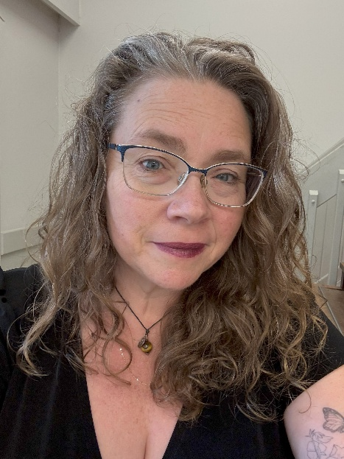
Hello, my name is Rev. Rebekah Duncan. I am currently the president of Western Ontario Waterways.
Thank you so much for trusting me with this position. It’s been a long journey, from finding passion for faith through my parents and youth forum (Maritime Conference), to gaining support through mentors such as the late Rev. D’Thea Webster, Rev. Neil Parker, Rev. Michael Kooiman, Rev. Sarah Giles, and the many talented and called classmates and professors I had at the Atlantic School of Theology. There are many other names I should list, friends, family, my discernment committee, the congregations of Bethel, Richview, Badjeros, Rob Roy, and Temple Hill United Churches, and even some strangers. I thank God for bringing them to me, and me on this journey to this place.
I heard God’s call sitting at the water's edge, quiet, nudging. Over time it became the roar of a waterfall too loud and insistent to ignore. So, I followed the beckoning, and I found myself listening for God’s voice then, as I do now, and God responds, “Do not doubt what I have chosen for you.” There have been many moments of weeping and gnashing of teeth throughout my short time in ministry, and I suspect there are many more to come, but with that comes unexpected joy, love and even some
tangible moments of peace.
I feel called to rural pastoral ministry but also called to serve the broader church. Stepping into the role of president comes with challenges and great footsteps to follow in. The support of our brilliant regional staff and the wonderful members of the executive have already been invaluable.
I hope to be able to meet you where you are, make time to sit with the clergy of our region, and figure out how to maintain the connections already made while continuing to foster new relationships. I hope to encourage us all to work towards the future of our church which will often mean choosing the road less travelled. Change is necessary for our church to remain, and that will be uncomfortable at times. We are meant to be each other’s inspiration and support as we move into our next 100 years. I pray we all find our way together, keeping what works and moving away from what isn’t anymore with careful discernment.
Blessings! Love! Light!
Rev. Rebekah Duncan
RMT, MA, M.Div, OM
President, Western Ontario Waterways Regional Council of The United Church of Canada

A gift of belonging to a church is that the practice of gathering together for worship … to pray, sing, listen to scripture and share how God touches our lives – helps us grow in deeper relationship with God and each other. We are offering this practice of sharing beyond Sunday morning to deepen our connection. Each week you are offered a picture, a scripture and a question for contemplation, as well as a short reflection for you to contemplate, have conversation with people in your life and/or join an online conversation on our Rockwood Stone Facebook page.

