Contemplation and Conversation: 14th Sunday after Pentecost, September 14, 2025
Scripture – Hebrews 13:1-8, 15-16 NRSVUE
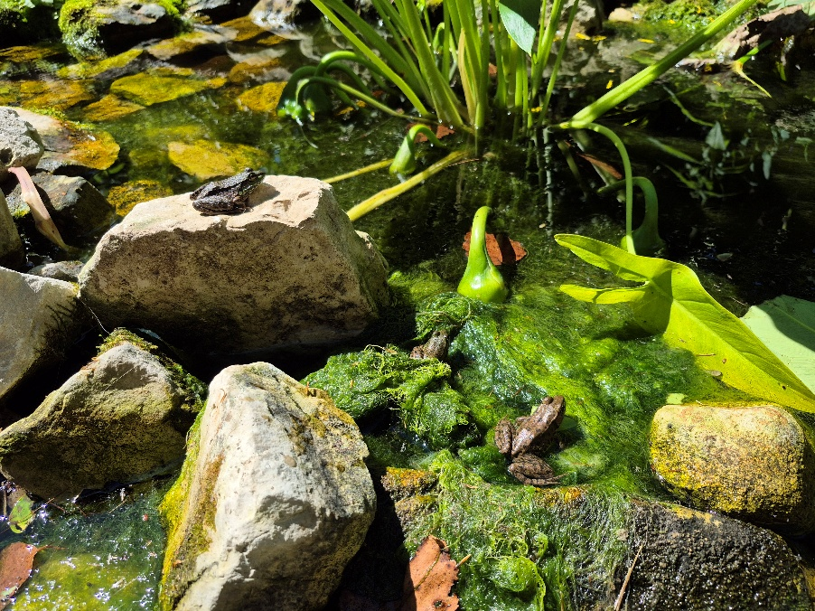
13 Let mutual affection continue. ² Do not neglect to show hospitality to strangers, for by doing that some have entertained angels without knowing it. ³ Remember those who are in prison, as though you were in prison with them, those who are being tortured, as though you yourselves were being tortured. ⁴ Let marriage be held in honor by all, and let the marriage bed be kept undefiled, for God will judge the sexually immoral and adulterers. ⁵ Keep your lives free from the love of money, and be content with what you have, for he himself has said, “I will never leave you or forsake you.” ⁶ So we can say with confidence,
“The Lord is my helper;
I will not be afraid.
What can anyone do to me?”
⁷ Remember your leaders, those who spoke the word of God to you; consider the outcome of their way of life, and imitate their faith. ⁸ Jesus Christ is the same yesterday and today and forever.
¹⁵ Through him, then, let us continually offer a sacrifice of praise to God, that is, the fruit of lips that confess his name. ¹⁶ Do not neglect to do good and to share what you have, for such sacrifices are pleasing to God.
From Lisa Leffler
This passage invites us to consider how universal agape love takes shape in daily life. The writer of Hebrews gives us practical, sometimes challenging examples of how love is lived out—in hospitality, in compassion, in relationships, and even in how we relate to money.
“Show hospitality to strangers”
Reaching out beyond our comfortable circles invites us into new relationships and new perspectives. It helps us to see the world in a new way and delve deeper into God’s Holy Mystery.
“Remember those who are in prison”
How often do we think of those who are incarcerated? It’s easy to assume they must have done something to deserve their situation, yet many are there because a lack of support and community led them down the wrong path. How might we offer compassion to people we may never meet? How can we work toward a system of justice that prioritizes support and rehabilitation over punishment?
“Let marriage be held in honor by all”
This is the kind of verse that people too often misuse to shame people who are divorced or encourage people to stay in unhealthy situations. For some, separation is the path that allows them to become their best selves. For others, honoring marriage means working through difficult times and growing together. Either way, the call is to approach marriage with respect and care.
“Keep your lives free from the love of money”
This challenge feels especially relevant in a culture that constantly tells us we need more—the biggest house, the newest car, the latest gadget. This verse isn’t saying we shouldn’t work hard or ever enjoy what we have. Instead, it reminds us that life is about more than material things, and that money should never come between our relationships with God, with each other, with ourselves, or with creation.
So we can say with confidence, "The Lord is my helper; I will not be afraid. What can anyone do to me?"
We don’t have to do any of this alone. We can always turn to God to help us discern what the loving action is. Sometimes we do that through prayer, other times through conversation with friends, family or neighbours. The important truth is this: whatever challenges we face, we are not alone. God’s presence steadies us as we seek to live out love in all things.
Contemplation and Conversation
Where in your daily life is God inviting you to practice agape love—through hospitality, compassion, generosity, or trust?
Prayer
God of love, guide our hearts toward generosity and grace.
Help us to see you in strangers, neighbors, and those in need.
Remind us that we are never alone, for you are always with us. Amen.
Further Conversation … Would you like to talk more about today’s reflection? Email Heather at hleffler@rogers.com.

Our Rockwood Stone Family
If you missed today’s worship service, you can watch it here:

United Church of Canada
xx

A gift of belonging to a church is that the practice of gathering together for worship … to pray, sing, listen to scripture and share how God touches our lives – helps us grow in deeper relationship with God and each other. We are offering this practice of sharing beyond Sunday morning to deepen our connection. Each week you are offered a picture, a scripture and a question for contemplation, as well as a short reflection for you to contemplate, have conversation with people in your life and/or join an online conversation on our Rockwood Stone Facebook page.

