Contemplation and Conversation
15th Sunday after Pentecost, September 21, 2025
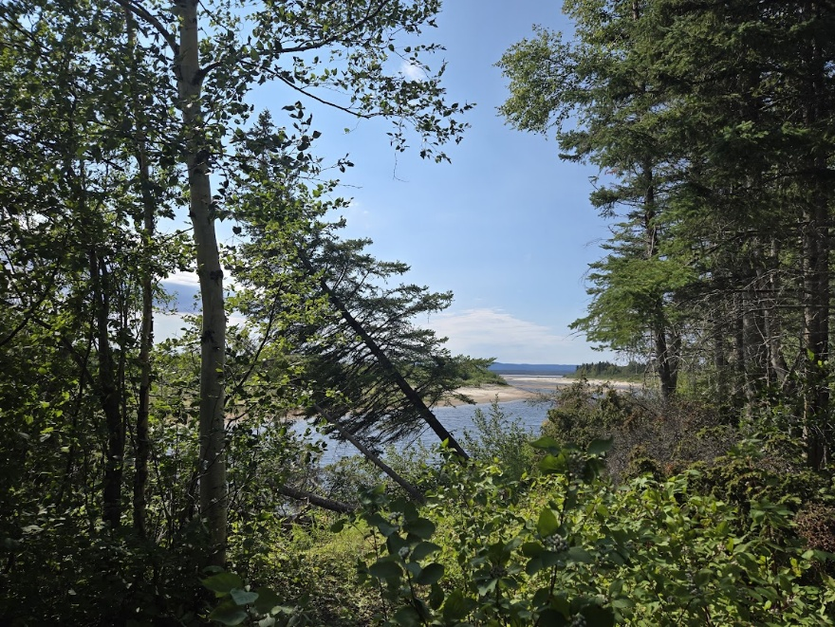
Scripture – 1 Timothy 2:1-7 NRSVUE
¹ First of all, then, I urge that supplications, prayers, intercessions, and thanksgivings be made for everyone, ² for kings and all who are in high positions, so that we may lead a quiet and peaceable life in all godliness and dignity. ³ This is right and acceptable before God our Savior, ⁴ who desires everyone to be saved and to come to the knowledge of the truth. ⁵ For
there is one God;
there is also one mediator between God and humankind,
Christ Jesus, himself human,
⁶ who gave himself a ransom for all
—this was attested at the right time. ⁷ For this I was appointed a herald and an apostle (I am telling the truth; I am not lying), a teacher of the gentiles in faith and truth.
From Rev. Heather Leffler
The writer of 1 Timothy urges us to offer supplications, prayers, intercessions, and thanksgivings for everyone – especially for our leaders. This feels like a timely message in a world where decisions made by those in power so often negatively affect people in their own countries and across the globe.
But what should we pray?
We trust that prayer – whether a single minute of silence or words of intercession – reaches the heart of God. Prayer also changes us, and through us, the world. Betty Pries of Credence & Co. teaches that taking a minute, two minutes, or twenty minutes of silence each day is like exercise for the soul: it strengthens and opens us to God.
Paul writes in Romans 8:26–27:
"Likewise the Spirit helps us in our weakness; for we do not know how to pray as we ought, but that very Spirit intercedes with sighs too deep for words. And God, who searches the heart, knows what is the mind of the Spirit, because the Spirit intercedes for the saints according to the will of God."
There are no easy answers to the challenges of world politics. Yet as people of faith, we know that God created the world to be held in love – earth, all creatures, and every person. When we pray for God’s highest good, or when we hold the world in silence before God, something shifts. Attending especially to the needs of those who are vulnerable or on the margins opens us to ways of bringing healing and hope where they are most needed.
Contemplation and Conversation
Who are you being called to pray for today?
Is it difficult to pray for certain people or leaders?
What might God be inviting you to in that challenge?
Prayer
God of all people, times, and places, we give thanks for your presence in this moment.
We pray for your highest good for those who are marginalized,
for people caught in the midst of war and strife.
We pray for humility and change of heart for leaders and for all who disregard those in need.
Make us channels of your peace and bearers of your hope. Amen.
Further Conversation … Would you like to talk more about today’s reflection? Email Heather at hleffler@rogers.com.

Our Rockwood Stone Family
If you missed today’s worship service, you can watch here: https://www.youtube.com/watch?v=pC8EQHG6G7o
Saturday, September 27 from 8 to 11 am plan to attend the Country Breakfast at Rockwood. Bring your family, friends and neighbours for a delicious breakfast and lively conversation. Breakfast is $10 per person for scrambled eggs, bacon, sausage, potato casserole, toast, juice, coffee or tea.
If anyone can help with clean up, please contact Marcia at cmhawort@sentex.net of 519 856 4968.
Sunday, September 28 is Orange Shirt Sunday. Please wear orange to honour survivors of residential schools, remember the children who never came home, and commit ourselves to the work of truth and reconciliation.
United Church of Canada
Credit: Pitquhirnikkut Ilihautiniq/Kitikmeot Heritage Society
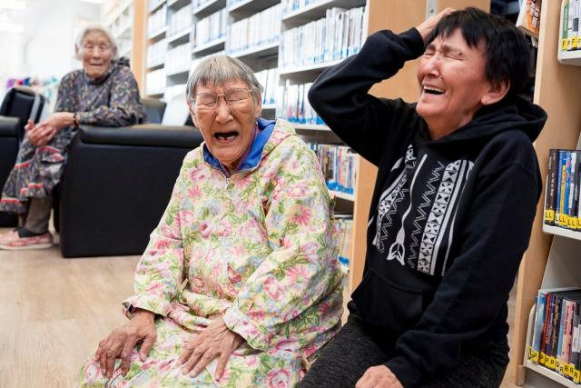
Published On: August 19, 2025
The Inuinnaqtun language is the cultural foundation of the Inuinnait people, who live in the central Canadian Arctic. The word Inuinnaqtun literally means “to be like an Inuinnaq (a person).” Today, fewer than 600 people can speak Inuinnaqtun fluently, with many having lost the language when they were taken from their communities and sent to residential schools.
Mission and Service partner Pitquhirnikkut Ilihautiniq/Kitikmeot Heritage Society in Cambridge Bay, Nunavut, is dedicated to keeping Inuinnaqtun alive. They offer one-on-one language immersion sessions with mentors to inspire reconnection.
Since the initial gathering of the Inikhaliuqatigiit team in 2021, many significant successes have occurred. Over the past year, the team has worked hard together, both in person and online, to create helpful resources for revitalizing the Inuinnaqtun language. They have spent many hours making sure these resources will make a positive impact.
One big success is the development of the Inuinnaqtun Dictionary app, which is newly available for free on Android and Apple. The team has also created a beginner Inuinnaqtun curriculum called Inuinnaujunga and is working on lessons for more advanced levels. They are also teaming up with linguist Richard Compton from the Université de Quebec à Montreal to create a Community Grammar of Inuinnaqtun.
Your compassionate gifts through Mission and Service are supporting programs that help preserve language and culture.
A gift of belonging to a church is that the practice of gathering together for worship … to pray, sing, listen to scripture and share how God touches our lives – helps us grow in deeper relationship with God and each other. We are offering this practice of sharing beyond Sunday morning to deepen our connection. Each week you are offered a picture, a scripture and a question for contemplation, as well as a short reflection for you to contemplate, have conversation with people in your life and/or join an online conversation on our Rockwood Stone Facebook page.

