Contemplation and Conversation: 16th Sunday after Pentecost, September 28, 2025
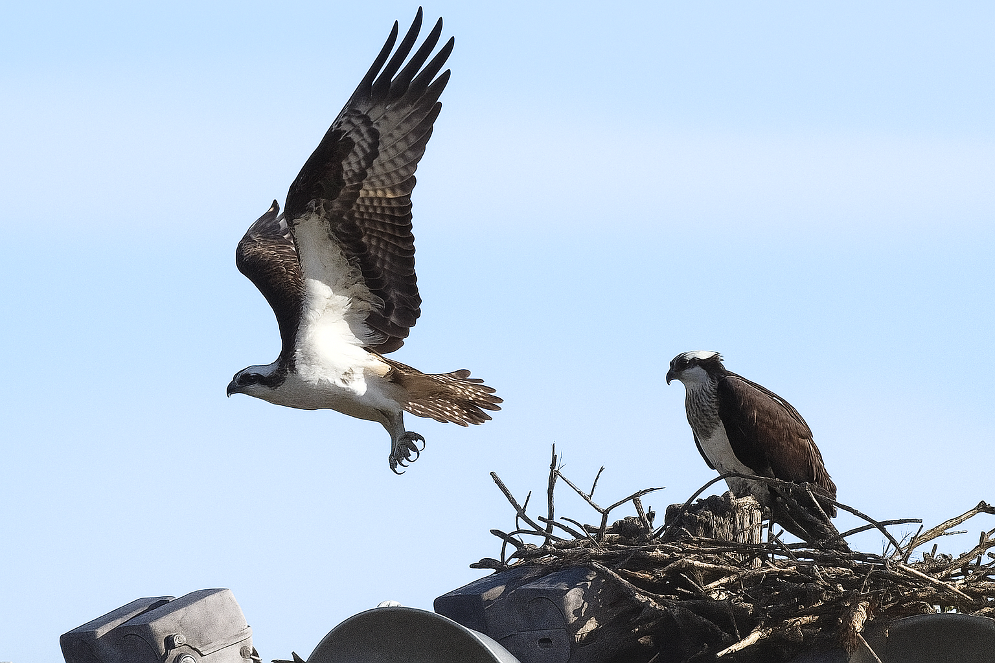
Scripture – Psalm 91:1-6, 14-16 NRSVUE
¹ You who live in the shelter of the Most High,
who abide in the shadow of the Almighty,
² will say to the Lord, “My refuge and my fortress;
my God, in whom I trust.”
³ For he will deliver you from the snare of the hunter
and from the deadly pestilence;
⁴ he will cover you with his pinions,
and under his wings you will find refuge;
his faithfulness is a shield and defense.
⁵ You will not fear the terror of the night
or the arrow that flies by day
⁶ or the pestilence that stalks in darkness
or the destruction that wastes at noonday.
¹⁴ Those who love me, I will deliver;
I will protect those who know my name.
¹⁵ When they call to me, I will answer them;
I will be with them in trouble;
I will rescue them and honor them.
¹⁶ With long life I will satisfy them
and show them my salvation.
From Rev. Heather Leffler
I can’t read the words of this Psalm or see a bird of prey flying overhead without hearing the music that we sing. That melody fills my heart and reminds me that no matter what is happening in my life or in the world God is with me – in life, in death and in life beyond death. We are not alone.
Again and again I realize how blessed we are to know God’s presence in our lives and to belong to our communities of Rockwood and Stone. Whether it was during the pandemic or in this time of political unrest and uncertainty, together we find comfort and hope in the words of scripture and the gift of community.
More and more I find myself wondering how we might share this incredible gift with others – those who have drifted away from our churches and those who have never known what it means to follow Jesus. May we find the words and ways to invite others into this loving community.
Contemplation and Conversation
Who would you like to invite into our community of faith?
Prayer
Holy Mystery, you are Wholly Love.
We give thanks for the gift of knowing we belong to you.
Guided by your Spirit, help us share this good news with others. Amen.

Further Conversation … Would you like to talk more about today’s reflection? Email Heather at hleffler@rogers.com.

Our Rockwood Stone Family
If you missed today’s worship service, you can watch it here: https://youtu.be/em-QrCoz0bc
Tuesday, September 30 at 10 am join Anishnabeg Outreach at the AO Spirit Garden, 1160 Spitzig Road, for their National Day for Truth & Reconciliation gathering.
Together we will share in bannock and cedar tea, sage harvest, tobacco ties, a learning table, and a fire circle. Orange shirt pins will be available by donation, and we will be sharing AO’s new Reconciliation Roadmap. Parking is available at Woodland Christian High School.
RSVP encouraged: info@aocan.org.

United Church of Canada
Alvin William Dixon (1937–2014), a respected Heiltsuk First Nation Elder, was taken from his family at age 10 to the Alberni Indian Residential School on Vancouver Island, where he survived years of abuse. Eventually, he enrolled at the University of British Columbia in Vancouver, as one of six First Nations students at the school. A respected leader, he advocated for Indigenous education.
To honour his commitment, The United Church of Canada established the Alvin Dixon Memorial Bursary Fund to support Indigenous students in post-secondary education. This fund is supported, in part, by the triennial Alvin Dixon Memorial Run/Walk, which recently raised a record-breaking $31,000.
Read the full news story on The United Church of Canada's website: https://united-church.ca/.../campaign-raised-more-31k...
#UCCan #AlvinDixonRun #UCCanGC45 #GC45 #IndigenousEducation
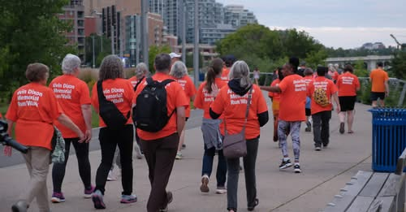

A gift of belonging to a church is that the practice of gathering together for worship … to pray, sing, listen to scripture and share how God touches our lives – helps us grow in deeper relationship with God and each other. We are offering this practice of sharing beyond Sunday morning to deepen our connection. Each week you are offered a picture, a scripture and a question for contemplation, as well as a short reflection for you to contemplate, have conversation with people in your life and/or join an online conversation on our Rockwood Stone Facebook page.

