Contemplation and Conversation
19th Sunday after Pentecost, October 19, 2025
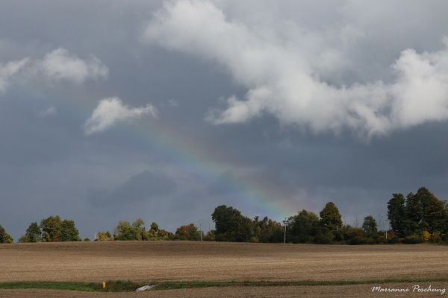
Scripture – Jeremiah 31:27-34 NRSVUE
²⁷ The days are surely coming, says the Lord, when I will sow the house of Israel and the house of Judah with the seed of humans and the seed of animals. ²⁸ And just as I have watched over them to pluck up and break down, to overthrow, destroy, and bring evil, so I will watch over them to build and to plant, says the Lord. ²⁹ In those days they shall no longer say:
“The parents have eaten sour grapes,
and the children’s teeth are set on edge.”
³⁰ But all shall die for their own sins; the teeth of the one who eats sour grapes shall be set on edge.
³¹ The days are surely coming, says the Lord, when I will make a new covenant with the house of Israel and the house of Judah. ³² It will not be like the covenant that I made with their ancestors when I took them by the hand to bring them out of the land of Egypt—a covenant that they broke, though I was their husband, says the Lord. ³³ But this is the covenant that I will make with the house of Israel after those days, says the Lord: I will put my law within them, and I will write it on their hearts, and I will be their God, and they shall be my people. ³⁴ No longer shall they teach one another or say to each other, “Know the Lord,” for they shall all know me, from the least of them to the greatest, says the Lord, for I will forgive their iniquity and remember their sin no more.
From Rev. Heather Leffler
What would the world look like if we really let God write a covenant on our hearts? What if we trusted that we don’t need to explain or teach each other who God is, but could believe that the Spirit already lives and moves within each of us?
Jeremiah shared this message during one of the hardest times in his people’s history. The Babylonians had invaded Judah and taken many leaders into exile. Those left behind—mostly the poor—believed God had abandoned them. Jeremiah stayed with them and reminded them that God’s love was still present and that God hadn’t given up on them.
When we look at the state of our world—with its divisions, conflicts, and worries—it’s easy to feel discouraged, just like the people of Judah. But Jeremiah’s promise of a “new covenant” reminds us that God’s commitment to us is unwavering. God continues to plant seeds of hope and healing even in difficult times.
We’re invited to live each day trusting that God’s Spirit is still at work—in us, through us, and around us. When we choose to love, forgive, and care for those closest to us, we become part of God’s renewing work in the world.
At Stone today, we were blessed by the beautiful, heartfelt music of the Rainbow Chorus. What a gift to see people who once had to hide their true selves now able to share songs of hope and healing openly. Their voices remind us of the power of God’s inclusive love.
Contemplation and Conversation
Where do you see God’s Spirit of love at work in the world?
Prayer
Holy One, write your words on our hearts
so we can discern where your loving Spirit is at work in the world.
Help us build your kingdom on earth as it is in heaven. Amen.

Further Conversation … Would you like to talk more about today’s reflection? Email Heather at hleffler@rogers.com.

Our Rockwood Stone Family
If you missed today’s worship service, you can watch it here: https://youtu.be/IJzKpz7Ykj0
Thank you to everyone who took part in Stone’s 163 Anniversary Worship, Foodgrains wrap up, lunch and Rainbow Chorus concert. Hearing the important work of the Canadian Foodgrains Bank, if you would like to make a donation, etransfers can be sent to stoneuc.treasurer@gmail.com . 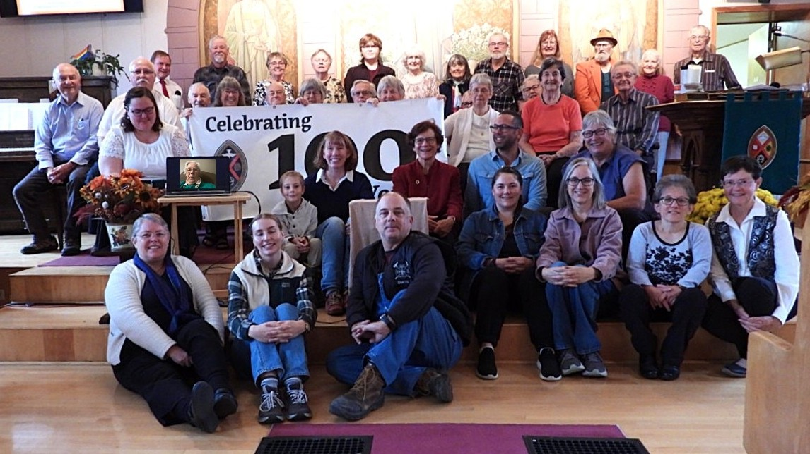

United Church of Canada
Creator,
Conspire with us
to create a world where all have access to nutritious and sustainable food sources,
and none live with scarcity or food insecurity.
Redeemer,
Save us from oppressive and unjust systems.
Mobilize us to be a part of a world response
that works in partnership with those of good will
to foster equitable resource sharing.
Sustainer,
Cultivate our resilience and expand our imaginations,
so that we might continually find new ways
to answer the call to end hunger—
until all may flourish.
Amen.
—A prayer for World Food Day by Alydia Smith
A gift of belonging to a church is that the practice of gathering together for worship … to pray, sing, listen to scripture and share how God touches our lives – helps us grow in deeper relationship with God and each other. We are offering this practice of sharing beyond Sunday morning to deepen our connection. Each week you are offered a picture, a scripture and a question for contemplation, as well as a short reflection for you to contemplate, have conversation with people in your life and/or join an online conversation on our Rockwood Stone Facebook page.

