Contemplation and Conversation
20th Sunday after Pentecost, October 26, 2025
Reformation Sunday
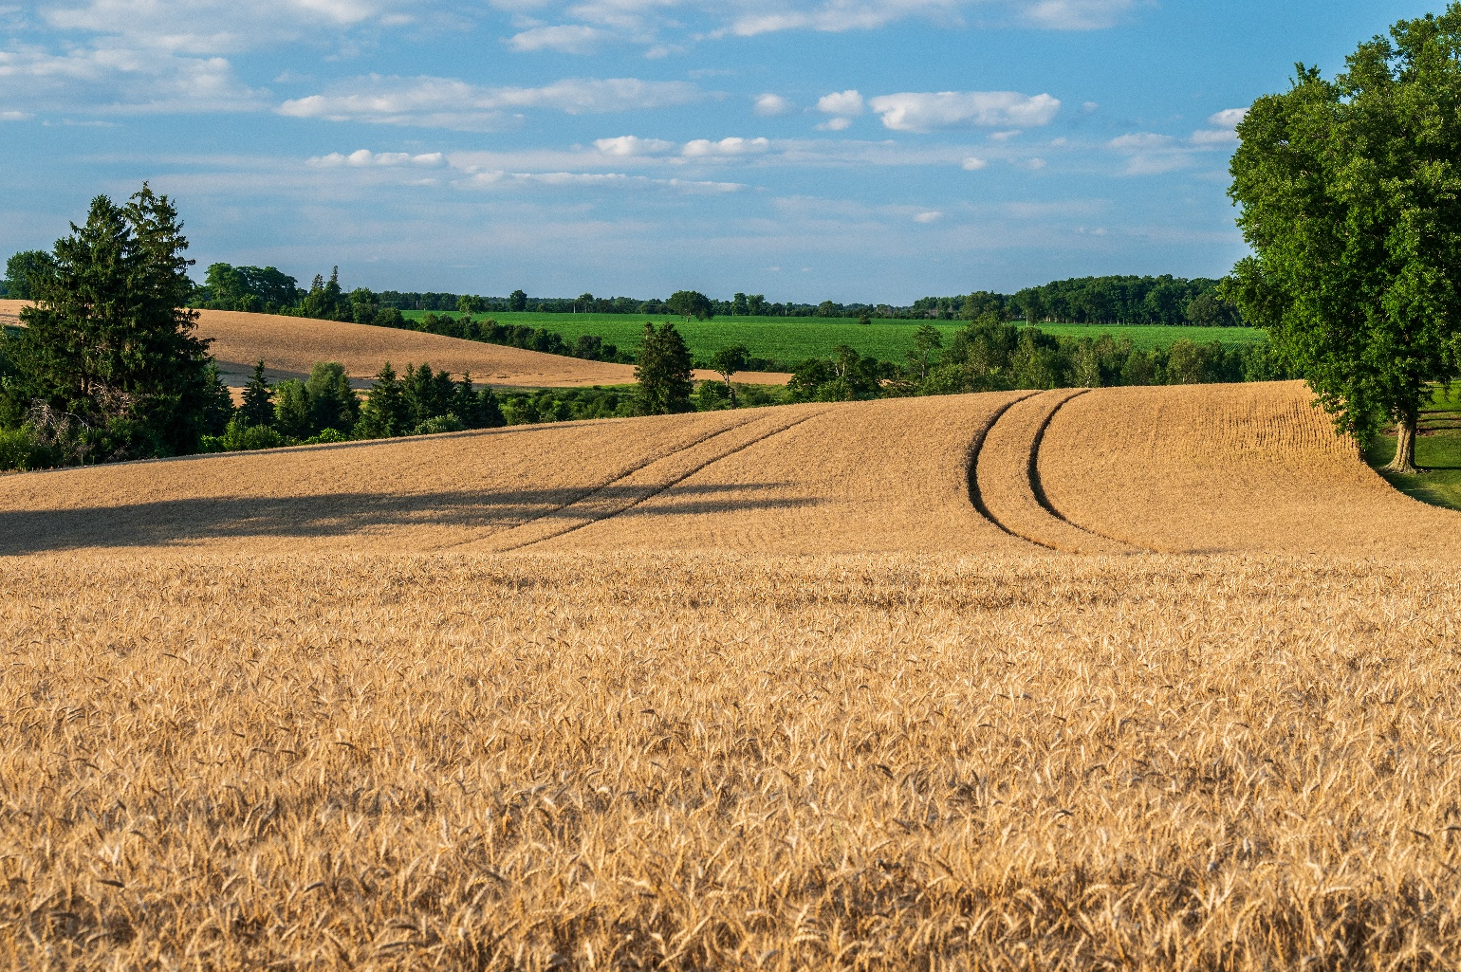
G Carothers
Scripture – Psalm 65 NRSVUE
¹ Praise is due to you,
O God, in Zion,
and to you shall vows be performed,
² O you who answer prayer!
To you all flesh shall come.
³ When deeds of iniquity overwhelm us,
you forgive our transgressions.
⁴ Happy are those whom you choose and bring near
to live in your courts.
We shall be satisfied with the goodness of your house,
your holy temple.
⁵ By awesome deeds you answer us with deliverance,
O God of our salvation;
you are the hope of all the ends of the earth
and of the farthest seas.
⁶ By your strength you established the mountains;
you are girded with might.
⁷ You silence the roaring of the seas,
the roaring of their waves,
the tumult of the peoples.
⁸ Those who live at earth’s farthest bounds are awed by your signs;
you make the gateways of the morning and the evening shout for joy.
⁹ You visit the earth and water it;
you greatly enrich it;
the river of God is full of water;
you provide the people with grain,
for so you have prepared it.
¹⁰ You water its furrows abundantly,
settling its ridges,
softening it with showers,
and blessing its growth.
¹¹ You crown the year with your bounty;
your wagon tracks overflow with richness.
¹² The pastures of the wilderness overflow;
the hills gird themselves with joy;
¹³ the meadows clothe themselves with flocks;
the valleys deck themselves with grain;
they shout and sing together for joy.
From Rev. Heather Leffler
What a gift it is to know the steadfast love, mercy, and forgiveness of our Creator. The psalmist reminds us that when we live in relationship with the Holy One, we are able to offer prayer and praise, experience forgiveness, and trust that God listens and responds with grace.
If we ever begin to doubt that God is present and active in the world, we need only look around us—to the beauty and majesty of creation. Seeing how the Creator waters the earth, enriches it, and blesses it with abundance, we are reminded that we, too, are sustained and cared for through the gifts of the harvest
On this spectacular fall day, surrounded by the rich colours of the season and the lingering warmth of the sun, our natural response is gratitude—thanksgiving to the One who gives us life and renews us through Christ. May our lives reflect that gratitude in all we say and do.
Contemplation and Conversation
What makes your heart rejoice today?
Prayer
God of the earth and the rain, the furrow and the harvest,
we offer you thanks and praise for the abundance of your creation.
May we honour you by sharing the good things we receive with others.
In gratitude and joy, we pray. Amen.

Further Conversation … Would you like to talk more about today’s reflection? Email Heather at hleffler@rogers.com.

Our Rockwood Stone Family
If you missed today’s worship service, visit our Rockwood Stone YouTube page.
Want to learn more about the reformation, go to History 101: The Protestant Reformation | National Geographic or A Fun, Animated History of the Reformation and the Man Who Started It All | Short Film Showcase .

United Church of Canada

A gift of belonging to a church is that the practice of gathering together for worship … to pray, sing, listen to scripture and share how God touches our lives – helps us grow in deeper relationship with God and each other. We are offering this practice of sharing beyond Sunday morning to deepen our connection. Each week you are offered a picture, a scripture and a question for contemplation, as well as a short reflection for you to contemplate, have conversation with people in your life and/or join an online conversation on our Rockwood Stone Facebook page.

