Contemplation and Conversation
21st Sunday after Pentecost, November 2, 2025

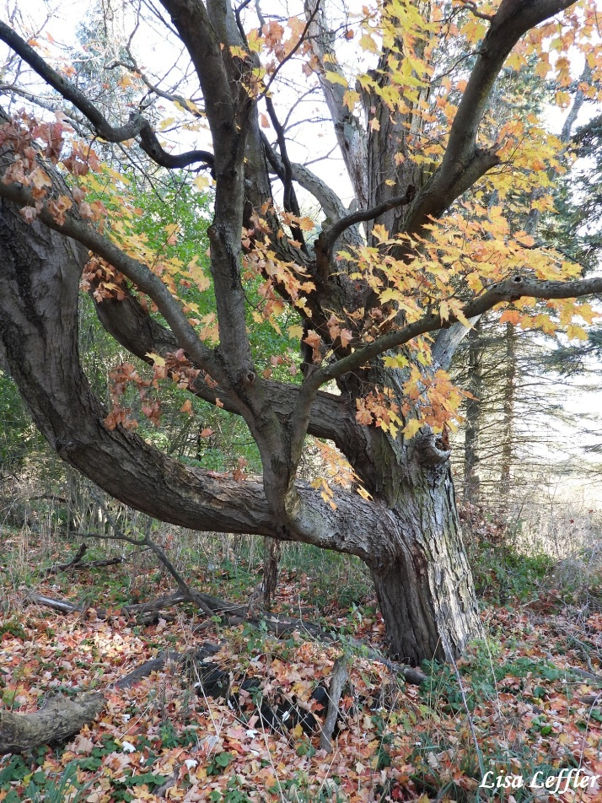
Scripture – Luke 19:1-10 NRSVUE
¹ He entered Jericho and was passing through it. ² A man was there named Zacchaeus; he was a chief tax collector and was rich. ³ He was trying to see who Jesus was, but on account of the crowd he could not, because he was short in stature. ⁴ So he ran ahead and climbed a sycamore tree to see him, because he was going to pass that way. ⁵ When Jesus came to the place, he looked up and said to him, “Zacchaeus, hurry and come down, for I must stay at your house today.” ⁶ So he hurried down and was happy to welcome him. ⁷ All who saw it began to grumble and said, “He has gone to be the guest of one who is a sinner.” ⁸ Zacchaeus stood there and said to the Lord, “Look, half of my possessions, Lord, I will give to the poor, and if I have defrauded anyone of anything, I will pay back four times as much.” ⁹ Then Jesus said to him, “Today salvation has come to this house, because he, too, is a son of Abraham. ¹⁰ For the Son of Man came to seek out and to save the lost.”
From Rev. Heather Leffler
Most of us know Zacchaeus’ story from our Sunday School days — the chief tax collector who became wealthy through unjust gain and had a change of heart after encountering Jesus. For many of us, the story has always been about a sinner being saved.
What struck me today was how meeting Jesus not only allowed Zacchaeus to see his wealth in a new light, but also allowed others to see him differently. When Zacchaeus declared to Jesus that he would give half of his possessions to the poor and repay fourfold anyone he had cheated, he wasn’t doing so privately at home. He stood there in the midst of the very people who had glared at him, muttered against him, and kept him at a distance.
Again and again, Jesus restores people to right relationship. Repentance isn’t something we do once and then become forever righteous. Living in community means we sometimes disappoint and hurt one another. Yet Jesus keeps offering us the chance to confess, to seek healing and hope, and to be restored to one another.
May we, like Zacchaeus, welcome Christ into our homes and hearts so fully that others come to see us—and we come to see one another—through the eyes of grace.
Contemplation and Conversation
When have you experienced healing in a relationship?
Prayer
Loving Christ, you call each of us by name and invite us into new life.
Help us open our hearts to your transforming presence,
so that our relationships—within this community and beyond—
may be marked by honesty, compassion, and grace. Amen.
Further Conversation … Would you like to talk more about today’s reflection? Email Heather at hleffler@rogers.com.

Our Rockwood Stone Family
If you missed today’s worship service, visit our Rockwood Stone YouTube page.

From Pat Weir, Barrie Hill United Church
Hello Team;
I just wanted to share this photo from Khadouj that she sent me yesterday. She has become a Canadian Citizen. It was a long journey with slow paperwork during covid but she persevered and is so proud to have reached this achievement. She is amazing!
I also have included a photo of Chaymaa who graduated from Grade 8 in June. Muhammad graduated from grade 9 and is doing well in high school and GCVI where Chaymaa will be going next week. All the kids are now in school this fall! Khadouj is looking for full time work. Hussein is working for an Arabic food store in Kitchener so that limits Khadouj with only the one vehicle for the family.
The last photo is of the family this spring during Eid. Look how tall those kids are now!
Back row left to right: Chaymaa, Abir, Mohammad, Khadouj, Hussein, Zainab. Front row: Bissan, Retaj
Next year Muhammad will be able to apply as a paid Leader in Training for the Y camp. Chaymaa and Abir are in their second and third year of leadership training this summer at YWCA camp too. They all make friends easily in new situations and are very helpful at Eramosa Pastoral Charge VBS.
Thanks everyone for all your support with the family. It is so touching to see how much they have grown and independent they have become.
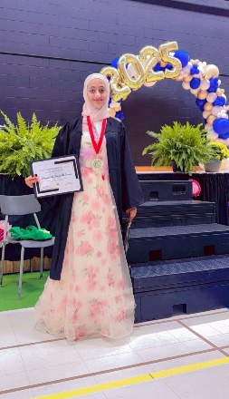
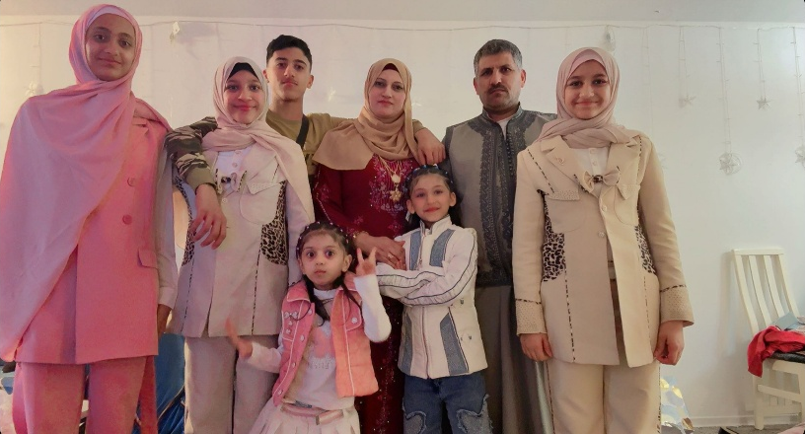
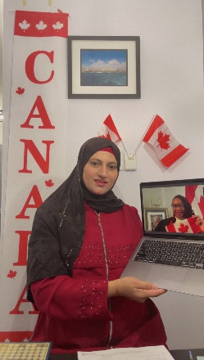

United Church of Canada
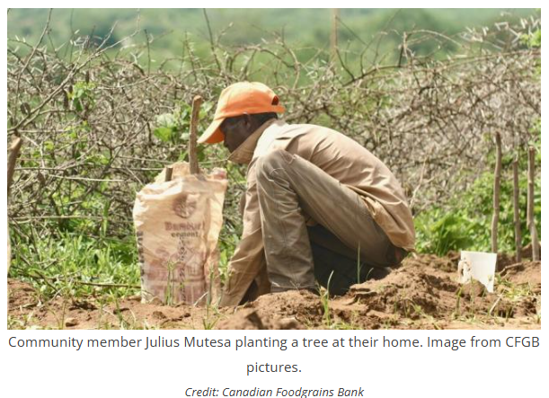
Published On: October 15, 2025
When members of the Diakonia of The United Church of Canada (DUCC) prepared to travel to Tanzania for the World Diakonia Conference, they knew their flights would carry a heavy carbon cost. Together, they decided to take collective responsibility for that footprint.
At the time, The United Church of Canada didn’t yet have a carbon offset program. DUCC members were determined to find a credible and meaningful way to act. They reached out to the Canadian Foodgrains Bank and contributed to its Nature+ program, which supported communities in Kenya, Ethiopia, Mozambique, and Zimbabwe who were revitalizing the land through nature-based solutions: planting trees, restoring soil, improving biodiversity, and strengthening food security.
Their example inspired change. Because of the DUCC members’ faithful leadership in charting a path, the United Church established a carbon offset option through Mission and Service. This made it possible for anyone travelling for church work or personal reasons to contribute to a climate action project supported by Mission and Service and the Canadian Foodgrains Bank.
Through this partnership, the National Council of Churches of Kenya (NCCK) is working closely with communities in Kitui County to provide training on conservation agriculture and other sustainable farming techniques, beekeeping, and land and water conservation, reaching more than 11,000 people adapt to climate change. The United Church accompanies the NCCK on this exciting climate initiative.
What began as one group’s effort to travel responsibly grew into an ongoing movement of faithful action. Today, your gifts for Mission and Service continue to support this carbon offset program, caring for creation and planting seeds of hope around the world.

A gift of belonging to a church is that the practice of gathering together for worship … to pray, sing, listen to scripture and share how God touches our lives – helps us grow in deeper relationship with God and each other. We are offering this practice of sharing beyond Sunday morning to deepen our connection. Each week you are offered a picture, a scripture and a question for contemplation, as well as a short reflection for you to contemplate, have conversation with people in your life and/or join an online conversation on our Rockwood Stone Facebook page.

