Contemplation and Conversation: 22nd Sunday after Pentecost, November 9, 2025
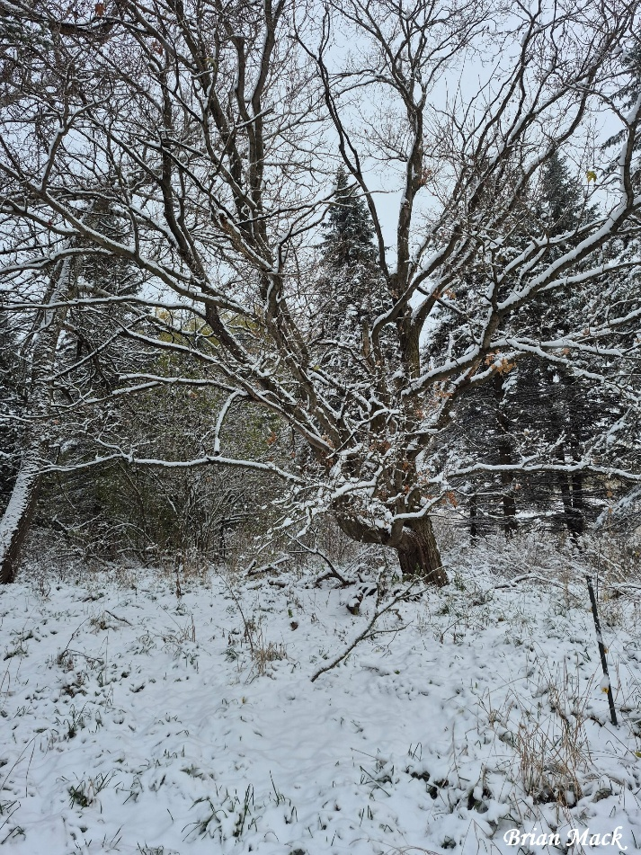
Scripture – Psalm 17: 1-9 NRSVUE
¹ Hear a just cause, O Lord; attend to my cry;
give ear to my prayer from lips free of deceit.
² From you let my vindication come;
let your eyes see the right.
³ If you try my heart, if you visit me by night,
if you test me, you will find no wickedness in me;
my mouth does not transgress.
⁴ As for what others do, by the word of your lips
I have avoided the ways of the violent.
⁵ My steps have held fast to your paths;
my feet have not slipped.
⁶ I call upon you, for you will answer me, O God;
incline your ear to me; hear my words.
⁷ Wondrously show your steadfast love,
O savior of those who seek refuge
from their adversaries at your right hand.
⁸ Guard me as the apple of the eye;
hide me in the shadow of your wings,
⁹ from the wicked who despoil me,
my deadly enemies who surround me.
From Lisa Leffler
When we watch the news, it can feel like enemies are all around us – not only in wars and conflicts far away, but in the ways people are treated close to home. We see people harmed by racism, homophobia, religious intolerance, ableism, and gender discrimination. We watch those in power make choices that cause suffering, and it can seem as though history is repeating itself. In moments like these, it’s easy to feel weary, fearful, and unsure of what the future holds.
Psalm 17 is a prayer from someone surrounded by danger – someone who turns to God for protection and guidance, trusting that God’s love will hold them fast. On this Remembrance Sunday, these words remind us that even in the face of violence and injustice, faith invites us to choose another way. We are called to keep walking the path of peace, to hold fast to compassion, and to stand alongside those our world has pushed to the margins.
When we stand together in love, when we speak truth and work for justice, we resist the powers that seek to divide and destroy. Our witness becomes a living remembrance – honouring those who have suffered and sacrificed by building the kind of world they longed for: a world where love is stronger than hate, peace is stronger than fear, and all people have what they need not just to survive, but to thrive in the light of God’s love.
Contemplation and Conversation
Where do you see signs of love and courage in a world that often feels divided,
and how might you join in God’s work of peace this week?
Prayer
God of peace, hold us steady in love when the world feels uncertain.
Open our hearts to see your image in every person we meet.
Guide our steps in the way of Jesus, that we may be builders of peace. Amen.
Further Conversation … Would you like to talk more about today’s reflection? Email Heather at hleffler@rogers.com.

Our Rockwood Stone Family
If you missed today’s worship service, you can watch it here: https://www.youtube.com/watch?v=A6Mco9w2gwA.United Church of Canada
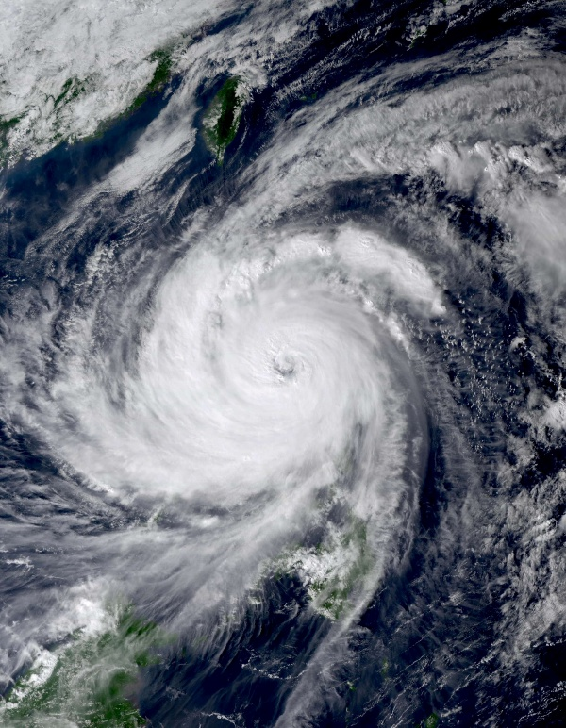
Please pray for the people of the Philippines as the country faces Super Typhoon Fung-wong. Over one million people have been evacuated and many more are at risk, just after Typhoon Kelmaegi devastated the country last week.
Compassionate God,
Mysterious and unfathomable, we turn to you in moments like this—
when life feels chaotic and devastating,
as Super Typhoon Fung-wong is sweeping across the Philippines,
causing unbearable loss and destruction, Following Kelmaegi.
At a time like this, words are hard to find...
Breathe with us with sighs too deep for words.
Give strength and courage to those who evacuate, seek safety,
search for the missing, and continue the long work of recovery.
Unite us in our common humanity,
that our prayers may be joined with compassion and action
as we help the people pick up the pieces of their lives.
O God of indomitable spirit,
may your undying hope rest upon the people of the Philippines.
May they know they are not alone in their struggles, grief, and loss.
Together with your Spirit, may your will be done among us.
May your compassion be made real—through caring hearts, open hands,
and a world moved to respond in love.
Trusting in the power of your all-embracing love,
we pray in the name of Jesus,
who calms the storms and brings peace to all creation.
Amen.
—by Rev. Won Hur
[Photo: Japan Meteorological Agency, Wikipedia, CC by 4.0, https://creativecommons.org/licenses/by/4.0]
#UCCan #Philippines #TyphoonFungWong

A gift of belonging to a church is that the practice of gathering together for worship … to pray, sing, listen to scripture and share how God touches our lives – helps us grow in deeper relationship with God and each other. We are offering this practice of sharing beyond Sunday morning to deepen our connection. Each week you are offered a picture, a scripture and a question for contemplation, as well as a short reflection for you to contemplate, have conversation with people in your life and/or join an online conversation on our Rockwood Stone Facebook page.

