Contemplation and Conversation
23rd Sunday after Pentecost, November 16, 2025

Scripture – 2 Thessalonians 3:6-13 NRSVUE
⁶ Now we command you, brothers and sisters, in the name of our Lord Jesus Christ, to keep away from every brother or sister living irresponsibly and not according to the tradition that they received from us. ⁷ For you yourselves know how you ought to imitate us; we were not irresponsible when we were with you, ⁸ and we did not eat anyone’s bread without paying for it, but with toil and labor we worked night and day so that we might not burden any of you. ⁹ This was not because we do not have that right but in order to give you an example to imitate. ¹⁰ For even when we were with you, we gave you this command: anyone unwilling to work should not eat. ¹¹ For we hear that some of you are living irresponsibly, mere busybodies, not doing any work. ¹² Now such persons we command and exhort in the Lord Jesus Christ to do their work quietly and to earn their own living. ¹³ Brothers and sisters, do not be weary in doing what is right.
From Rev. Heather Leffler
Like the gospel reading for this Sunday—Luke 21:5–19—this passage is one we might prefer to skip. Paul’s words, “Anyone unwilling to work should not eat,” have often been misused, but Paul was not telling the Thessalonian church to judge those who were unemployed or to abandon vulnerable neighbours. He was writing to a community in a particular moment, where some believers had stopped participating in daily life because they were convinced Jesus would return at any moment. Their withdrawal placed a burden on the wider community and weakened their common ministry. Paul responds with a moral teaching meant to draw them back into shared responsibility and faithful living.
When we read this alongside Jesus’ words in Luke, a deeper theme emerges. Jesus cautions his disciples not to be distracted by rumours of wars, political upheaval, or disasters—realities that have always marked human history. Instead, he calls them to steadfast trust: do not be terrified… I will give you words and wisdom… by your endurance you will gain your souls. Jesus is less concerned with predicting the end and far more concerned with how his followers live in the present.
Where Paul speaks of working quietly and responsibly for the good of the community, Jesus calls us to active faithfulness—not anxious waiting, but courageous participation in God’s work. Jesus would not stop with urging us to contribute our share; he invites us to be agents of compassion, justice, and care for all creation. We are here to embody Christ’s love, responding to the grace we have received by making that grace visible to others.
It is easy to slip into the temptation of separation—believing we are more faithful, more righteous, or more correct than someone else. But God does not compare us. God sees each of us as a beloved child and desires that we live full, rich lives rooted in the assurance that no matter what is happening around us, we are not alone. It is in choosing to “not grow weary in doing what is right”—in loving as we have been loved—that we most clearly feel God’s presence.
Contemplation and Conversation
What helps me stay faithful to God’s call when the world feels overwhelming?
Prayer
Loving Jesus, when we are tempted to wait passively for you
or to place ourselves above others, forgive us.
Draw us into your active, compassionate love.
Renew our courage to do what is right
and show us the gift of living our lives in you. Amen.
Further Conversation … Would you like to talk more about today’s reflection? Email Heather at hleffler@rogers.com.

Our Rockwood Stone Family
If you missed today’s worship service, you can watch it here: https://youtu.be/LUkFQNGybro?si=I1FKgocbGfXmA9MW

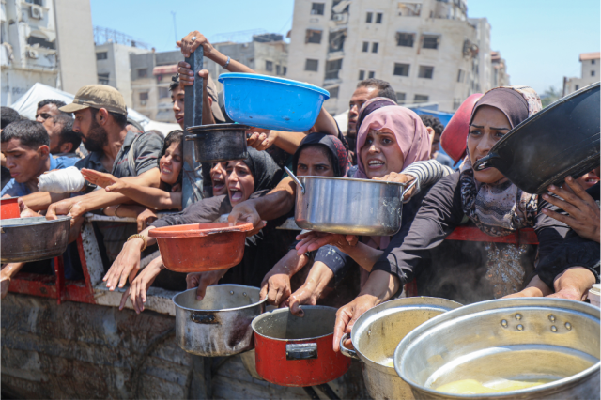
United Church of Canada: Faithful Witness in a Time of Despair
Palestinians in Gaza desperately seek aid amidst starvation.
Credit: Defense for Children International – Palestine (DCIP)
Published On: October 15, 2025
Body
“[T]he army surrounded us,” recalled 16-year-old Ramez. “We had nowhere to go. Either we move toward death, or we stay and risk dying. Either way, it’s death.”
For most children, childhood is a time to dream, go to school, play with friends, and imagine the future. But for children in Gaza, those simple dreams have been replaced by fear and survival.
Mission and Service partner Defense for Children International–Palestine (DCIP) shares that the situation in Gaza remains catastrophic. Families face famine, and the lack of access to clean water and medicine. Many have seen their homes bombed and are forced to live in tents or makeshift shelters. Parents spend hours in line each day for a small ration of bread or water, while children go hungry. Hospitals have run out of supplies, and schools have been reduced to rubble.
In interviews conducted by DCIP, children described their lives in stark, heartbreaking words. “We have no rights,” said one child. Fourteen-year-old Jana shared what life is like now: “We live in a tent. Every few days we have to move again. We spend hours waiting for water or food. Even to use the bathroom, we wait in line for hours. There’s no rest. We can’t go on like this.”
These children have endured unimaginable hardship. Many have been displaced multiple times, separated from friends, and have lost their entire family. Hospitals have run out of medicine. Schools are destroyed. Safe water is rare. Hunger is constant.
And yet, through it all, DCIP continues its mission, documenting violations of children’s rights, amplifying the voices of those who have been silenced, and calling the international community to act. Their courage ensures that the world cannot look away.
Your gifts to Mission and Service help support organizations like DCIP, who stand beside children in Gaza with compassion and conviction. When you give, you help make sure their stories are heard, and that the call for justice and protection does not fade into silence.
This Giving Tuesday, we invite you to join in prayer and action for the children of Gaza. May every child one day live free from fear, with food on the table, a place to learn, and the chance to simply be a child again.
Because every child has the right to food, shelter, safety, and education.
In collaboration with Maastricht University, Defense for Children International–Palestine interviewed four children living in Gaza about the status of their rights.
For more information about The United Church and Gaza go to Social Action > Justice Initiatives.

A gift of belonging to a church is that the practice of gathering together for worship … to pray, sing, listen to scripture and share how God touches our lives – helps us grow in deeper relationship with God and each other. We are offering this practice of sharing beyond Sunday morning to deepen our connection. Each week you are offered a picture, a scripture and a question for contemplation, as well as a short reflection for you to contemplate, have conversation with people in your life and/or join an online conversation on our Rockwood Stone Facebook page.

