Contemplation and Conversation
2nd Sunday of Advent, December 7, 2025
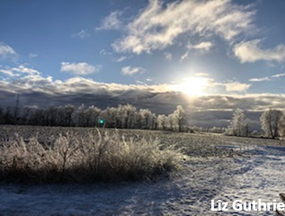
Scripture – Matthew 1:18-25 NRSVUE
¹⁸ Now the birth of Jesus the Messiah took place in this way. When his mother Mary had been engaged to Joseph, but before they lived together, she was found to be pregnant from the Holy Spirit. ¹⁹ Her husband Joseph, being a righteous man and unwilling to expose her to public disgrace, planned to divorce her quietly.
²⁰ But just when he had resolved to do this, an angel of the Lord appeared to him in a dream and said, “Joseph, son of David, do not be afraid to take Mary as your wife, for the child conceived in her is from the Holy Spirit. ²¹ She will bear a son, and you are to name him Jesus, for he will save his people from their sins.”

²² All this took place to fulfill what had been spoken by the Lord through the prophet:
²³ “Look, the virgin shall become pregnant and give birth to a son,
and they shall name him Emmanuel,”
which means, “God is with us.”
²⁴ When Joseph awoke from sleep, he did as the angel of the Lord commanded him; he took her as his wife ²⁵ but had no marital relations with her until she had given birth to a son, and he named him Jesus.
From Rev. Heather Leffler
Everything was arranged. Joseph and Mary had been chosen for each other. Mary had agreed, and they were betrothed. Their future was laid out before them. They would be married within the year. Then Joseph learned she was expecting a child. What was he to do? It was an impossible situation. If he didn’t divorce her quietly, she could be stoned for adultery.
When he went to bed that night, Joseph decided that was exactly what he would do. He would divorce Mary so they could both minimize the damage to their reputations. Then he slept … and dreamt.
God was asking him to be the father to Mary’s child – the promised one – to give the child his name and adopt him into the lineage of David.
Joseph did what God asked. He took Mary as his wife and named the child Jesus – Emmanuel, God with us. What he could have never imagined in the harsh light of day, Joseph could accept in the stillness of his dreams. God had a plan for this precious child and Joseph would care for him and his mother, becoming part of God’s saving work in the world.
Contemplation and Conversation
When have you found clarity or courage in the stillness of a dream, prayer, or quiet moment?
How might God be speaking to you in places you do not usually expect?
Prayer
God of our waking and our dreaming,
teach us to look beyond the easy or familiar solutions the world offers.
Open our hearts and imaginations to your greater possibilities
so that we may take our place in your work of love and restoration. Amen.
Further Conversation … Would you like to talk more about today’s reflection? Email Heather at hleffler@rogers.com.

Our Rockwood Stone Family
If you missed today’s worship service, you can watch it here: https://youtu.be/3mXIl3rtFic

Poem: For Grief
When you lose someone you love,
Your life becomes strange,
The ground beneath you gets fragile,
Your thoughts make your eyes unsure;
And some dead echo drags your voice down
Where words have no confidence.
Your heart has grown heavy with loss;
And though this loss has wounded others too,
No one knows what has been taken from you
When the silence of absence deepens.
Flickers of guilt kindle regret
For all that was left unsaid or undone.
There are days when you wake up happy;
Again inside the fullness of life,
Until the moment breaks
And you are thrown back
Onto the black tide of loss.
Days when you have your heart back,
You are able to function well
Until in the middle of work or encounter,
Suddenly with no warning,
You are ambushed by grief.
It becomes hard to trust yourself.
All you can depend on now is that
Sorrow will remain faithful to itself.
More than you, it knows its way
And will find the right time
To pull and pull the rope of grief
Until that coiled hill of tears
Has reduced to its last drop.
Gradually, you will learn acquaintance
With the invisible form of your departed;
And, when the work of grief is done,
The wound of loss will heal
And you will have learned
To wean your eyes
From that gap in the air
And be able to enter the hearth
In your soul where your loved one
Has awaited your return
All the time.
“For Grief” by John O’Donohue, from To Bless the Space Between Us: A Book of Blessings (Doubleday, 2008). In the depth of winter, enliven our senses, O God.
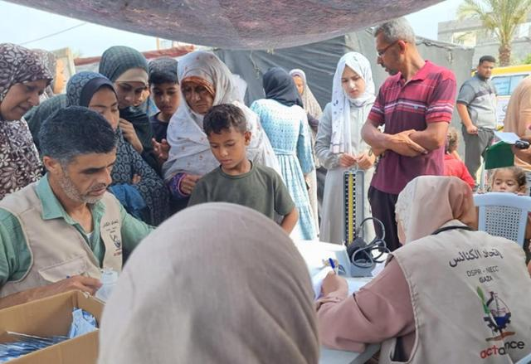
United Church of Canada
Together in Prayer and Solidarity
Published On: October 15, 2025
Through Mission and Service, The United Church of Canada accompanies global partners who bring compassion and courage to some of the world’s most difficult places. Today, we hold in prayer our partners in Gaza, where the situation remains catastrophic.
Partners in the ACT Palestine Forum share that families are facing famine, and shortages of clean water, medicine, and shelter. The cost of even the most basic items has risen far beyond reach. Many are forced to make painful choices simply to survive. Children are especially vulnerable as malnutrition and lack of medical care take a growing toll.
ACT Alliance member DSPR-MECC (Department of Service to Palestinian Refugees of the Middle East Council of Churches) provides medical support to people in Gaza.
Even amid these overwhelming challenges, Mission and Service partners continue to serve with remarkable faith and perseverance. Through ACT Alliance, they distribute food parcels, clean water, and medical supplies. They offer hygiene kits and psychosocial support to children and families living through trauma. And they raise their voices for a just and lasting peace, humanitarian access, and the protection of human dignity.
Each month, the ACT Palestine Forum organizes a global prayer vigil for Palestine and Gaza. “It gives us strength,” one representative says, “to know that people around the world are praying with us, for justice, peace, and human dignity.”
Your gifts for Mission and Service make this work possible. They help contribute to efforts to provide food, health care, and hope to reach those in greatest need, and that our partners know they are not alone.
Please continue to pray for all who are affected by this violence, and for peace rooted in justice to take root and grow.

A gift of belonging to a church is that the practice of gathering together for worship … to pray, sing, listen to scripture and share how God touches our lives – helps us grow in deeper relationship with God and each other. We are offering this practice of sharing beyond Sunday morning to deepen our connection. Each week you are offered a picture, a scripture and a question for contemplation, as well as a short reflection for you to contemplate, have conversation with people in your life and/or join an online conversation on our Rockwood Stone Facebook page.

