
Contemplation and Conversation: 3rd Sunday of Advent, December 14, 2025
Scripture – Luke 1:39-56 NRSVUE
³⁹ In those days Mary set out and went with haste to a Judean town in the hill country, ⁴⁰ where she entered the house of Zechariah and greeted Elizabeth.
⁴¹ When Elizabeth heard Mary’s greeting, the child leaped in her womb. And Elizabeth was filled with the Holy Spirit ⁴² and exclaimed with a loud cry, “Blessed are you among women, and blessed is the fruit of your womb. ⁴³ And why has this happened to me, that the mother of my Lord comes to me? ⁴⁴ For as soon as I heard the sound of your greeting, the child in my womb leaped for joy. ⁴⁵ And blessed is she who believed that there would be a fulfillment of what was spoken to her by the Lord.”
⁴⁶ And Mary said,
“My soul magnifies the Lord,
⁴⁷ and my spirit rejoices in God my Savior,
⁴⁸ for he has looked with favor on the lowly state of his servant.
Surely from now on all generations will call me blessed,
⁴⁹ for the Mighty One has done great things for me,
and holy is his name;
⁵⁰ indeed, his mercy is for those who fear him
from generation to generation.
⁵¹ He has shown strength with his arm;
he has scattered the proud in the imagination of their hearts.
⁵² He has brought down the powerful from their thrones
and lifted up the lowly;
⁵³ he has filled the hungry with good things
and sent the rich away empty.
⁵⁴ He has come to the aid of his child Israel,
in remembrance of his mercy,
⁵⁵ according to the promise he made to our ancestors,
to Abraham and to his descendants forever.”
⁵⁶ And Mary remained with her about three months and then returned to her home.
From Tammy Smits
I struggled with writing this contemplation about Mary, because … well … she’s MARY. How do you relate to someone who is God’s chosen vessel for God’s only Son? To my knowledge, no one in the history of time before or since has had a similar experience.
For inspiration, I turned to my friend Google to explore what life was like for her in Nazareth at the time of Jesus’ conception.
Judea and Galilee were under Roman control and ruled by Herod, who was known for heavy taxation and brutal suppression of dissent, which made him widely despised by Jews and fed into an “anti-government” sentiment. Apparently, it was a time of “pervasive political tension, economic hardship, and religious conflict which contributed to a climate of instability”. Sounds awfully familiar, actually.
I realized, Mary was just a young girl trying her best to survive in a tumultuous time, who was blindsided with an unbelievable message from an unusual and incredible source – a message that had the potential to make her a social outcast. What if Joseph didn’t stand by her? What if this was big misunderstanding?
Mary hurried off to visit Elizabeth for some independent verification of what Gabriel had told her, and to her great relief, found Elizabeth both pregnant and already “in the know” of Mary’s big news. Knowing that she was not alone, crazy, or outcast, Mary then gave thanks to God for the honour she realized had been bestowed on her.
Maybe no one else has had Mary’s exact experience, but we have all had times where life throws us a curveball, and with support from others and faith in God, what seems like an untenable situation can actually turn out to be the best thing that ever happens to us.
Contemplation and Conversation
When has a supportive person or community
helped you move from fear to joy?
How did that relationship change your perspective
on what was happening in your life?
Prayer
Thank you, Creator, for the gift of your Son,
for the blessings of community and fellowship,
and for the peace and joy that grow when we walk together.
Help us be that kind of support for others. Amen.
Further Conversation … Would you like to talk more about today’s reflection? Email Heather at hleffler@rogers.com.

Our Rockwood Stone Family
If you missed today’s worship service, you can watch it here: https://youtu.be/ojMfHU2SWV4

United Church of Canada
Advent calls us to joy rooted in God's abundance. May our lives shine with the joy of Christ, a witness to God's goodness in the world.
May that abundance come alive as joy - Rev. Won Hur
#UCCan #DeepBoldDaring #Advent3
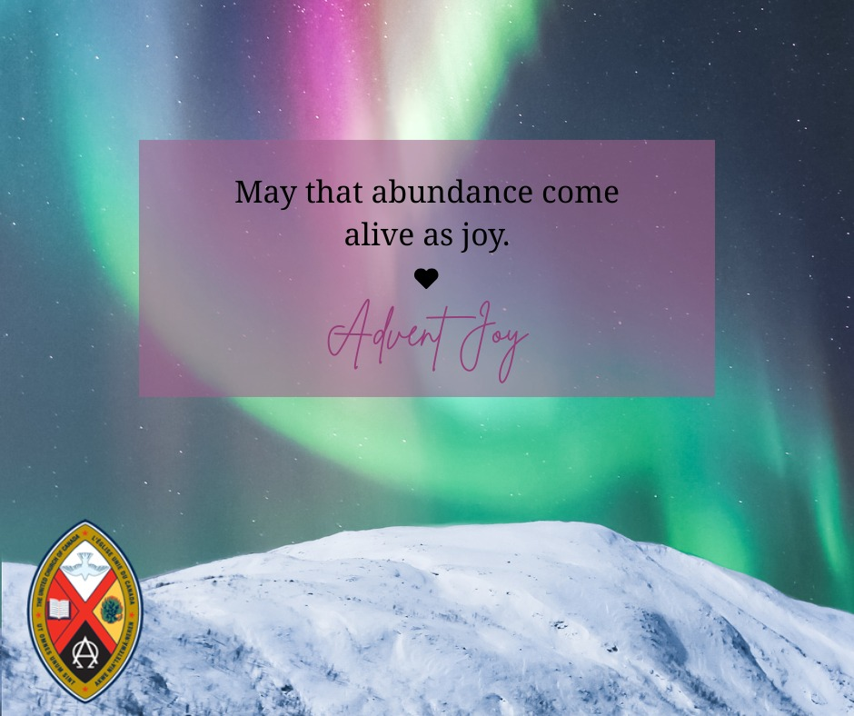

A gift of belonging to a church is that the practice of gathering together for worship … to pray, sing, listen to scripture and share how God touches our lives – helps us grow in deeper relationship with God and each other. We are offering this practice of sharing beyond Sunday morning to deepen our connection. Each week you are offered a picture, a scripture and a question for contemplation, as well as a short reflection for you to contemplate, have conversation with people in your life and/or join an online conversation on our Rockwood Stone Facebook page.

