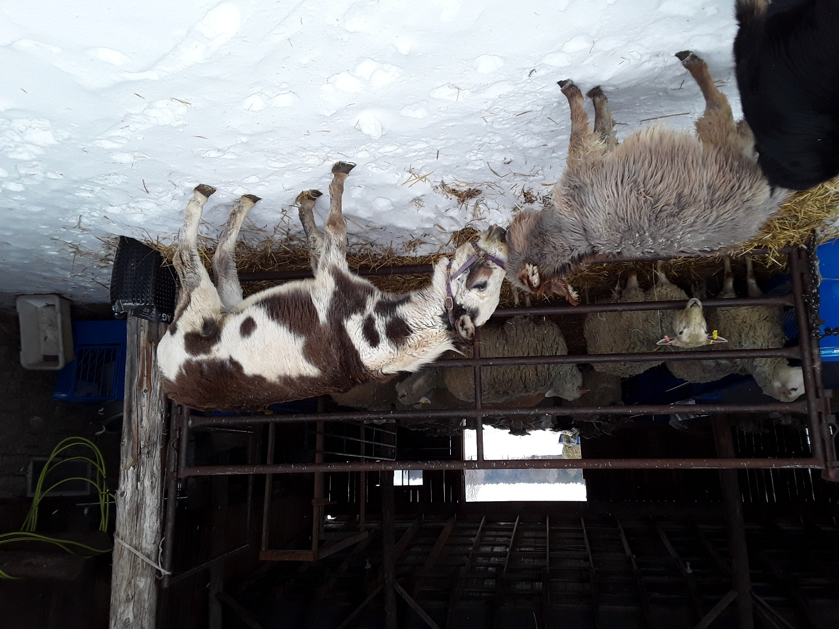
Contemplation and Conversation
4th Sunday of Advent, December 21, 2025
B Parker
Scripture – Luke 2:8-15 NRSVUE
⁸ Now in that same region there were shepherds living in the fields, keeping watch over their flock by night. ⁹ Then an angel of the Lord stood before them, and the glory of the Lord shone around them, and they were terrified.
¹⁰ But the angel said to them, “Do not be afraid, for see, I am bringing you good news of great joy for all the people: ¹¹ to you is born this day in the city of David a Savior, who is the Messiah, the Lord. ¹² This will be a sign for you: you will find a child wrapped in bands of cloth and lying in a manger.”
¹³ And suddenly there was with the angel a multitude of the heavenly host, praising God and saying,
¹⁴ “Glory to God in the highest heaven,
and on earth peace among those whom he favors!”
¹⁵ When the angels had left them and gone into heaven, the shepherds said to one another, “Let us go now to Bethlehem and see this thing that has taken place, which the Lord has made known to us.”
From Barb Parker
Luke 2: 8-15 tells us of the “Annunciation to the Shepherds”. It is a vital part of The Nativity of Jesus, in which an angel appeared to a group of shepherds, telling them the news that Christ had been born that day in Bethlehem. This pronouncement is followed by a crowd of angels proclaiming, “Glory to God in the highest heaven, and on earth peace among those whom he favours!”
Until doing some thinking and “research” for this reflection, I had not previously understood that this well-known scripture was an “annunciation”. I had been conditioned to consider the angel Gabriel’s appearance to Mary, as “the Annunciation” of the Nativity Story, even though Gabriel’s appearance to Joseph, is possibly equally important to how the story goes. Given that an annunciation is defined as an “announcement from angels” all three qualify. In fact, later in this reflection, you will find that there are five annunciations associated with the Nativity Story – who knew!
One article points out that the Annunciation to the Shepherds, should not be confused with the Adoration of the Shepherds, in which they go to Bethlehem, and bear “near witness” to the birth of Jesus. These are “distinct events”. The article notes that The Adoration of the Shepherds is often combined in art with the Adoration of the Magi. I agree with the suggestions that this combination of the lowly shepherds, who are the first to hear the news, with the majesty and mystery of the Magi, reinforces the truth that the message of Christs birth is for all people of the world.
When I volunteered to prepare this reflection on the Shepherds, I did so with some initial high-level thoughts that my experience with raising sheep, and all of their associated challenges, might provide a bit of humour, and perhaps a more lighthearted look at the life of the biblical shepherds, that Christmas Eve long ago. More time in “reflection” has resulted in a new awareness for me, of the not only the shepherds, but also the role of the angel(s) as God’s messengers.
I recommend you view the YouTube video “How Many Annunciations are there in the Bible”, in which Father William Nichols, explores this question, detailing not only the Annunciations related to Christmas (five), but also other important “announcements” made through angels, John the Baptist, Peter and others. He concludes this remarks with the following challenge: “Someone must have announced the good news of the Lord to you. You, in turn, must announce it to someone else!”
Contemplation and Conversation
How does the Annunciation to the Shepherds deepen your understanding of who the Good News
is for — and who God still chooses to speak through today?
Prayer
God, we give you thanks for the lowly shepherds,
who answered “yes” to the angels’ amazing news of the Messiah’s birth.
Help us to hear your call, trust your message,
and respond with courage, just as they did.
May we carry your good news of peace and hope
into the world you love. Amen.

Further Conversation … Would you like to talk more about today’s reflection? Email Heather at hleffler@rogers.com.

Our Rockwood Stone Family
If you missed today’s worship service, visit our Rockwood Stone YouTube page.

United Church of Canada
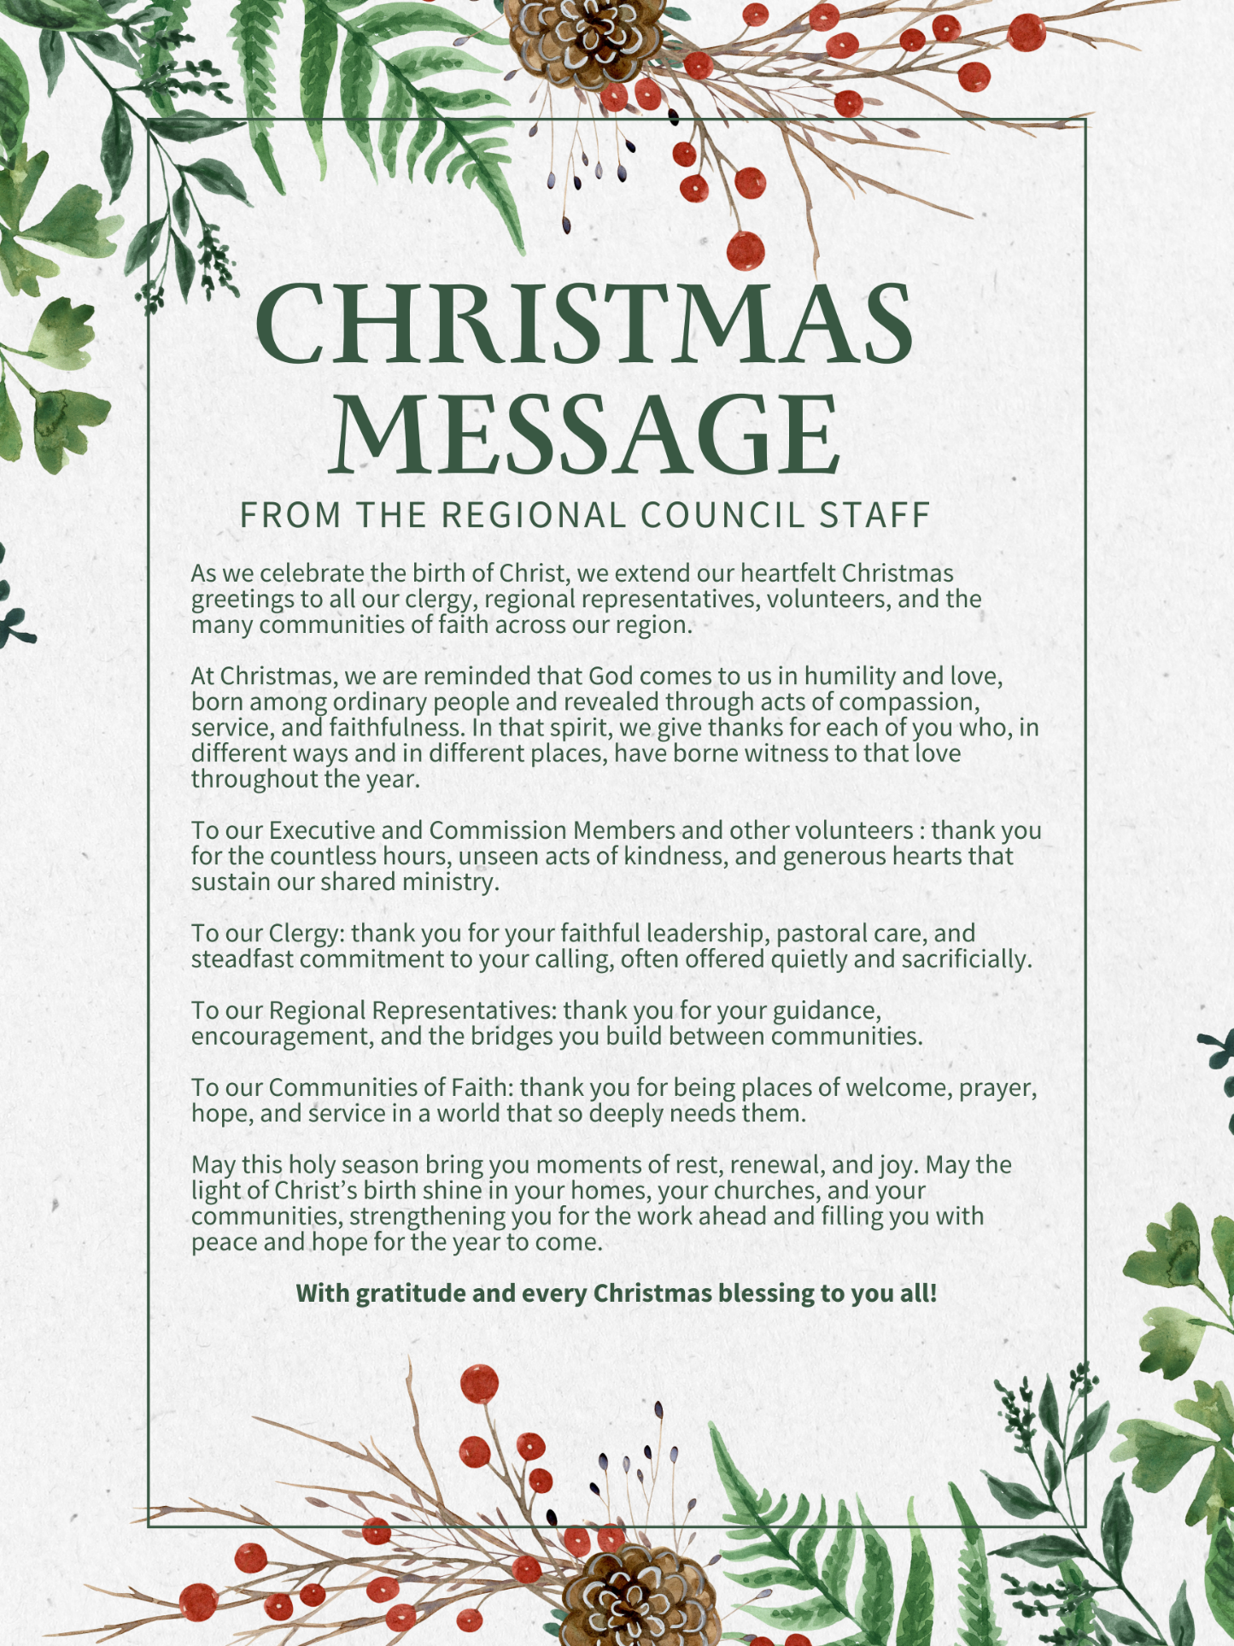

A gift of belonging to a church is that the practice of gathering together for worship … to pray, sing, listen to scripture and share how God touches our lives – helps us grow in deeper relationship with God and each other. We are offering this practice of sharing beyond Sunday morning to deepen our connection. Each week you are offered a picture, a scripture and a question for contemplation, as well as a short reflection for you to contemplate, have conversation with people in your life and/or join an online conversation on our Rockwood Stone Facebook page.

