Contemplation and Conversation: 4th Sunday of Advent, December 21, 2025
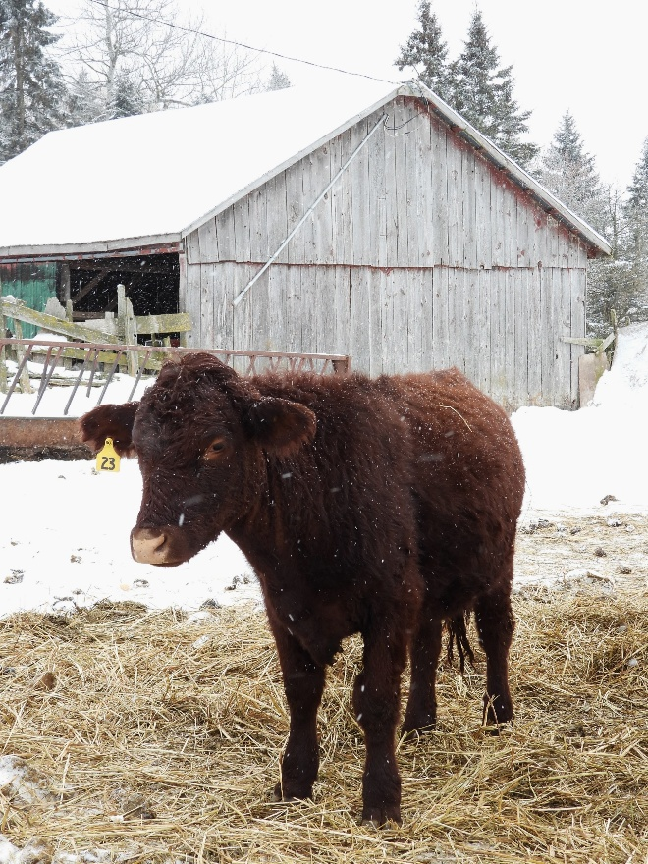
Scripture – Luke 2:1-7, 16-20 NRSVUE
¹ In those days a decree went out from Caesar Augustus that all the world should be registered. ² This was the first registration and was taken while Quirinius was governor of Syria. ³ All went to their own towns to be registered.
⁴ Joseph also went from the town of Nazareth in Galilee to Judea, to the city of David called Bethlehem, because he was descended from the house and family of David. ⁵ He went to be registered with Mary, to whom he was engaged and who was expecting a child.
⁶ While they were there, the time came for her to deliver her child. ⁷ And she gave birth to her firstborn son and wrapped him in bands of cloth and laid him in a manger, because there was no place in the guest room.
¹⁶ So they went with haste and found Mary and Joseph and the child lying in the manger. ¹⁷ When they saw this, they made known what had been told them about this child, ¹⁸ and all who heard it were amazed at what the shepherds told them, ¹⁹ and Mary treasured all these words and pondered them in her heart. ²⁰ The shepherds returned, glorifying and praising God for all they had heard and seen, just as it had been told them.
From Liz Guthrie
My parents, Mary and Joseph, needed to travel from Nazareth to Bethlehem to register for Caeser Agustus’ census. It was a long journey. So many people and animals. My mother was very tired, but she didn’t complain. My father took very good care of us.
In Bethlehem, there were no rooms to be found. Eventually, my parents found a place in a stable. That’s where I was born. My parents named me Jesus. My mother wrapped me snuggly in clothes. My bed was a manger filled with straw. The cooing doves, and the animals munching on their food all lulled me to sleep.
Then something out of the ordinary happened. Shepherds came to visit us. They told stories of how afraid they were when angels appeared. They couldn’t believe the news of a Saviour being born. But they decided to come and see for themselves. The shepherds were so excited; they praised God and told everyone about my birth.
For now, I am content to be surrounded by my parents’ care and love.
Contemplation and Conversation
How did you share the news of your newborn child
or a child in your family?
What expectations did you have for this child?
Prayer
Loving God, thank you for the gift of your son, Jesus.
Help us to joyfully spread the wonder of his birth
just as the shepherds did. Amen.

Further Conversation … Would you like to talk more about today’s reflection? Email Heather at hleffler@rogers.com.

Our Rockwood Stone Family
If you missed today’s worship service, you can watch it here: https://youtu.be/vJXz1UP0H0M
The story shared in the message can be found here: https://www.youtube.com/watch?v=2rZNTFf35Aw
Please hold the family and friends of Murray Duffield in your prayers as they mourn his death.
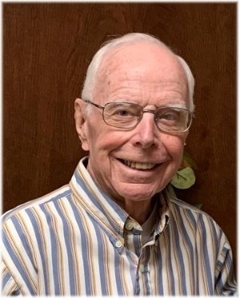
DUFFIELD, MURRAY - Of Elora, passed away suddenly on Thursday, December 25th, 2025, with family by his side, in his 92nd year.
Beloved husband of Margaret Duffield (nee Beaton) for 66 cherished years. Beloved father of Janet (John) of Bobcaygeon and Carol (Paul) of Puslinch. Devoted grandpa to Christopher (Angie), Ashley (Chris) and Nicholas (Steph). Fondly remembered by his nephews and nieces.
Murray was predeceased by his sister Helen (Stuart) Wilson and brother Wayne (Joyce) Duffield.
Murray was born and raised on the corner of the 4th line of Eramosa and Hwy 124 where he grew up and built his family home which he shared with Margaret from 1959 until moving to Elora in 2009.
Murray worked for 34 years as a draftsman for Armco Canada in Guelph before retiring. His hobbies included woodworking and making cherished items for his grandchildren. He was also an avid sports fan of hockey and baseball. Murray was always eager to lend a helping hand to anyone who needed it. He was a long-time member of Stone United Church in Eramosa.
Special thanks to the caring doctor and nursing staff at Groves Memorial Hospital for their compassionate care.
Donations in Murray’s memory can be made to Diabetes Canada or Stone United Church.
Cremation has taken place and a celebration of life will be held at a later date in the spring; details to be announced. Arrangements entrusted to the WALL-CUSTANCE FUNERAL HOME & CHAPEL 519-822-0051 / www.wallcustance.com.
A tree will be planted in memory of Murray J. Duffield in the Wall-Custance Memorial Forest.

United Church of Canada
Building on a Year of Care

Published On: December 12, 2025
As we step into a new year, we pause to celebrate the faithful work of our Mission and Service partners around the world. These partners—farmers, educators, community leaders, and local organizations—are on the ground responding to needs, creating opportunities, and building stronger, more resilient communities.
Through your prayers and your support of Mission and Service, they are able to focus on what matters most. Financial support helps ease the practical challenges of running programs, providing meals, training leaders, and responding to emergencies. Your partnership allows them to carry out their work with steadiness and care.
As 2026 begins, our partners have already been looking ahead with intentionality and hope. They are preparing to support people seeking stability, respond to crises both local and global, strengthen communities, and equip people with the skills, confidence, and opportunities to thrive. Each partner continues to adapt and innovate, finding new ways to meet the needs of their communities today, while preparing for the challenges of tomorrow.
This year, and in the years to come, your support helps ensure that these efforts can continue. Together, we walk alongside partners who are living out God’s call to justice, care, and hope—creating spaces where people are seen, supported, and empowered. As we look forward to 2026, we do so with gratitude for what has been achieved, and with intentional hope for all that is yet to come.

A gift of belonging to a church is that the practice of gathering together for worship … to pray, sing, listen to scripture and share how God touches our lives – helps us grow in deeper relationship with God and each other. We are offering this practice of sharing beyond Sunday morning to deepen our connection. Each week you are offered a picture, a scripture and a question for contemplation, as well as a short reflection for you to contemplate, have conversation with people in your life and/or join an online conversation on our Rockwood Stone Facebook page.

