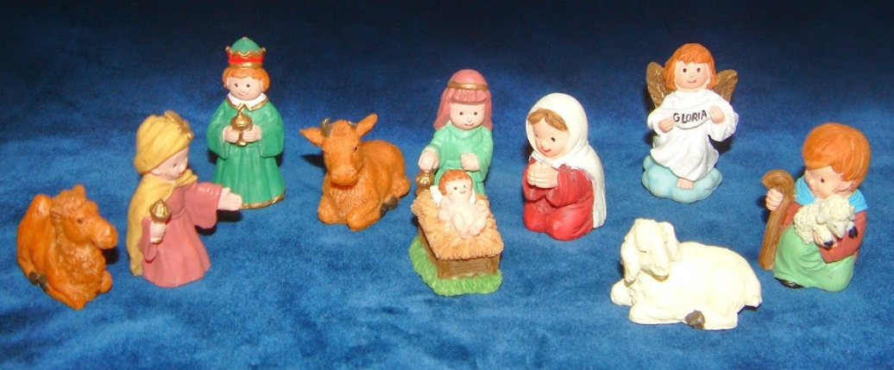
Contemplation and Conversation: 1st Sunday after Christmas, December 28, 2025

Scripture – Matthew 2:1-12 NRSVUE
¹ In the time of King Herod, after Jesus was born in Bethlehem of Judea, magi from the east came to Jerusalem, ² asking, “Where is the child who has been born king of the Jews? For we observed his star in the east and have come to pay him homage.” ³ When King Herod heard this, he was frightened, and all Jerusalem with him, ⁴ and calling together all the chief priests and scribes of the people, he inquired of them where the Messiah was to be born. ⁵ They told him, “In Bethlehem of Judea, for so it has been written by the prophet:
⁶ ‘And you, Bethlehem, in the land of Judah,
are by no means least among the rulers of Judah,
for from you shall come a ruler
who is to shepherd my people Israel.’ ”
⁷ Then Herod secretly called for the magi and learned from them the exact time when the star had appeared. ⁸ Then he sent them to Bethlehem, saying, “Go and search diligently for the child, and when you have found him, bring me word so that I may also go and pay him homage.”
⁹ When they had heard the king, they set out, and there, ahead of them, went the star that they had seen in the east, until it stopped over the place where the child was. ¹⁰ When they saw that the star had stopped, they were overwhelmed with joy. ¹¹ On entering the house, they saw the child with Mary his mother, and they knelt down and paid him homage. Then, opening their treasure chests, they offered him gifts of gold, frankincense, and myrrh.
¹² And having been warned in a dream not to return to Herod, they left for their own country by another road.
From Brian Mack
Without warning, a knock occurred at the door of a humble abode. Joseph and Mary looked at each other and scooped their son Jesus into their arms. They wondered if it could be Roman soldiers. A member of the Sanhedrin? A wayward traveller needing shelter for the night. Surely there was a logical explanation for the pounding on the door since they had led a quiet, faithful life since the birth and circumcision of their child.
As Joseph carefully opened the door, he saw a strange sight. A group of men, some on camels, and some on foot took up a considerable amount of space on the narrow street. A few of the men, speaking Aramaic, indicated that they were from the East. Joseph really couldn’t remember if it was two, three, or more who spoke to him. They told him that they had seen a star some time earlier and had felt compelled to set off on a journey that had ended up at this place. From the nature of their comments, Joseph deduced that the men who spoke were scholarly astrologers or priests. To reassure him of their status as members of the elite, they showed him various charts, maps, and sacred texts which they carried in both leather bags and cloth bundles. Sometimes, they turned away from him and bantered amongst themselves arguing over questions of astronomy, astrology, mathematics, and the meaning of sacred texts. Of one thing they were certain, after a long and perilous journey supported by their entourage, they had arrived at the right place.
Feeling reassured, Joseph invited the spokesmen into the house. Upon seeing Jesus, they knelt and offered expensive gifts. Although these gifts were meant to honour the child, the wisemen knew that Joseph and Mary might have to sell those precious gifts. They would soon need money to sustain them on a journey to Egypt to save their child from the wrath of King Herod as he would order all males under two years of age to be killed. The wise men and their entourage departed as abruptly as they had arrived determined to take an alternate route back to their homeland so that they did not have to tell King Herod what they had witnessed in that home.
The story of the wise men has much to teach us in 2025. Consider the following:
- Don’t be afraid to seek God. The magi saw a star and followed it willingly.
- Persevere with faith. The journey of the magi was filled with uncertainty, difficult travel conditions, and a tricky encounter with King Herod but they did not give up.
- Give your best to God through acts of praise, worship and service. The gifts that were given by the wise men represented the best that they had to offer in recognition of the importance of Jesus.
- Listening to God may lead to new paths in life. God warned the magi in a dream, and they took a new path home.
Contemplation and Conversation
The Wise Men went on a journey to find and worship Christ. What journeys of faith might God be calling you to take today?
Prayer
God, we give you thanks for prompting
the wise men to follow the star.
Give us courage to trust your guidance,
wisdom to follow new paths,
and hearts that seek Christ, the true Light of the world. Amen.

Further Conversation … Would you like to talk more about today’s reflection? Email Heather at hleffler@rogers.com.

Our Rockwood Stone Family
If you missed today’s worship service, you can watch it here: https://youtu.be/eZYGXFvUyHo

United Church of Canada
From the Right Rev. Dr. Kimberly Heath

A pause at the threshold of a new year.
These threshold places are not comfortable – they are far too narrow and far too full. They are full of cherished moments we want to cling to (that time on the rocky beach with the family in BC; that Holy Spirit connection at the conference breakfast table with new friends). And they are full of great disappointments that we can’t forget (golden-ballroom plans and ICE-cold detention centers; boasts of peace while Palestinian children lick flour dust from an empty supply truck).
It's hard to move through the tight space. We will need to acknowledge and let go of what was.
But there is something small enough to pick up and valuable enough to keep.
Hope comes very small at Christmas – small enough to carry through this narrow new-year space. Hope is so small it can be missed but when we commit to seeing it, carrying it, sharing it, it grows and grows. Hope so big we discover it is carrying us.
May you be carried into this new year in the arms of Hope
—By the tender mercy of our God,
the dawn from on high will break upon us,
to give light to those who sit in darkness and in the shadow of death,
to guide our feet into the way of peace. Luke 1:78-79

A gift of belonging to a church is that the practice of gathering together for worship … to pray, sing, listen to scripture and share how God touches our lives – helps us grow in deeper relationship with God and each other. We are offering this practice of sharing beyond Sunday morning to deepen our connection. Each week you are offered a picture, a scripture and a question for contemplation, as well as a short reflection for you to contemplate, have conversation with people in your life and/or join an online conversation on our Rockwood Stone Facebook page.

