Contemplation and Conversation
Baptism of the Lord, Sunday, January 11, 2026
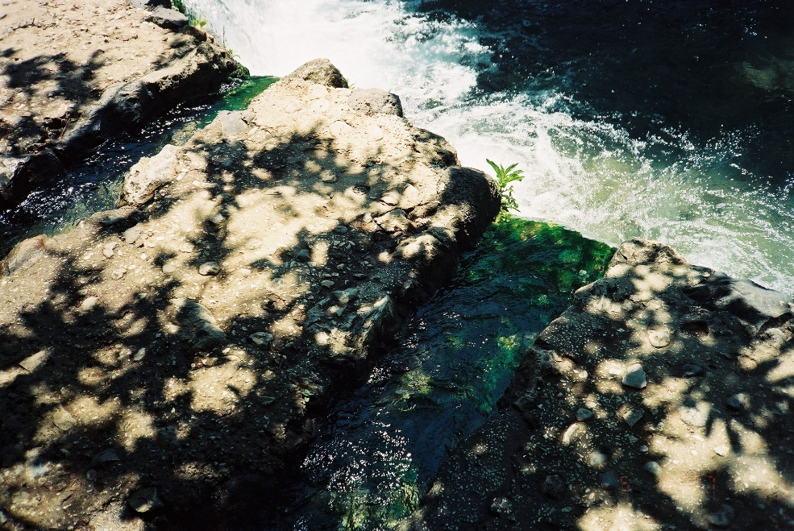
Scripture – Matthew 3:13-17 NRSVUE
¹³ Then Jesus came from Galilee to John at the Jordan, to be baptized by him. ¹⁴ John would have prevented him, saying, “I need to be baptized by you, and do you come to me?” ¹⁵ But Jesus answered him, “Let it be so now, for it is proper for us in this way to fulfill all righteousness.” Then he consented. ¹⁶ And when Jesus had been baptized, just as he came up from the water, suddenly the heavens were opened to him and he saw God’s Spirit descending like a dove and alighting on him. ¹⁷ And a voice from the heavens said, “This is my Son, the Beloved, with whom I am well pleased.”
Source of the Jordan River H Leffler
From Rev. Heather Leffler
John was urging people to repent and be baptized as a sign of turning their lives toward God. preparing them for the coming of the Messiah. When he recognized Jesus, John couldn’t imagine baptizing him. Jesus was the Son of God, the one without sin. Why would he need to be baptized?
Jesus reassured John that this was the right thing to do, not because Jesus needed repentance, but because he chose to fully enter into the human story. John baptized him, God’s Spirit descended on Jesus like a dove and God spoke. In that moment, heaven and earth met: Jesus’ baptism made him known to those gathered and marked the beginning of his public ministry.
This moment also shapes our understanding of baptism today. What began as a ritual of repentance became, through Jesus, a sacrament of belonging and blessing. Rather than a repeated act of repentance, baptism became a once-for-all sign of knowing who we belong to and of being welcomed into a community shaped by God’s grace.
When we are baptized, we belong not only to our local church or even the United Church, but to the Holy Catholic Church—the whole body of Christ across time and place. In baptism, we are claimed as part of Christ’s body in the world – held in God’s deep and abiding love and sent out to do justice, love kindness, and walk humbly with our God.
Contemplation and Conversation
What does it mean for you to belong to Christ’s body,
and how might you live that belonging more fully this week?
Prayer
Holy One – Parent, Beloved Son and Spirit, help us live into our baptism.
Teach us to trust the gift of belonging you have given us,
and to share it freely, so that others might come to know you
in new and deeper ways. Amen.

Further Conversation … Would you like to talk more about today’s reflection? Email Heather at hleffler@rogers.com.

Our Rockwood Stone Family
If you missed today’s worship service, you can watch it here: https://youtu.be/0jwWYDZE-AI

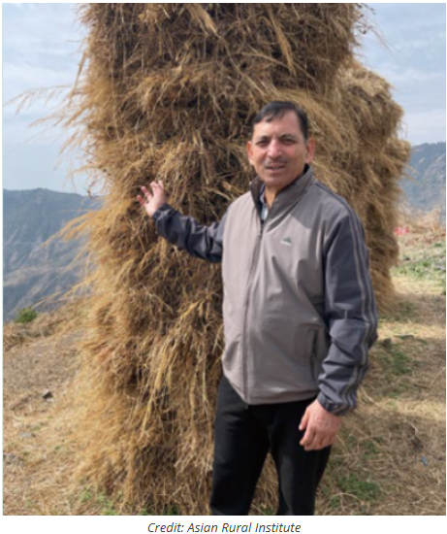
United Church of Canada – Mountains of Service
If you ever travel to the northern mountains of India and meet a man named Surrender Singh, the first thing he’ll do is invite you on a walk. Not a short stroll, but a real mountain trek. And the beauty of the Himalayas is only part of what he wants to show you.
With him as your guide, the trail becomes a story. Every bend holds a memory. Every village has a face he knows.
Many still call him “Singh san” from his time training at the Asian Rural Institute, a Mission and Service partner in Japan. For more than four decades, he has climbed these ridges. As you walk beside him, people call out greetings. He calls them by name. Someone brings tea. He digs in his pack and pulls out bananas or biscuits to share. And suddenly you’re not just passing through—you’re part of the conversation.
He’ll point to a house and tell you how he once slept on the floor there while helping build a water pipeline with the Mussoorie Village Development Committee, the group he now leads. Another turn in the path, and he’s showing you the school that has given local children a chance to learn close to home.
And then there are the women’s groups. Surrender Singh lights up talking about them. He trained them in organic farming. Now they grow and sell their produce, earning steady incomes and strengthening their families and communities.
By the time you reach the end of the trail, you realize that you haven’t just taken a hike. You’ve walked through the story of a life spent in gratitude and service to others.
Mission and Service partners like the Asian Rural Institute are where leaders like Surrender Singh gain the skills and confidence to transform their communities. When you support Mission and Service, you help grow this kind of leadership and community—the kind that takes root, spreads, and changes lives, one mountain path at a time.

A gift of belonging to a church is that the practice of gathering together for worship … to pray, sing, listen to scripture and share how God touches our lives – helps us grow in deeper relationship with God and each other. We are offering this practice of sharing beyond Sunday morning to deepen our connection. Each week you are offered a picture, a scripture and a question for contemplation, as well as a short reflection for you to contemplate, have conversation with people in your life and/or join an online conversation on our Rockwood Stone Facebook page.

