Contemplation and Conversation: 3rd Sunday after Epiphany, January 25, 2026
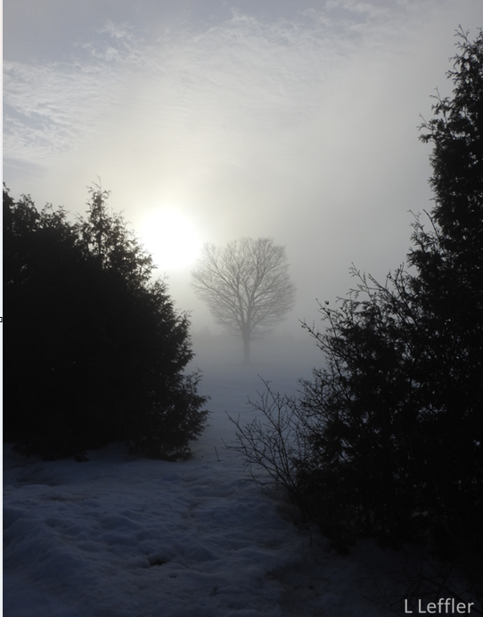
Scripture – 1 Corinthians 1:10-18 NRSVUE
¹⁰ Now I appeal to you, brothers and sisters, by the name of our Lord Jesus Christ, that all of you be in agreement and that there be no divisions among you but that you be knit together in the same mind and the same purpose. ¹¹ For it has been made clear to me by Chloe’s people that there are quarrels among you, my brothers and sisters. ¹² What I mean is that each of you says, “I belong to Paul,” or “I belong to Apollos,” or “I belong to Cephas,” or “I belong to Christ.” ¹³ Has Christ been divided? Was Paul crucified for you? Or were you baptized in the name of Paul? ¹⁴ I thank God that I baptized none of you except Crispus and Gaius, ¹⁵ so that no one can say that you were baptized in my name. ¹⁶ I did baptize also the household of Stephanas; beyond that, I do not know whether I baptized anyone else. ¹⁷ For Christ did not send me to baptize but to proclaim the gospel—and not with eloquent wisdom, so that the cross of Christ might not be emptied of its power.
¹⁸ For the message about the cross is foolishness to those who are perishing, but to us who are being saved it is the power of God.
From Rev. Heather Leffler
It seems like we are living in stormy times. Not just snowstorms on Sunday morning where we can pivot online and still worship together on Zoom. Not times of conflict in our churches, like the people of Corinth were experiencing when Paul wrote his words urging them not to quarrel and reminding them that Christ is not divided. In the world, in the United States and even in places in Canada, we see people choosing sides, separating themselves from people who they perceive as different and justifying hurting others to protect their wealth, power, and position.
Paul urged the people of Corinth not to divide into groups saying they belonged to Paul or Apollos or even Christ. In a community marked by status, competition, and inequality, Paul points them back to the cross — not as a symbol of power, but of self-giving love. He is reminding us – baptized or not, believing or not – Christ came for all people. The gospel calls us not to separate ourselves but to share what we have, like Christ to pour ourselves out for the good of all people.
We may not be able to end the war in Ukraine or in Gaza, or undo systems that reward fear and division. What we can do is build community around us – caring for our family, friends and neighbours, partnering with groups and individuals who are making a difference in our communities and beyond, protecting dignity where it is threatened, offering welcome where it is withheld, and speaking out in love to challenge our politicians to care for all people. In stormy times, faith does not ask us to secure our place, but to anchor ourselves in Christ — and to become, for one another, signs of God’s steadfast, reconciling love.
Contemplation and Conversation
What helps you stay grounded in compassion and community
when the world feels divided or stormy?
Prayer
Holy One, when fear tempts us to divide and protect what we think is ours,
draw us back to the way of Christ.
Give us courage to share, compassion to listen,
and grace to build communities rooted in love. Amen.

Further Conversation … Would you like to talk more about today’s reflection? Email Heather at hleffler@rogers.com.

Our Rockwood Stone Family
If you missed today’s worship service, you can watch it here: https://youtu.be/AsfkDyhLXcQ
Annual Reports will be arriving soon by email. If you need a printed copy, please contact the church office.

United Church of Canada
Click here to see the Moderator’s video Toward 2035. To read more and find the prayer practices she spoke of, go to Toward 2035: Envisioning the Future of the United Church .

A gift of belonging to a church is that the practice of gathering together for worship … to pray, sing, listen to scripture and share how God touches our lives – helps us grow in deeper relationship with God and each other. We are offering this practice of sharing beyond Sunday morning to deepen our connection. Each week you are offered a picture, a scripture and a question for contemplation, as well as a short reflection for you to contemplate, have conversation with people in your life and/or join an online conversation on our Rockwood Stone Facebook page.

