Contemplation and Conversation: 2nd Sunday after Epiphany, Sunday, January 18, 2026

Scripture – Psalm 40 NRSVUE
¹ I waited patiently for the Lord;
he inclined to me and heard my cry.
² He drew me up from the desolate pit,
out of the miry bog,
and set my feet upon a rock,
making my steps secure.
³ He put a new song in my mouth,
a song of praise to our God.
Many will see and fear
and put their trust in the Lord.
⁴ Happy are those who make
the Lord their trust,
who do not turn to the proud,
to those who go astray after false gods.
⁵ You have multiplied, O Lord my God,
your wondrous deeds and your thoughts toward us;
none can compare with you.
Were I to proclaim and tell of them,
they would be more than can be counted.
⁶ Sacrifice and offering you do not desire,
but you have given me an open ear.
Burnt offering and sin offering
you have not required.
⁷ Then I said, “Here I am;
in the scroll of the book it is written of me.
⁸ I delight to do your will, O my God;
your law is within my heart.”
⁹ I have told the glad news of deliverance
in the great congregation;
see, I have not restrained my lips,
as you know, O Lord.
¹⁰ I have not hidden your saving help within my heart;
I have spoken of your faithfulness and your salvation;
I have not concealed your steadfast love and your faithfulness
from the great congregation.
¹¹ Do not, O Lord, withhold
your mercy from me;
let your steadfast love and your faithfulness
keep me safe forever.
¹² For evils have encompassed me
without number;
my iniquities have overtaken me
until I cannot see;
they are more than the hairs of my head,
and my heart fails me.
¹³ Be pleased, O Lord, to deliver me;
O Lord, make haste to help me.
¹⁴ Let all those be put to shame and confusion
who seek to snatch away my life;
let those be turned back and brought to dishonor
who desire my hurt.
¹⁵ Let those be appalled because of their shame
who say to me, “Aha, Aha!”
¹⁶ But may all who seek you
rejoice and be glad in you;
may those who love your salvation
say continually, “Great is the Lord!”
¹⁷ As for me, I am poor and needy,
but the Lord takes thought for me.
You are my help and my deliverer;
do not delay, O my God.
From Brian Mack
When I was praying the scriptures in response to the first eleven verses of psalm 40, I found myself returning again and again to the word “pit”. In Biblical times, pits were often dug by hand to be used as cisterns to collect rainwater. In such a context, a pit was essential for survival in a region that was arid. Pits were sometimes dug to be used as traps for animals that would provide sustenance. Mostly in scripture, however, pits were associated with danger, despair, or even death. The story of Joseph being thrown into a pit by his brothers (Genesis 37:20) or Jeremiah being lowered into a muddy cistern and left to die (Jeremiah 38:6) come to mind.
In psalm 40, the pit represents a time of deep emotional or spiritual distress for David. The imagery he uses of being an entrapped prisoner or a traveller floundering in an inescapable quagmire of clay is a powerful one. We are not made privy to the exact nature of his distress, but we can imagine it as being a time of experiencing feelings of danger, vulnerability, betrayal, injustice, or despair. Whatever the cause of David’s despondency, he cries out to the Lord, waits patiently for a response to his prayers, and when delivered from his plight offers songs of praise to God and vows to do the will of the Creator.
In the context of the world in which we live today, we are often overwhelmed with a sense of fear about what lies ahead for us individually or collectively. In the daily news, we are bombarded with stories that bring us angst. The geo-political world that we grew up in is being turned upside down. Alliances are being cast aside, patterns of trade are being disrupted, and commitments to international law are being torn asunder. Like David, we may feel that we are floundering in a morass of unforgiving clay. As the psalmist did so long ago, we can lift up our concerns to God, wait patiently for a response secure in the knowledge that we are not alone, and give the Holy One praise for being our constant companion, our protector, and our source of guidance in all that we do. Thanks be to God.
Contemplation and Conversation
What might the “pit” and the “rock’ represent in our lives today, and how have you seen God bring stability or hope out of a time of waiting or struggle?
Prayer
Gracious God, you are the One who hears our cries.
Put a new song in our mouths even when the way forward is unclear.
Fill us with praise, trust, and hope and help us to lift ourselves and others from the pit of uncertainty. Amen.

Further Conversation … Would you like to talk more about today’s reflection? Email Heather at hleffler@rogers.com.

Our Rockwood Stone Family
If you missed today’s worship service, you can watch it here: https://youtu.be/lMbTF8veMcE

United Church of Canada …from The Right Rev. Dr. Kimberly Heath is Moderator of the United Church of Canada
Words of Hope, in the Face of Fear
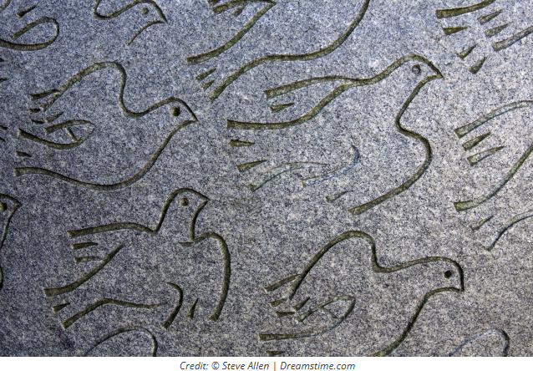
I am alarmed by the escalation of the ICE raids and violence in the US, and the killing of Renee Good. The president of the United States is intensifying his fight against his enemies: Democrats and anyone else who opposes him, even people in his own party who try to limit his power. Our temptation is to retreat to fear, to hide, or to become what he wants us to be—his adversary—and to fight. Fight, flight, freeze, or fawn.
The Christian response is to love. Read 1 Corinthians 13 and you will be reminded that love is not weak (it endures all things) and neither is it arrogant or resentful. Love stands in the place of hatred and is not moved. Love defends those suffering and welcomes them in.
As Christians, our call is to a path of peace.
We need to deepen our faith to meet the needs of this day—to learn spiritual practices, and the tools of peaceful resistance, and be ready to use them. We need to fill ourselves not with hate or fear, but with the love of Jesus, because this is the path of peace and healing to share with a divided world.
In this Epiphany season, we celebrate the coming of God’s light in Jesus: “the sunrise shall visit us from on high to give light to those who sit in darkness and, in the shadow of death, to guide our feet into the way of peace.”
Guide our feet, Lord, we pray.

A gift of belonging to a church is that the practice of gathering together for worship … to pray, sing, listen to scripture and share how God touches our lives – helps us grow in deeper relationship with God and each other. We are offering this practice of sharing beyond Sunday morning to deepen our connection. Each week you are offered a picture, a scripture and a question for contemplation, as well as a short reflection for you to contemplate, have conversation with people in your life and/or join an online conversation on our Rockwood Stone Facebook page.

