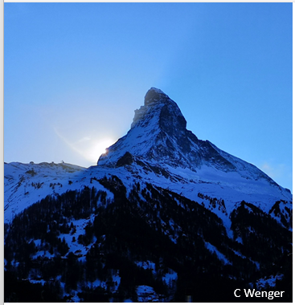
Contemplation and Conversation
4th Sunday after Epiphany, February 1, 2026
Scripture – Psalm 14 NRSVUE
¹ O Lord, who may abide in your tent?
Who may dwell on your holy hill?
² Those who walk blamelessly and do what is right
and speak the truth from their heart;
³ who do not slander with their tongue
and do no evil to their friends
nor heap shame upon their neighbors;
⁴ in whose eyes the wicked are despised
but who honor those who fear the Lord;
who stand by their oath even to their hurt;
⁵ who do not lend money at interest
and do not take a bribe against the innocent.
Those who do these things shall never be moved.
From Rev. Heather Leffler
Those who do these things shall never be moved – but what about the rest of us? The psalmist’s vision of who may dwell with God feels far beyond me. I want to walk blamelessly, speak truth from the heart, and never cause harm. And yet, even when I am trying to help, I sometimes hurt. I miss the mark.
This psalm is not a checklist for entry into God’s presence so much as a vision of who we are called to become. Too often, words like these tempt us to compare ourselves to others instead of letting them shape us more deeply.
What gives me hope is that God has always worked through imperfect people – Abraham and Sarah, Moses and David, Rahab and Tamar, Peter and Paul. God does not wait for perfection. God works through honesty, repentance, and grace.
Perhaps faithfulness is not about never falling short, but about continuing to show up, open to being shaped by love.
Contemplation and Conversation
Which part of the psalm feels hardest to live into right now –
and what might it be inviting you to practice, gently, this week?
Prayer
All-seeing God, you know when we fall short of who you call us to be.
Forgive us, and transform our shortcomings, so that we may share your love in the world. Amen.
Further Conversation … Would you like to talk more about today’s reflection? Email Heather at hleffler@rogers.com.

Our Rockwood Stone Family
If you missed today’s worship service, visit our Rockwood Stone YouTube page.

United Church of Canada
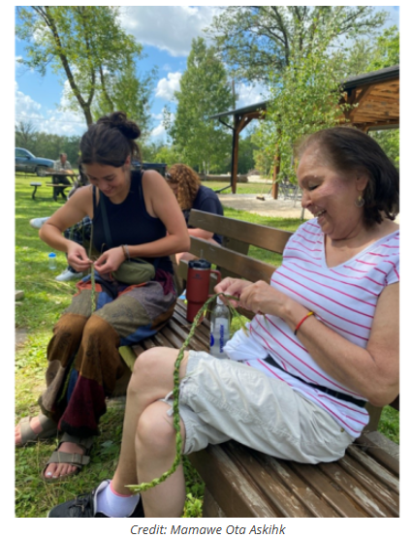
At Mamawe Ota Askihk, the land is more than a backdrop. It’s a sacred space where Indigenous children, youth, and families reconnect with culture, language, and one another.
Hosted by Sandy-Saulteaux Spiritual Centre and supported by your Mission and Service gifts, the 2023 summer gathering brought together 31 participants, supported by a team of staff, Knowledge Keepers, and youth leaders. From the first day, participants began building a community grounded in sharing, learning, and ceremony.
Workshops throughout the week included cultural teachings, hands-on skills like soapmaking and meat smoking, and powerful ceremonies, such as sweat lodges led by Knowledge Keeper Melody. Youth helped prepare medicines, served as firekeepers, and took part in every element of the lodge, deepening their understanding of tradition while finding a place of belonging.
Each evening, the group gathered around the sacred fire, where Knowledge Keeper Carla led drum songs and stories. The sound of the grandfather drum carried through the air as learning and healing wove through the circle.
The presence and engagement of the Neechi Youth Camp was central to the week’s success. These young leaders, many of whom returned in mentorship roles, participated in every activity and helped shape the program itself. Their voices, ideas, and enthusiasm brought energy and vision to the gathering. One participant reflected on how meaningful it was to feel part of something so connected: “Yes, in a way it reminds me that I am connected to people and not alone.”
The gathering was also deeply intergenerational. One participant, a Sixties Scoop survivor and niece of residential school survivors, joined with her great-niece to reconnect with culture and family. She found the experience, particularly the sweat lodge, to be profoundly healing.
There were many stories of transformation. Participants spoke of feeling safe, learning in hands-on ways that resonated deeply, and experiencing a sense of community that stayed with them long after the week ended.
Thank you for supporting the Healing Fund through Mission and Service. Your generosity makes gatherings like Mamawe Ota Askihk possible, creating space for cultural renewal, healing, and deep connection across generations.

A gift of belonging to a church is that the practice of gathering together for worship … to pray, sing, listen to scripture and share how God touches our lives – helps us grow in deeper relationship with God and each other. We are offering this practice of sharing beyond Sunday morning to deepen our connection. Each week you are offered a picture, a scripture and a question for contemplation, as well as a short reflection for you to contemplate, have conversation with people in your life and/or join an online conversation on our Rockwood Stone Facebook page.

