Contemplation and Conversation: 4th Sunday of Lent, March 15, 2026
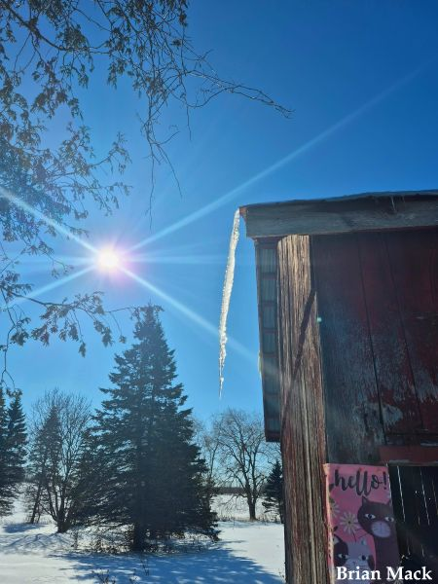
Scripture – Ephesians 5:8-14 NRSVUE
⁸ for once you were darkness, but now in the Lord you are light. Walk as children of light, ⁹ for the fruit of the light is found in all that is good and right and true. ¹⁰ Try to find out what is pleasing to the Lord. ¹¹ Take no part in the unfruitful works of darkness; rather, expose them. ¹² For it is shameful even to mention what such people do secretly, ¹³ but everything exposed by the light becomes visible, ¹⁴ for everything that becomes visible is light. Therefore it says,
“Sleeper, awake!
Rise from the dead,
and Christ will shine on you.”
From Brian Mack
I have recently been introduced to Kaizen, a Japanese philosophy, rooted in the notion of improvement through small, consistent, and daily actions rather than trying to make large sweeping changes all at once. Examples of putting this philosophy into action would be as follows:
- decluttering a room-clean out drawers one at a time rather than attempting to do the whole room in a single afternoon
- if you currently walk 5,000 steps a day, aim to add just 50 steps more each day rather than immediately aiming for 10,000
- if you are procrastinating, commit to working on a dauting task for just five minutes.
In Ephesians 5:8-14, Paul reminds us that we are not just “in the light” but rather that we are to “live as children of the light”. He encourages us to live a life filled with love by following Christ’s example. We are called to avoid evil and expose false truth, immorality, and injustice as we encounter them in our own lives or in the wider community. We are to practice humility, avoid foolish talk, and focus on gratitude. Overarching all of these directives is his admonishment to “find out what pleases the Lord.”
As we proceed on our spiritual journeys, I would like to think there is wisdom to be found in the Kaizen philosophy. As we seek to “find out what pleases the Lord”, the importance of establishing routine habits through incremental steps is key. Some of these habits such as daily scripture reading and prayer can be practiced in solitude. At other times, we will want to establish habits in community. Such habits include regular worship attendance, immersion in scripture study, or affirming our personal choices/decisions with other believers. Whatever steps we take to discern what pleases God should not be allowed to overwhelm us or be perceived as a burden. The small, daily steps we willingly take should be seen as unique chances to grow in faith and to walk “as children of the light”. May each step be seen as an opportunity to walk humbly and in gratitude with the Holy One. Thanks be to God.
Contemplation and Conversation
What practical steps do you take to discern what pleases God in your daily life?
Prayer
Holy One, we give you thanks for the letter of Paul to the Ephesians.
Strengthen our resolve to grow in faith daily.
Help us to live so that others may see your light in us. Amen.

Further Conversation … Would you like to talk more about today’s reflection? Email Heather at hleffler@rogers.com.

Our Rockwood Stone Family
If you missed today’s worship service, you can watch it here: https://youtu.be/kBgq7ha6br8
The video shared in worship today was How Finland Solved Homelessness. To learn more about Homes First, watch Housing First – a way towards ending homelessness with Juha Kaakinen, TEDxBratislava.

United Church of Canada
PIE day reminds us to embody love and celebrate gender and sexual diversity in all its forms.
Primary Media

Credit: Affirm United/S’affirmer Ensemble
Published On: February 11, 2025
Body
March 14 is PIE Day, and in church circles it has nothing to do with math. “PIE” is short for “public, intentional, and explicit”—the standards we hold ourselves to when we seek to live into being affirming, welcoming, and inclusive people and communities.
PIE Day was co-founded by Affirm United/S’affirmer Ensemble and Affirming Connections. Every year, Affirm United invites the church to celebrate the full inclusion of 2SLGBTQIA+ people in faith communities and beyond. The day also reminds and challenges us to continue widening our welcome to embody love and celebrate gender and sexual diversity in all its forms. It’s critical that we do.
Gender identity and sexual orientation continue to be used to justify serious human rights violations around the world. Same-sex sexual activity is a crime in 71 countries; in 11 of these the death penalty is at least a possibility. Statistics Canada’s recently released data on police-reported hate crimes(opens in a new tab) reveals a significant increase in hate crimes targeting individuals based on their sexual orientation. These crimes increased by 69% in 2023, up from 3% in 2020, 70% in 2021 and 16% in 2022. Based on this data, this is an increase of 225% in the past five years (2019–2023).
Your gifts through Mission and Service sustain life-transforming advocacy and education work, including supporting 2SLGBTQIA+ refugees fleeing for their lives and providing community awareness education, human rights programs, and safe spaces.
This work is vitally important. For some, it means the difference between life and death.
Thank you for giving through Mission and Service. God’s compassionate love knows no boundaries. Your generosity shows ours doesn’t either.

This week, Isla Sheridan-Jonah talks with the Moderator over cupcakes and lemonade about remaining conscious of where your food comes from.
Published On: March 15, 2026
Kitchen Conversations with the Moderator is a new video series exploring faith, food, and the power of inviting one another to the table, hosted by United Church of Canada Moderator Kimberly Heath.
Drawing inspiration and recipes from the United Church’s Lenten devotional, Bless Break Share(opens in a new tab), we’re breaking bread with guests from across the church throughout Lent, reflecting on how food can nourish both body and soul.
This week, we’re joined by Isla Sheridan-Jonah, a Youth Climate Motivator with the United Church, for a classic after-church snack of cupcakes and lemonade at Speedside United Church, a historic community of faith in rural Ontario with roots dating back to the 1840s. Isla reflects with the Moderator on how what we choose to eat connects us with the wider world, whether through its impact on climate, or on the lives of those who harvest it.
“We should be looking more into the brands that we are supporting, even though it might be more expensive and it might be harder to come by... I think it’s overall worth it if we’re helping someone. And that’s what God calls us to do—we are supposed to help people that are not just in front of us.” —Isla Sheridan-Jonah
Stay tuned for more conversations like this each Sunday throughout Lent. For our final episode next week, we’ll be joined by Alydia Smith, editor of Bless Break Share, for bulla, a delicious Jamaican treat.
You can find new episodes on our YouTube channel(opens in a new tab)—be sure to subscribe to be notified when episodes release. They’re also featured on the Kitchen Conversations webpage, where you can download recipe cards for each week’s dish and more delicious recipes from Bless Break Share.
Bless Break Share, as well as the matching mug and apron you see in this video, are available now at UCRDstore.ca(opens in a new tab).
Have a story to share? Send your reflections on food and faith, or a photo of your take on today’s dish, to kitchenconversations@united-church.ca(opens in a new tab).
The views contained within these blogs are personal and do not necessarily reflect those of The United Church of Canada.

A gift of belonging to a church is that the practice of gathering together for worship … to pray, sing, listen to scripture and share how God touches our lives – helps us grow in deeper relationship with God and each other. We are offering this practice of sharing beyond Sunday morning to deepen our connection. Each week you are offered a picture, a scripture and a question for contemplation, as well as a short reflection for you to contemplate, have conversation with people in your life and/or join an online conversation on our Rockwood Stone Facebook page.

