Contemplation and Conversation: 5th Sunday of Lent, March 22, 2026
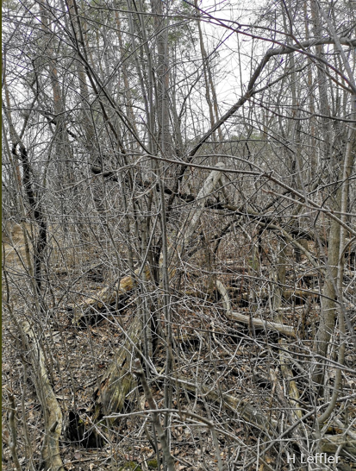
Scripture – Psalm 130 NRSVUE
¹ Out of the depths I cry to you, O Lord.
² Lord, hear my voice!
Let your ears be attentive
to the voice of my supplications!
³ If you, O Lord, should mark iniquities,
Lord, who could stand?
⁴ But there is forgiveness with you,
so that you may be revered.
⁵ I wait for the Lord; my soul waits,
and in his word I hope;
⁶ my soul waits for the Lord
more than those who watch for the morning,
more than those who watch for the morning.
⁷ O Israel, hope in the Lord!
For with the Lord there is steadfast love,
and with him is great power to redeem.
⁸ It is he who will redeem Israel
from all its iniquities.
From Rev. Heather Leffler
Last Sunday, someone asked how they might support a friend grieving the sudden death of an adult son. The mother was angry with God.
I was reminded of a woman I once visited in Clifford. Not long before, she had lost both her husband and her son. She sat with her Bible open on her lap and told me how much the Psalms meant to her.
The Psalms hold the full range of human experience – songs of praise and thanksgiving, yes, but also cries of sorrow, fear, guilt, and anger. These are the Psalms of lament.
In Psalm 130, the psalmist cries “out of the depths,” pleading to be heard and daring to hope in God’s mercy. This is not polite or carefully worded prayer – it is raw, honest, heartfelt prayer, the kind of prayer we are all invited to bring.
Even Jesus, in his anguish on the cross, reached for the words of Psalm 22: “My God, my God, why have you forsaken me?”
Scripture reminds us that God does not turn away from our grief or anger. The Holy One receives it. The Spirit holds us in it. Just as Jesus wept with Mary and Martha at Lazarus’ tomb, God meets us in the depths – and waits with us for the morning.
Contemplation and Conversation
What do you want or need to bring to God today?
Prayer
Holy Mystery, you are wholly Love.
You hear us when we cry out from the depths – our grief, our anger, our fear, and our longing.
Give us courage to be honest with you, and patience to wait for you,
trusting that even in the longest night, your light is coming.
Hold all who are hurting this day in your compassion,
and remind us that nothing we carry is too much for your love. Amen.

Further Conversation … Would you like to talk more about today’s reflection? Email Heather at hleffler@rogers.com.

Our Rockwood Stone Family
If you missed today’s worship service, you can watch it here: https://youtu.be/3hGH6WIrpXM
Tyler Dawe interviewed Heather on his podcast Tyler Dawe’s Show. You can watch it on YouTube.

Good Friday, April 3 at 10 am join our choirs and Heather as we worship at Speedside United Church, 5903 Wellington Rd 29.

United Church of Canada – Kitchen Conversations with the Moderator Episode 6: Bulla with Alydia
This story is one example of the healing, justice, and community‑building made possible through Mission and Service—please consider giving today: https://united-church.ca/donate
Kitchen Conversations with the Moderator is a series exploring faith, food, and the power of inviting one another to the table, hosted by United Church of Canada Moderator Kimberly Heath: https://united-church.ca/kitchenconve....
Drawing inspiration and recipes from the United Church’s Lenten devotional, Bless Break Share, we’re breaking bread with guests from across the church throughout Lent, reflecting on how food can nourish both body and soul.
For the series’ final episode, Rev. Dr. Alydia Smith, editor of and contributor to Bless Break Share, joins us to bake her grandmother’s recipe for bulla, a Jamaican cookie. From the kitchen of Toronto’s Beach United Church, the conversation explores the true meaning of food justice, and how to welcome those of all different cultures to the tables of our communities.
Download this recipe and find more info: https://united-church.ca/kitchenconve...

A gift of belonging to a church is that the practice of gathering together for worship … to pray, sing, listen to scripture and share how God touches our lives – helps us grow in deeper relationship with God and each other. We are offering this practice of sharing beyond Sunday morning to deepen our connection. Each week you are offered a picture, a scripture and a question for contemplation, as well as a short reflection for you to contemplate, have conversation with people in your life and/or join an online conversation on our Rockwood Stone Facebook page.

