Contemplation and Conversation: 3rd Sunday of Easter, April 19, 2026
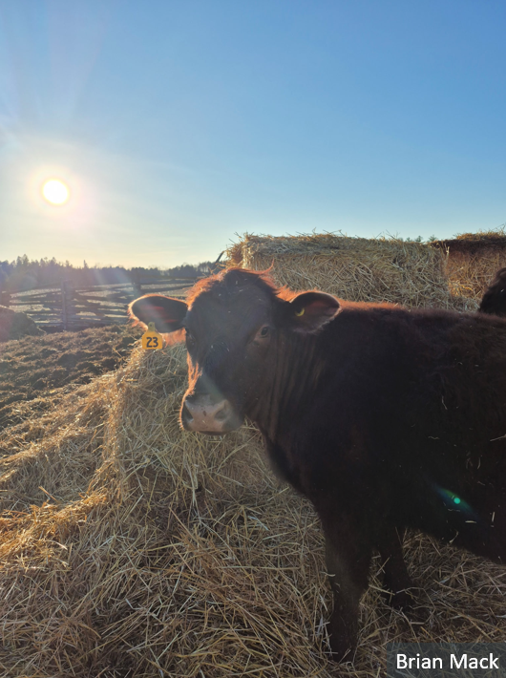
Scripture – Psalm 116 NRSVUE
¹ I love the Lord because he has heard
my voice and my supplications.
² Because he inclined his ear to me,
therefore I will call on him as long as I live.
³ The snares of death encompassed me;
the pangs of Sheol laid hold on me;
I suffered distress and anguish.
⁴ Then I called on the name of the Lord,
“O Lord, I pray, save my life!”
⁵ Gracious is the Lord and righteous;
our God is merciful.
⁶ The Lord protects the simple;
when I was brought low, he saved me.
⁷ Return, O my soul, to your rest,
for the Lord has dealt bountifully with you.
⁸ For you have delivered my soul from death,
my eyes from tears,
my feet from stumbling.
⁹ I walk before the Lord
in the land of the living.
¹⁰ I kept my faith, even when I said,
“I am greatly afflicted”;
¹¹ I said in my consternation,
“Everyone is a liar.”
¹² What shall I return to the Lord
for all his bounty to me?
¹³ I will lift up the cup of salvation
and call on the name of the Lord;
¹⁴ I will pay my vows to the Lord
in the presence of all his people.
¹⁵ Precious in the sight of the Lord
is the death of his faithful ones.
¹⁶ O Lord, I am your servant;
I am your servant, the child of your serving girl.
You have loosed my bonds.
¹⁷ I will offer to you a thanksgiving sacrifice
and call on the name of the Lord.
¹⁸ I will pay my vows to the Lord
in the presence of all his people,
¹⁹ in the courts of the house of the Lord,
in your midst, O Jerusalem.
Praise the Lord!
From Brian Mack
During the past seven days, I am amazed at the huge number of people that I have instinctively trusted as I go about my day to day life. Off the top of my head, I can think of the following:
- The meat cutter at a local butcher shop who ensured a high level of cleanliness so that the meat I bought would not expose me to lysteria
- The auto mechanic who repaired the tie rods on my car when they showed signs of wear so that I could drive confidently without fear of mishap
- The Guelph Eramosa Public Works employees who were filling in potholes on my road to ensure that my car wasn’t damaged when I went for a leisurely drive
- The dentist who wore protective gear so that I wouldn’t be exposed to harmful germs
The list could go on an on. We take the action of trusting folks who we depend upon for granted. We just assume that our common interests are being looked after or that if we have a need we can find the right person to render assistance.
As the experience of the psalmist teaches us, the act of trusting in God is somewhat more complicated. In this song of thanksgiving, the poet begins by acknowledging the source of his love for God. The psalmist has been delivered from a near death experience at some point in his past and acknowledges that God has heard his prayers, answered those prayers with compassion, and has allowed the psalmist to experience peace. The psalmist had trusted God in a time of great affliction but clearly demonstrates faith not just in times of a crisis but throughout life. In response to God’s care for him, the psalmist is determined to offer service and continuous praise.
The words of the psalmist remind us that God is not distant. We are expected to show our trust in God by engaging in continuous dialogue with the Holy One. When we come to understand that God cares deeply for us and that Yaweh is gracious, righteous, and merciful, we are encouraged to live a life of service. Such a life includes acknowledging through worship the importance of God in our lives. Offering thankful praise should not be a chore but a recognition of the central importance of Holy Mystery who is Wholly Love in our daily lives. Thanks be to God.
Contemplation and Conversation
How do you express your gratitude to God?
Prayer
Gracious God, we give you thanks for the words of the psalmist.
We acknowledge the central role that you play in our lives.
Help us through prayer, service, or acts of kindness,
to honor the One who we call Holy Mystery who is Wholly love. Amen.

Further Conversation … Would you like to talk more about today’s reflection? Email Heather at hleffler@rogers.com.

Our Rockwood Stone Family
If you missed today’s worship service, you can watch it here.

United Church of Canada
Our kin, the flora and fauna are calling,
The earth, the sea, and the sky join in,
Mother earth is hurting
they cry
We need you to act with us
they call
We need you to join us in the restoring Creation
So that our mother may flourish once more.
We need you, they plead.
Discerning God,
How do we faithfully respond to these calls?
[moment of silence]
What would you have us do?
How would you like us to act?
Guide us, we pray and lead us towards transformative actions.
Amen.
#EarthSunday #EarthWeek #UCCan
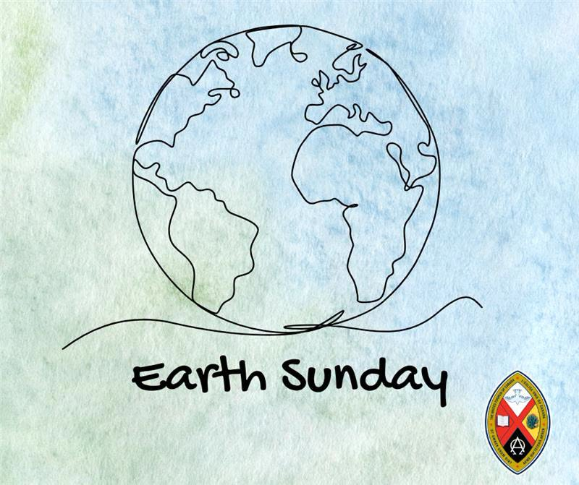

A gift of belonging to a church is that the practice of gathering together for worship … to pray, sing, listen to scripture and share how God touches our lives – helps us grow in deeper relationship with God and each other. We are offering this practice of sharing beyond Sunday morning to deepen our connection. Each week you are offered a picture, a scripture and a question for contemplation, as well as a short reflection for you to contemplate, have conversation with people in your life and/or join an online conversation on our Rockwood Stone Facebook page.

