Contemplation and Conversation: 4th Sunday of Easter, April 26, 2026
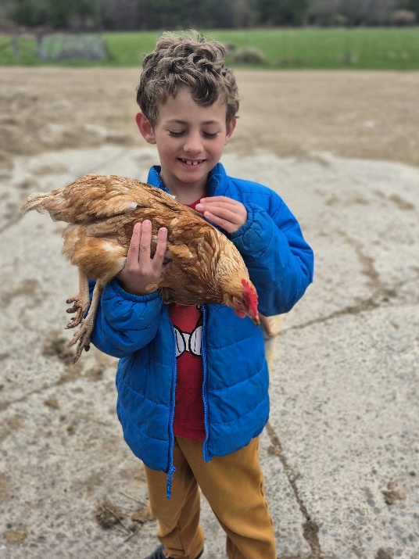
Scripture – Acts 2:42–47 NRSVUE
⁴² They devoted themselves to the apostles’ teaching and fellowship, to the breaking of bread and the prayers.
⁴³ Awe came upon everyone because many wonders and signs were being done through the apostles. ⁴⁴ All who believed were together and had all things in common; ⁴⁵ they would sell their possessions and goods and distribute the proceeds to all, as any had need. ⁴⁶ Day by day, as they spent much time together in the temple, they broke bread at home and ate their food with glad and generous hearts, ⁴⁷ praising God and having the goodwill of all the people. And day by day the Lord added to their number those who were being saved.
From Lisa Leffler
This passage paints an inspiring portrait of the early Christian church. People gathered together, shared what they had, cared for one another’s needs, learned together, prayed together, and broke bread in remembrance of Jesus. It is a beautiful image of a community shaped by generosity, trust, and love. Yet this passage is not simply a step-by-step instruction manual requiring every believer to sell all they own. Rather, it invites us to see the spirit of that community: people placing relationships above possessions, and the wellbeing of the whole above individual gain.
The early followers of Jesus had every reason to live in fear and uncertainty, yet they chose to gather, support one another, and keep faith alive. Because of that courage, their community grew. The challenge for the church today is not to recreate their exact actions, but to embrace their same willingness to risk being present, open, and faithful. We are called to keep showing up for one another, to welcome change, and to nurture communities where people are known, valued, and cared for.
Most importantly, we are called to share the hope we have found in faith. In a world where Christianity is too often associated with judgment or exclusion, we are invited to show another way: a faith rooted in grace, compassion, and love. When we live our faith openly and authentically, we make space for others to encounter God’s presence. The church grows not through fear or obligation, but through communities whose love gives people courage to seek and to belong.
Contemplation and Conversation
Where are you being called to share your faith?
Prayer
Loving God, awaken our hearts to the places and people
where Your Spirit is calling us to share Your love.
Give us courage to speak with grace, to listen with compassion, and to live our faith with joy.
Lead us into the world as signs of hope, trusting that You go before us always. Amen.

Further Conversation … Would you like to talk more about today’s reflection? Email Heather at hleffler@rogers.com.

Our Rockwood Stone Family
If you missed today’s worship service, you can watch it here: https://youtu.be/ou_UCWSkdtk
Rockwood Financial Update…
On behalf of the Property and Finance Committee and the Treasurer, we wanted to share a brief update on our current financial situation. In order to meet ongoing expenses, we have needed to temporarily borrow from both the Maple Wingrove Fund and the Building Fund. While we are hopeful that the Trustees will be able to complete the sale of the house soon, we do anticipate additional expenses in the meantime and may face some financial shortfall.
In light of this, we kindly ask you to consider providing any additional support you may be able to offer during this time. Your contributions would greatly help ease these temporary short-term pressures. We also want to express our sincere appreciation for your continued generosity and support. As a committee, we felt it was important to keep everyone informed of our situation. Thank you for your consideration, understanding and ongoing support.

United Church of Canada
The reality faced by LGBTQIA+ Christians in South Korean society and churches remains harsh. With most denominations defining homosexuality as a sin and amplifying voices of hate, many individuals suffer while hiding their identities, and many eventually leave their beloved faith communities.
Breaking down these high walls of discrimination and ensuring that everyone can find wholeness within God's love is essential. To do this, Q&A (Queer Question for Korean Churches), a grassroots Christian non-profit organization based in Seoul, is facilitating core projects to support LGBTQIA+ individuals through counselling, training courses for allies, and educational programs.
The United Church of Canada is supporting Q&A through a new partnership, accompanying the organization’s efforts to build an inclusive, transformative faith movement, while advocating against discriminatory denominational policies against sexual and gender minorities, and developing educational resources for affirming ministries.
Read more about this crucial ministry: https://united-church.ca/.../qa-light-darkness-queer...
[Photos courtesy of Q&A]
#UCCan #LBGTQIA+ #Korea
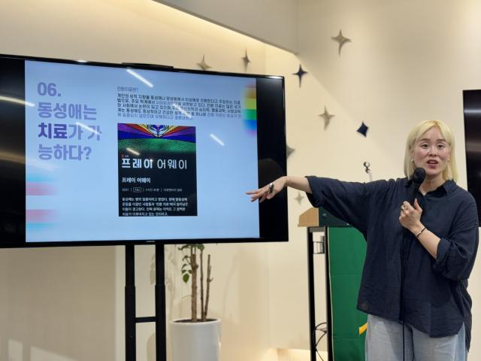

A gift of belonging to a church is that the practice of gathering together for worship … to pray, sing, listen to scripture and share how God touches our lives – helps us grow in deeper relationship with God and each other. We are offering this practice of sharing beyond Sunday morning to deepen our connection. Each week you are offered a picture, a scripture and a question for contemplation, as well as a short reflection for you to contemplate, have conversation with people in your life and/or join an online conversation on our Rockwood Stone Facebook page.

