Contemplation and Conversation
5th Sunday of Easter, May 3, 2026
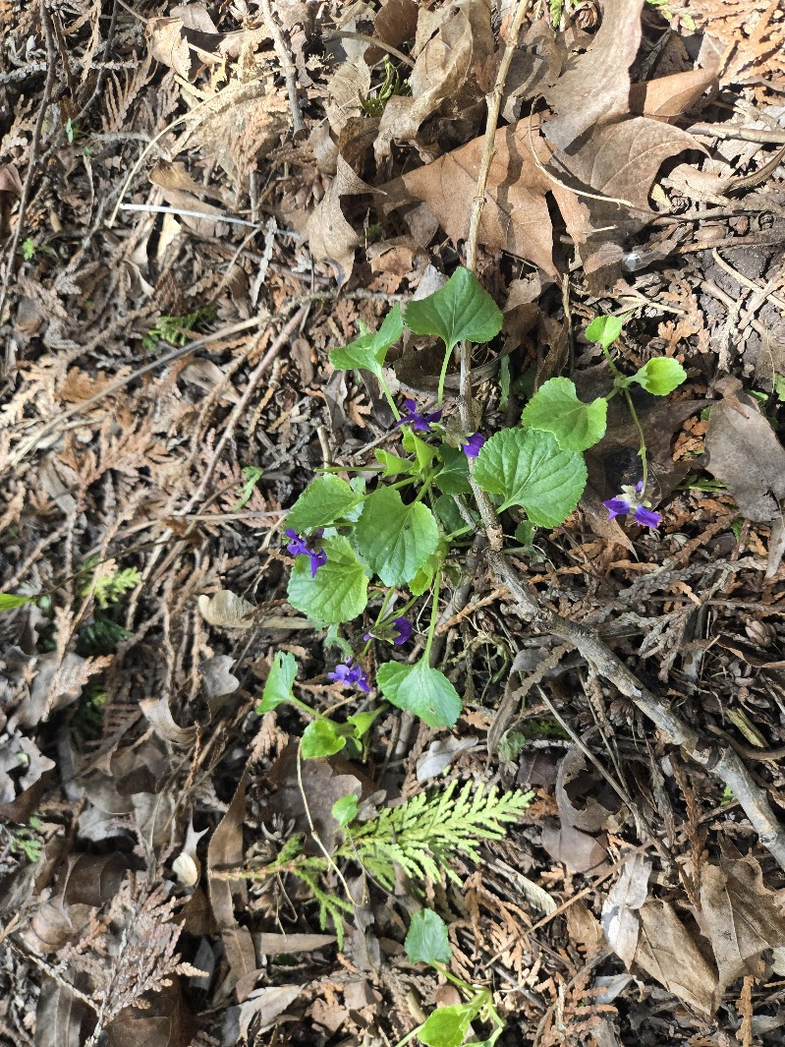
Scripture – John 14:1-14 NRSVUE
“Do not let your hearts be troubled. Believe in God; believe also in me. ² In my Father’s house there are many dwelling places. If it were not so, would I have told you that I go to prepare a place for you? ³ And if I go and prepare a place for you, I will come again and will take you to myself, so that where I am, there you may be also. ⁴ And you know the way to the place where I am going.” ⁵ Thomas said to him, “Lord, we do not know where you are going. How can we know the way?” ⁶ Jesus said to him, “I am the way and the truth and the life. No one comes to the Father except through me. ⁷ If you know me, you will know my Father also. From now on you do know him and have seen him.”
⁸ Philip said to him, “Lord, show us the Father, and we will be satisfied.” ⁹ Jesus said to him, “Have I been with you all this time, Philip, and you still do not know me? Whoever has seen me has seen the Father. How can you say, ‘Show us the Father’? ¹⁰ Do you not believe that I am in the Father and the Father is in me? The words that I say to you I do not speak on my own, but the Father who dwells in me does his works. ¹¹ Believe me that I am in the Father and the Father is in me, but if you do not, then believe because of the works themselves. ¹² Very truly, I tell you, the one who believes in me will also do the works that I do and, in fact, will do greater works than these, because I am going to the Father. ¹³ I will do whatever you ask in my name, so that the Father may be glorified in the Son. ¹⁴ If in my name you ask me for anything, I will do it.
From Rev. Heather Leffler
There was a joke about arriving in heaven. St. Peter is leading a group past different rooms, pointing things out. As they approach one door, he stops and whispers, “Be very quiet as we pass this one.” Someone asks why. Peter replies, “That’s where the (insert another church name) are—they think they’re the only ones here.”
It’s funny—but it also holds a truth. At one time or another, many of us have fallen into that trap of thinking we have the right way, the right understanding of God, or that we are somehow more faithful than others.
We see something different in Peter’s own story. He knew what it was to get it wrong. He stepped out on the water in faith and then sank in fear. He tried to correct Jesus and was sharply rebuked. He denied even knowing Jesus when it mattered most. And yet, Jesus entrusted him with the keys of the kingdom. I don’t believe those keys were given to keep people out—but to open the door wide.
In John’s Gospel, we hear Jesus offering comfort to his disciples as he prepares to leave them. “Do not let your hearts be troubled.” He speaks of preparing a place—not for a few, but for many. For all.
And when Thomas says, “We don’t know the way,” Jesus responds, “I am the way, the truth, and the life.” Too often, those words have been used to draw lines and set limits. But Jesus is not pointing to a narrow gate we must figure out how to pass through. He is pointing to a relationship—to a way of living in love.
The way is t, his: to love God, and to love one another. To see in each person a beloved child of God. To choose compassion over judgment. To trust that we are never alone—whatever lies ahead.
In life, in death, and in life beyond death, God is with us. And there is room—more than enough room—for all. May it be so.
Contemplation and Conversation
Have your images or understanding of heaven changed over time?
Where do these words of Jesus offer you comfort and hope?
Prayer
Jesus, you are the way, the truth, and the life.
When our hearts are troubled, remind us that we are never alone.
Guide us in your way of love and teach us to welcome others as you welcome us.
In your name we pray. Amen.

Further Conversation … Would you like to talk more about today’s reflection? Email Heather at hleffler@rogers.com.

Our Rockwood Stone Family
If you missed today’s worship service, visit our Rockwood Stone YouTube page.

United Church of Canada – From Moderator Kimberley Heath
National Volunteer Week is April 19-25, 2026 and we share with you a message of appreciation from the Moderator to volunteers in all parts of the church:
Thank you. You are the volunteers that helps make what the United Church's Song of Faith describes as a "church with a purpose," where faith is nurtured, and hearts are comforted, and where gifts are shared for the good of all.
Thank you for giving your gifts. Thank you for giving your time, thank you for giving your expertise and your energy in countless different ways.
I see you in your church kitchen, making sandwiches for funerals. I see you setting up chairs and tables. I see you engaging in governance, at all levels of the church, in committees and sub-committees.
I see you serving in your community. In so many ways you make a difference.
I am touched by your dedication, when it's not the easiest thing to do.
I am also so grateful for how you serve with joy and with care.
On behalf of the entire United Church of Canada, thank you. Thank you for giving your gifts. You make a difference to the church, and far beyond the church.
I give thanks to God for you and I pray that God will bless you and all that you do. And I pray God will bless this church. Amen.
#UCCan #VolunteerWeek #Volunteers
A gift of belonging to a church is that the practice of gathering together for worship … to pray, sing, listen to scripture and share how God touches our lives – helps us grow in deeper relationship with God and each other. We are offering this practice of sharing beyond Sunday morning to deepen our connection. Each week you are offered a picture, a scripture and a question for contemplation, as well as a short reflection for you to contemplate, have conversation with people in your life and/or join an online conversation on our Rockwood Stone Facebook page.

