Contemplation and Conversation
2nd Sunday after Pentecost, June 7, 2026
Scripture – Matthew 9:9-13, 18-26 NRSVUE 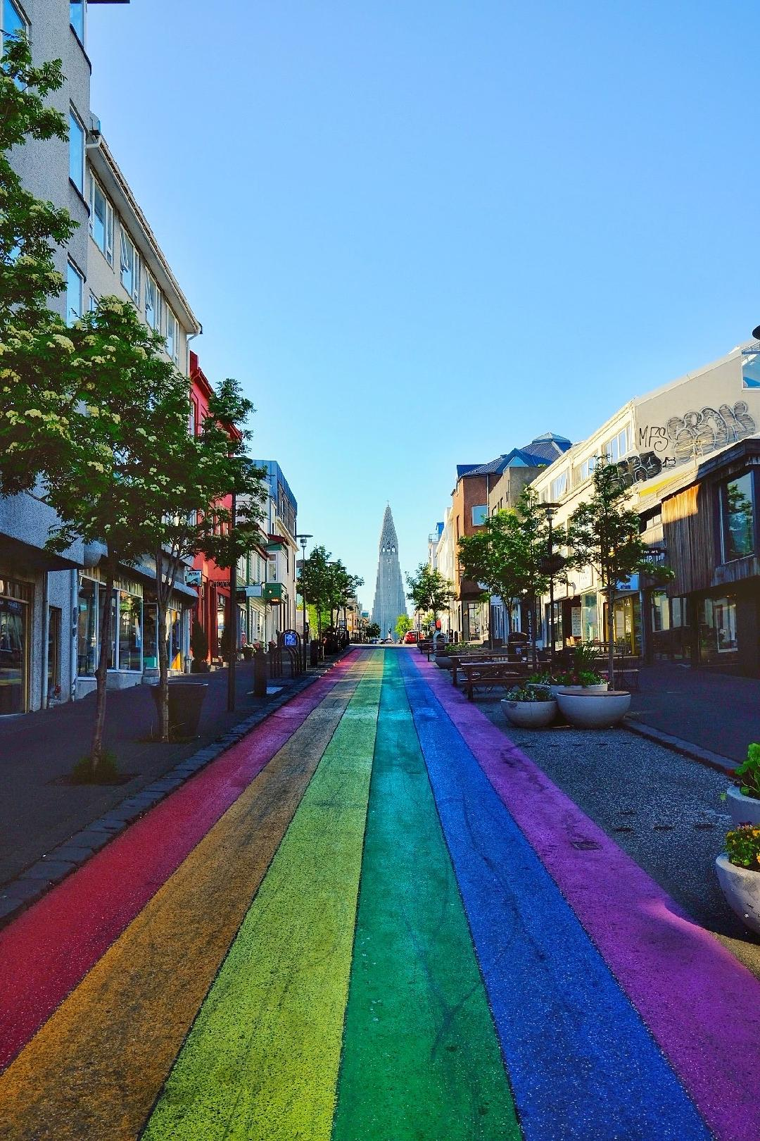

⁹ As Jesus was walking along, he saw a man called Matthew sitting at the tax-collection station, and he said to him, “Follow me.” And he got up and followed him.
¹⁰ And as he sat at dinner in the house, many tax collectors and sinners came and were sitting with Jesus and his disciples. ¹¹ When the Pharisees saw this, they said to his disciples, “Why does your teacher eat with tax collectors and sinners?” ¹² But when he heard this, he said, “Those who are well have no need of a physician, but those who are sick. ¹³ Go and learn what this means, ‘I desire mercy, not sacrifice.’ For I have not come to call the righteous but sinners.”
¹⁸ While he was saying these things to them, suddenly a leader came in and knelt before him, saying, “My daughter has just died, but come and lay your hand on her, and she will live.” ¹⁹ And Jesus got up and followed him, with his disciples. ²⁰ Then suddenly a woman who had been suffering from a flow of blood for twelve years came up behind him and touched the fringe of his cloak, ²¹ for she was saying to herself, “If I only touch his cloak, I will be made well.” ²² Jesus turned, and seeing her he said, “Take heart, daughter; your faith has made you well.” And the woman was made well from that moment. ²³ When Jesus came to the leader’s house and saw the flute players and the crowd making a commotion, ²⁴ he said, “Go away, for the girl is not dead but sleeping.” And they laughed at him. ²⁵ But when the crowd had been put outside, he went in and took her by the hand, and the girl got up. ²⁶ And the report of this spread through all of that district.
From Rev. Heather Leffler
I remember the first time the connection between the woman and the girl truly struck me. I was preparing to preach at a World Day of Prayer service and was reading this story from Luke's gospel when I noticed something I had never seen before.
For twelve years the woman had lived with a flow of blood. Countless doctors and healers had been unable to help her. According to the purity laws of her day, her condition would have separated her from much of community life and worship. For twelve years she lived on the margins, longing not only for healing but also for belonging.
For those same twelve years, a little girl was growing up surrounded by the love of her family and community. She was cherished, nurtured, and filled with hopes for the future. Then illness struck, and she died before her father could reach Jesus.
As Jesus made his way to the girl's home, the woman reached out and touched the fringe of his cloak. In that moment she was healed. Yet Jesus did more than heal her body. He stopped, saw her, called her "daughter," and restored her dignity and place within the community.
When Jesus arrived at the leader's house, he reached out once again. Taking the girl by the hand, he raised her up and restored her to her family and community.
In the verses that come just before these stories, Jesus shares a meal with tax collectors and sinners. The Pharisees question his actions because they believe they are protecting the faithfulness of their community. Jesus responds by pointing them toward God's deeper desire: "I desire mercy, not sacrifice."
Again and again, Jesus widens the circle – welcoming Matthew the tax collector, restoring the woman, raising the girl, and inviting those who had been pushed to the margins back into community. His circle of love is always wider than people expect.
On this Pride Sunday, we remember that Christ continues to call the church to be a place where all people know they are loved, valued, and belong.
Each time we extend a hand of welcome, friendship, compassion, support, or peace to someone who has been excluded from a community, we are faithfully following Jesus. The community the Holy One invites us into is an ever-widening circle of love for all God's children. May it be so.
Contemplation and Conversation
Where do you see Jesus inviting us to widen the circle of belonging in our community today?
Prayer
Loving Jesus, you reached out to those who were excluded, overlooked, and pushed to the margins.
You healed bodies, restored relationships, and welcomed people back into community.
On this Pride Sunday, remind us that your love reaches beyond every barrier we create.
Open our hearts and our hands so that all people may know
they are cherished, valued, and welcomed as beloved children of God.
May your ever-widening circle of love continue to grow through us. Amen.
Further Conversation … Would you like to talk more about today’s reflection? Email Heather at hleffler@rogers.com.

Our Rockwood Stone Family
If you missed today’s worship service, visit our Rockwood Stone YouTube page.

United Church of Canada Published On: June 1, 2026
Pride is more than just a celebration. It is remembrance. It is resistance.
In 2025, The United Church of Canada offered an apology to 2S and LGBTQIA+ people and communities—naming the real harm caused through words, actions, silence, and systems that failed to protect and affirm God’s beloved people.
This Pride Month, Moderator Kimberly Heath, along with the church, reflects on that apology—not as an ending, but as a beginning. A threshold into deeper healing, accountability, and transformation.
Pride is more than celebration. It is remembrance. It is resistance. It is a witness to the sacred truth that every identity rooted in love and authenticity is a divine gift. Radical belonging is not optional—it is at the heart of the Gospel. May we continue the work of becoming a church that learns, acts with courage, and lives out love in word and deed.
From the whole United Church of Canada, Happy Pride!

A gift of belonging to a church is that the practice of gathering together for worship … to pray, sing, listen to scripture and share how God touches our lives – helps us grow in deeper relationship with God and each other. We are offering this practice of sharing beyond Sunday morning to deepen our connection. Each week you are offered a picture, a scripture and a question for contemplation, as well as a short reflection for you to contemplate, have conversation with people in your life and/or join an online conversation on our Rockwood Stone Facebook page.

