Contemplation and Conversation: 3rd Sunday after Pentecost, June 14, 2026
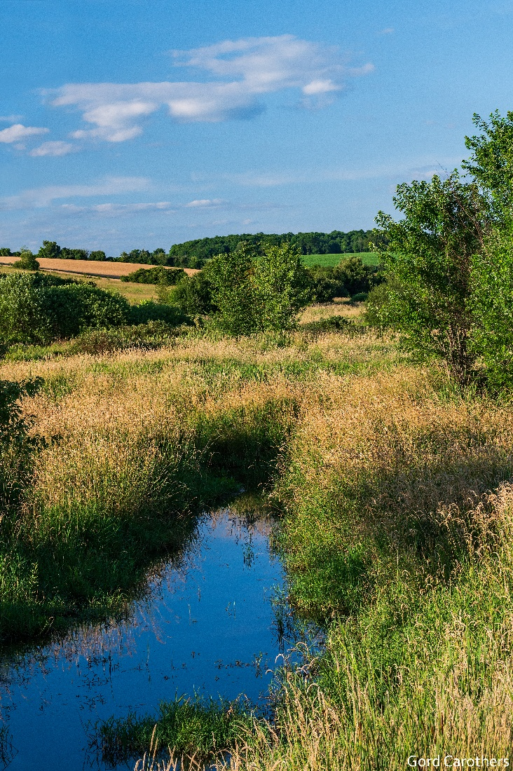
Scripture – Matthew 9:35-10:8 NRSVUE v
Then Jesus went about all the cities and villages, teaching in their synagogues and proclaiming the good news of the kingdom and curing every disease and every sickness. ³⁶ When he saw the crowds, he had compassion for them because they were harassed and helpless, like sheep without a shepherd. ³⁷ Then he said to his disciples, “The harvest is plentiful, but the laborers are few; ³⁸ therefore ask the Lord of the harvest to send out laborers into his harvest.”
¹ Then Jesus summoned his twelve disciples and gave them authority over unclean spirits, to cast them out, and to cure every disease and every sickness. ² These are the names of the twelve apostles: first, Simon, also known as Peter, and his brother Andrew; James son of Zebedee and his brother John; ³ Philip and Bartholomew; Thomas and Matthew the tax collector; James son of Alphaeus and Thaddaeus; ⁴ Simon the Cananaean and Judas Iscariot, the one who betrayed him.
⁵ These twelve Jesus sent out with the following instructions: “Do not take a road leading to gentiles, and do not enter a Samaritan town, ⁶ but go rather to the lost sheep of the house of Israel. ⁷ As you go, proclaim the good news, ‘The kingdom of heaven has come near.’ ⁸ Cure the sick; raise the dead; cleanse those with a skin disease; cast out demons. You received without payment; give without payment.
From Rev. Heather Leffler
Jesus will send the disciples out again after his resurrection to all the world, but during his ministry he sends them to the children of Israel – to the people they know. Go, cure the sick, raise the dead, cleanse those with a skin disease, cast out demons, and as you go proclaim the good news.
When we are invited into bold discipleship, most of us don’t for a moment imagine that we will cure the sick or cast out demons. What if Jesus is asking us to go into our communities mindful of the people around us, and that we can begin with prayer.
At the WOW Regional Council meeting, we were told to walk around our neighbourhoods to get to know them and open ourselves to sharing what belonging to God and the church means to us. I wondered the same thing as I did when people from our churches took part in Into the Promise with Waterloo Presbytery. Why do we always talk about walking around our neighbourhoods?
In Jesus’ day, it is true the disciples would walk, but our neighbourhoods are more spread out. Add to that for some of us walking is more challenging. Yet in the grocery store we can take time to greet people by name, hold them in our hearts in prayer and let the Spirit nudge us into sharing the Good News of Rockwood and Stone United Churches.
As we drive down a country road, we can name our neighbours to God in prayer, stop and chat at a mailbox, or share an invitation to have lemonade on the lawn of the church. At Rockwood, we met a man who claimed the bench in the minister’s parking spot, saying he stops there every time he walks. What if sometimes we hung out outside the church and simply said hello to the folk at the mailbox. Perhaps the people we hope to welcome are already stopping by.
It is easy to hear Jesus’s words and think – I can’t do that. More and more I believe we are able to make connections simply by being present with prayerful intention so the Spirit can use us to share the good news that means so much to us.
We serve the Holy One who is steadfast and faithful, who takes us as we are and loves us into communities that make a difference in the world. May it be so.
Contemplation and Conversation
Who might you pray for this week?
Who might you invite into a conversation about our church community?
Prayer
Jesus, help us hear your call to go and be disciples.
Show us how to be more public, intentional, and explicit in inviting others into communities
where all people are welcomed, where unique gifts are valued and shared,
and where your love is made known.
Guide our words, our actions, and our prayers, that we may share your good news with joy and compassion. Amen.
Our Affirming Vision Statement
As Rockwood and Stone United Churches, we are communities of faith that are grounded in God,
inspired by Jesus, and guided by the Holy Spirit.
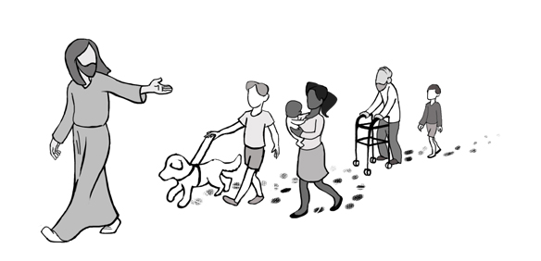
We strive to be a safe and inclusive place for all people especially those oppressed, excluded and marginalized by age, ability, dietary needs, mental health, economic status, language, racial and cultural backgrounds, marital status and family configurations, gender expression, and sexual orientation.
We are committed to creating a space where the unique gifts and skills of each person are valued, lifted up, and shared in service of God, our communities, and the world.
Recognizing our imperfections as a people of faith, we continue to seek God's forgiveness and
commit to learning and growing together.

Further Conversation … Would you like to talk more about today’s reflection? Email Heather at hleffler@rogers.com.

Our Rockwood Stone Family
If you missed today’s worship service, you can watch it here: https://youtu.be/c6KYO1eilAM
Thank you to Rev. Heather Leffler for sharing her pictures and stories from her 1997 Israel trip at Faith, Food, Friendship and Fun on Friday. https://youtu.be/4yP_Oy2mCCE

United Church of Canada
Watch the Moderator’s Pride message go to https://youtu.be/tH6JkGe3ME0 .
To read the full text of the 2025 Apology to 2S and LGBTQIA+ People and Communities, go to The General Council website.

A gift of belonging to a church is that the practice of gathering together for worship … to pray, sing, listen to scripture and share how God touches our lives – helps us grow in deeper relationship with God and each other. We are offering this practice of sharing beyond Sunday morning to deepen our connection. Each week you are offered a picture, a scripture and a question for contemplation, as well as a short reflection for you to contemplate, have conversation with people in your life and/or join an online conversation on our Rockwood Stone Facebook page.

