Contemplation and Conversation: 4th Sunday after Pentecost, June 21, 2026
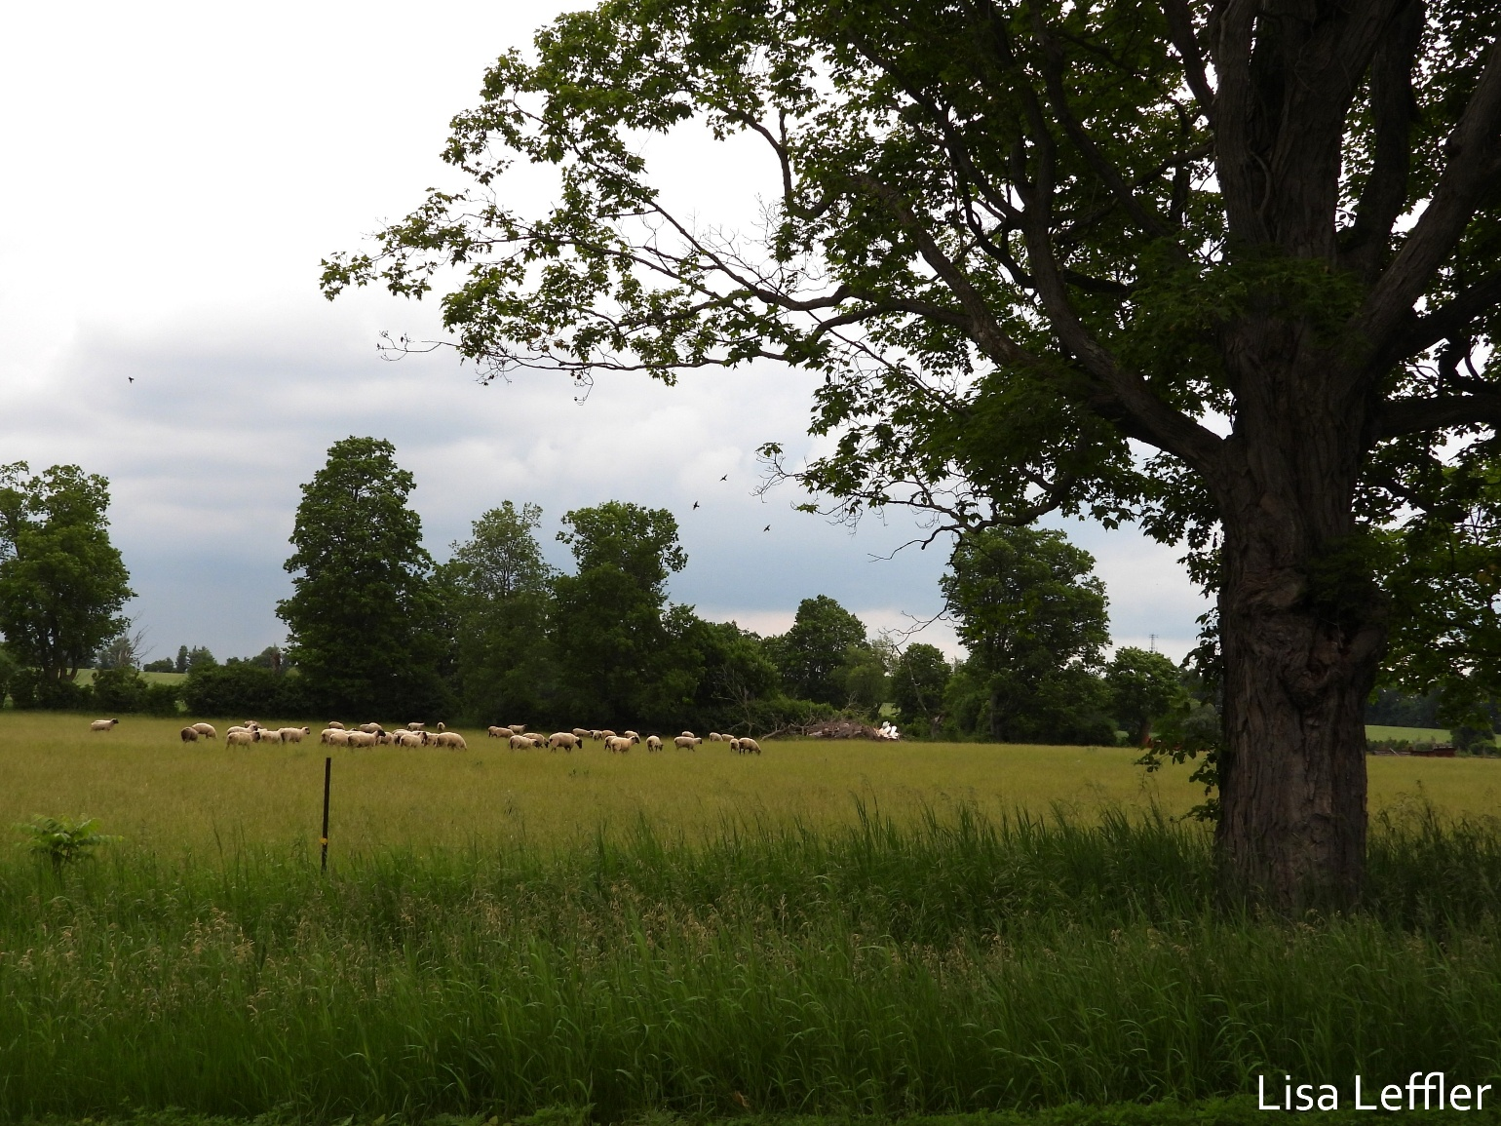
Scripture – Psalm 86:1-10, 16-17 NRSVUE
¹ Incline your ear, O Lord, and answer me,
for I am poor and needy.
² Preserve my life, for I am devoted to you;
save your servant who trusts in you.
You are my God; ³ be gracious to me, O Lord,
for to you do I cry all day long.
⁴ Gladden the soul of your servant,
for to you, O Lord, I lift up my soul.
⁵ For you, O Lord, are good and forgiving,
abounding in steadfast love to all who call on you.
⁶ Give ear, O Lord, to my prayer;
listen to my cry of supplication.
⁷ In the day of my trouble I call on you,
for you will answer me.
⁸ There is none like you among the gods, O Lord,
nor are there any works like yours.
⁹ All the nations you have made shall come
and bow down before you, O Lord,
and shall glorify your name.
¹⁰ For you are great and do wondrous things;
you alone are God.
¹⁶ Turn to me and be gracious to me;
give your strength to your servant;
save the child of your maidservant.
¹⁷ Show me a sign of your favor,
so that those who hate me may see it and be put to shame,
because you, Lord, have helped me and comforted me.
From Rev. Heather Leffler
How do you know God – as a distant being, ever watching, judging your every move? David, who did much that could be judged, knew God in a different way – an amazing Creator who did works like no other, a gracious, present God offering love and forgiveness.
David was loved and hated by King Saul, loved by his brother-in-law and hated by his wife, committed adultery and had Bathsheba’s husband murdered, experienced the death of a child, fought wars against his son, King Saul and other nations. He was a shepherd, a war hero, a musician and poet. He lived in caves and palaces, danced with abandon in the streets and brought all the people of Israel into one kingdom. He knew times when he honoured God and times when he let God down. Yet he always turned to God in prayer.
David invites us to know God as one who is ever listening to our prayers. Like him, we are invited to lift up our thanks and praise, our confessions and our prayers for ourselves and others. Prayers might be words – our own, the Psalmist’s, or someone else’s. They might be our thoughts. Often our songs are prayers that lift our hearts. There are times when we have no words, and the Spirit intercedes and prays for us. Through prayer, we come to know the Holy One in new and deeper ways. Prayer connects us to others even when we are far from them.
The Psalms and hymns we sing help us to know God and to offer our thanks and praise to the One who loved us into being and sent his son Jesus to draw people from the margins and build relationships that sustain all people and the earth.
Whatever we carry today – joy, gratitude, grief, fear, or hope – we can bring it to God, trusting that we are heard and loved.
Contemplation and Conversation
When have you experienced God’s healing, comfort, or presence through prayer?
Prayer
God, you are gracious and steadfast; thank you for the gift of knowing you.
Thank you for the Psalms that teach us to pray and for your Spirit that prays through us.
May your forgiveness and love sustain us and help us build relationships
that sustain all people and the earth. Amen.

Further Conversation … Would you like to talk more about today’s reflection? Email Heather at hleffler@rogers.com.

Our Rockwood Stone Family
If you missed today’s worship service, you can watch it here: https://youtu.be/hefEP3-_Jds

United Church of Canada – A Prayer for National Indigenous People’s Day
God, Creator and Great Mystery, we praise you for the Sacred Fires that burn today and for the prayer-filled smoke that you receive and bless. We offer our deep gratitude that the Fire’s light informs and guides our journey. We pray, just as the Elders prayed, for renewal and for the restoration of beauty to the land and its people.
We acknowledge the diverse and abundant gifts of Canada’s Indigenous Peoples. We recognize that their knowledge and wisdom have benefited generations past and present, and that this blessing will continue for generations to come. We remember the many who are committed to the healing of family, community, and nations.
We pray for Mother Earth, the waters, the winds, for our siblings the animals, birds, and fish, and all of life that surrounds us. We pray that we will walk the good Red Road of life, and that we will walk with courage, honesty, humility, love, respect, truth and wisdom.
We offer this prayer in humility and hope, and in the name, of our brother Jesus, the one who lights our path to wholeness, justice and peace. Amen.
—A prayer for Indigenous Day of Prayer by the Rev. Maggie Dieter, former Executive Minister, Aboriginal Ministries and Indigenous Justice; and Bill Snow, Stoney Nakoda First Nation, Alberta, member of the Indigenous Justice and Residential School Committee

A gift of belonging to a church is that the practice of gathering together for worship … to pray, sing, listen to scripture and share how God touches our lives – helps us grow in deeper relationship with God and each other. We are offering this practice of sharing beyond Sunday morning to deepen our connection. Each week you are offered a picture, a scripture and a question for contemplation, as well as a short reflection for you to contemplate, have conversation with people in your life and/or join an online conversation on our Rockwood Stone Facebook page.

