Contemplation and Conversation: 7th Sunday after Pentecost, July 19, 2026 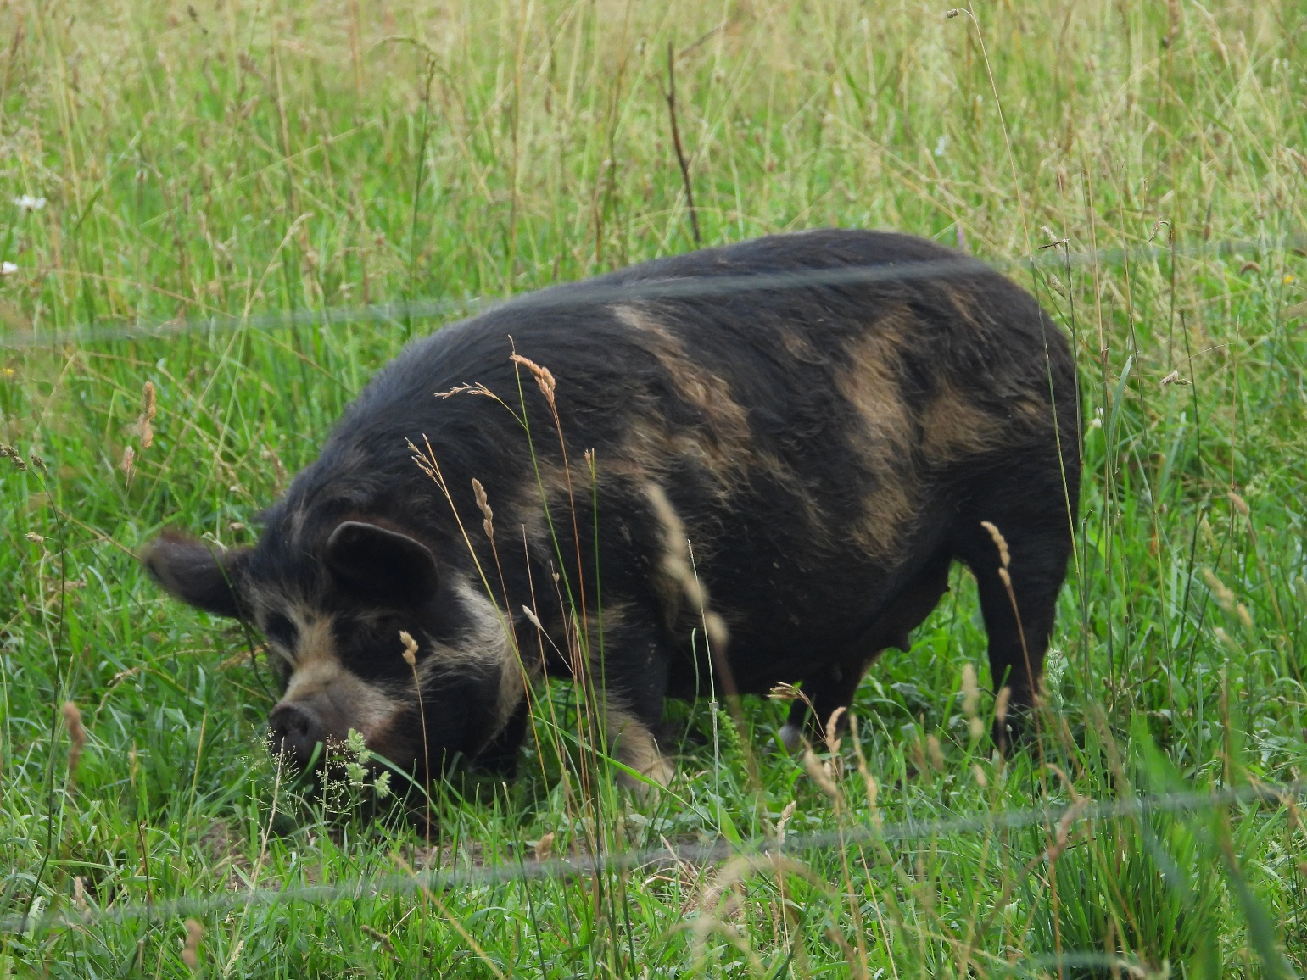

Scripture – Psalm 139:1-18 NRSVUE
¹ O Lord, you have searched me and known me.
² You know when I sit down and when I rise up;
you discern my thoughts from far away.
³ You search out my path and my lying down
and are acquainted with all my ways.
⁴ Even before a word is on my tongue,
O Lord, you know it completely.
⁵ You hem me in, behind and before,
and lay your hand upon me.
⁶ Such knowledge is too wonderful for me;
it is so high that I cannot attain it.
⁷ Where can I go from your spirit?
Or where can I flee from your presence?
⁸ If I ascend to heaven, you are there;
if I make my bed in Sheol, you are there.
⁹ If I take the wings of the morning
and settle at the farthest limits of the sea,
¹⁰ even there your hand shall lead me,
and your right hand shall hold me fast.
¹¹ If I say, “Surely the darkness shall cover me,
and night wraps itself around me,”^{[a]}
¹² even the darkness is not dark to you;
the night is as bright as the day,
for darkness is as light to you.
¹³ For it was you who formed my inward parts;
you knit me together in my mother’s womb.
¹⁴ I praise you, for I am fearfully and wonderfully made.
Wonderful are your works;
that I know very well.
¹⁵ My frame was not hidden from you,
when I was being made in secret,
intricately woven in the depths of the earth.
¹⁶ Your eyes beheld my unformed substance.
In your book were written
all the days that were formed for me,
when none of them as yet existed.^{[b]}
¹⁷ How weighty to me are your thoughts, O God!
How vast is the sum of them!
¹⁸ I try to count them—they are more than the sand;
I come to the end—I am still with you.
From Lisa Leffler
Psalm 139 is attributed to David, one of the most celebrated figures in Scripture. We remember him as the shepherd who defeated Goliath, the musician who soothed King Saul, the king who united Israel, and the poet whose prayers continue to shape our faith. Yet David was also capable of great failure. He abused his power, caused deep harm, and had to be confronted by the prophet Nathan before seeking God's forgiveness. David's story reminds us that being "fearfully and wonderfully made" does not mean being perfect. God knew David completely—his courage and his failures, his strengths and his weaknesses—and loved him through it all.
That is an important truth to hold onto in a culture that often measures our worth by our productivity, our achievements, or how closely we match society's expectations. We are constantly surrounded by messages telling us who we should be, what we should look like, and how we should contribute. When we cannot meet those expectations, it is easy to wonder if something is wrong with us. Psalm 139 offers a different story. Before anyone else formed an opinion of us, God was already knitting us together with love and delighting in the unique people we were created to be.
During Disability Pride Month, this psalm invites us to celebrate the beautiful diversity of God's creation. Every person bears the image of God, bringing unique gifts while also living with challenges, limitations, and struggles. As followers of Christ, we are called to build communities where people do not have to hide who they are in order to belong. Instead, may our churches become places where every person is welcomed, valued, and reminded that they are fully known, deeply loved, and truly fearfully and wonderfully made.
Contemplation and Conversation
When have you experienced being fully known and fully loved?
Prayer
Holy One,
Thank you for the many ways your image is reflected in each of us.
Teach us to honour every person as fearfully and wonderfully made,
and help us become a community where everyone belongs. Amen.

Further Conversation … We would love to hear from you! Please consider sharing your thoughts on the Contemplation and Conversation question on our Rockwood Stone Facebook Page.

Our Rockwood Stone Family
If you missed today’s worship service, you can watch it here: https://www.youtube.com/watch?v=TnnXpLh5lZ0

United Church of Canada
National Indigenous Spiritual Gathering to Meet on Traditional Algonquin Land
The five-day gathering next week will be a sacred time of worship, ceremony, community building, and responding to God's call
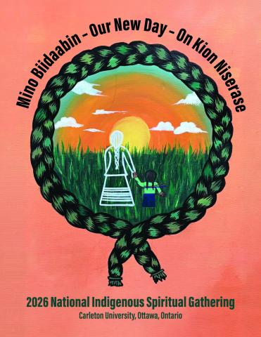
Credit: Art by Trinity Anderson
Published On: July 9, 2026
From July 15–19, 2026, members of Indigenous communities of faith will gather on traditional Algonquin territory at Carleton University in Ottawa, Ontario, for the National Indigenous Spiritual Gathering (NISG), the triennial gathering of the Indigenous Church in The United Church of Canada.
Under the leadership of the National Indigenous Elders Council (NIEC), participants will come together for sacred ceremony, worship, teachings, learning, fellowship, and community building. The gathering provides an important opportunity for Indigenous members to strengthen relationships and discern the future of the Indigenous Church.
A significant milestone for this year's gathering will be the establishment of a National Indigenous Council (NIC), which will provide leadership to the Indigenous Church as it continues its journey of self-determination. Participants will also take time to honour, acknowledge, and celebrate the leadership and service of the National Indigenous Elders Council. A time to remember and lift up retirees, individuals ordained, and those on their spirit journey since the last gathering, will also be offered.
Throughout the week, attendees will participate in worship led by their Indigenous ministry circles. They’ll also join in sharing circles, workshops, youth programming, cultural teachings, discussions on vocation and leadership development, and about the future of Indigenous ministry within the church.
Under the theme of “Our New Day,” the gathering will open with the lighting of the Sacred Fire, tended by the Miitig Healing Lodge Firekeepers, and will conclude with worship and celebration on Sunday, July 19.
A highlight of the final day will be the ordination of Brian George, a member of the NIEC. The service of worship will include the laying on of hands, as the gathered community celebrates his call and ministry.
"Gatherings such as NISG are sacred opportunities to strengthen connections, honour culture and tradition, and discern together the ways God is calling the Indigenous Church forward," said organizers. "This year, as new leadership structures are established and ministry milestones are celebrated, the gathering will mark an important moment in the continuing journey of self-determination."
A Call to Prayer
The United Church of Canada invites people across the church to hold the NISG in prayer.
Please pray:
- For safe travel for all participants journeying to Ottawa.
- For the wisdom and guidance of the NIEC and all gathering leaders.
- For the covenanting of the new NIC and its future ministry.
- For meaningful conversations, teachings, worship, and community building.
- For the Sacred Fire, ceremonies, and all who share their gifts and knowledge.
- For Brian George as he prepares for ordination, and for the ministry to which God is calling him.
- For the ongoing journey of healing, reconciliation, and self-determination within the Indigenous Church and throughout The United Church of Canada.
May all who gather experience God's presence, guidance, and blessing as they meet in Ottawa from July 15–19.
For updates throughout the week, follow Indigenous Ministries(opens in a new tab) and The United Church of Canada(opens in a new tab) on social media and watch for stories and photos from the NISG.

A gift of belonging to a church is that the practice of gathering together for worship … to pray, sing, listen to scripture and share how God touches our lives – helps us grow in deeper relationship with God and each other. We are offering this practice of sharing beyond Sunday morning to deepen our connection. Each week you are offered a picture, a scripture and a question for contemplation, as well as a short reflection for you to contemplate, have conversation with people in your life and/or join an online conversation on our Rockwood Stone Facebook page.
Go to https://www.rockwoodstoneunitedchurches.com/ learn more about our churches.

