Contemplation and Conversation: 8th Sunday after Pentecost, July 26, 2026
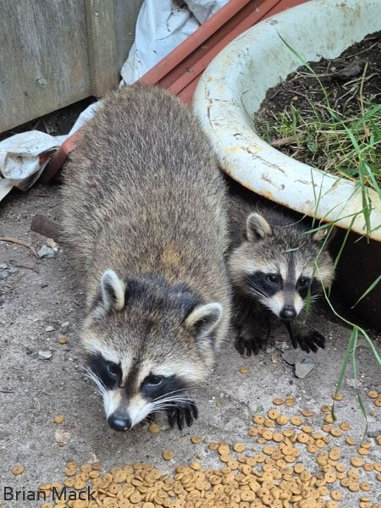
Scripture – Matthew 13:31-33, 44-52 NRSVUE
³¹ He put before them another parable: “The kingdom of heaven is like a mustard seed that someone took and sowed in his field; ³² it is the smallest of all the seeds, but when it has grown it is the greatest of shrubs and becomes a tree, so that the birds of the air come and make nests in its branches.”
³³ He told them another parable: “The kingdom of heaven is like yeast that a woman took and mixed in with three measures of flour until all of it was leavened.”
⁴⁴ “The kingdom of heaven is like treasure hidden in a field, which a man found and reburied; then in his joy he goes and sells all that he has and buys that field.
⁴⁵ “Again, the kingdom of heaven is like a merchant in search of fine pearls; ⁴⁶ on finding one pearl of great value, he went and sold all that he had and bought it.
⁴⁷ “Again, the kingdom of heaven is like a net that was thrown into the sea and caught fish of every kind; ⁴⁸ when it was full, they drew it ashore, sat down, and put the good into baskets but threw out the bad. ⁴⁹ So it will be at the end of the age. The angels will come out and separate the evil from the righteous ⁵⁰ and throw them into the furnace of fire, where there will be weeping and gnashing of teeth.
⁵¹ “Have you understood all this?” They answered, “Yes.” ⁵² And he said to them, “Therefore every scribe who has become a disciple in the kingdom of heaven is like the master of a household who brings out of his treasure what is new and what is old.”
From Lisa Leffler
The Kingdom of Heaven is one of Jesus' most beloved images, yet it can be difficult to describe. We often imagine it as a place we will reach someday, but Jesus' parables suggest something much bigger. The Kingdom begins like a mustard seed or a pinch of yeast—small, ordinary acts that quietly transform the world. It is not built on fear of punishment or the hope of reward, but on God's invitation to live lives of love, welcome, and compassion.
As we wonder what heaven might be like, perhaps it is less about becoming different people and more about becoming fully who God created us to be. The experiences that shape us, including the ways we see the world through disability, neurodiversity, or life's struggles, need not be erased to make us whole. Instead, God's Kingdom may be like C.S. Lewis' vision of a "deeper country," where everything is more vibrant, more beautiful, and more alive than we have ever imagined. Every glimpse of kindness, every act of justice, every moment of belonging is a reflection of that coming Kingdom.
When we pray, "Your kingdom come, your will be done, on earth as it is in heaven," we are not simply waiting for a future promise. We are asking God to help us build that Kingdom here and now—through the way we care for creation, welcome our neighbours, and love one another. In those moments, heaven feels just a little closer.
Contemplation and Conversation
Where have you caught a glimpse of God's Kingdom – a moment when the world felt a little more loving, welcoming, or beautiful?
Prayer
Loving God,
Open our eyes to the glimpses of your Kingdom already among us.
Help us to welcome one another as you have welcomed us, and to share your love in all that we do.
May our lives reflect the deeper beauty of your Kingdom, today and always. Amen.

Further Conversation … We would love to hear from you! Please consider sharing your thoughts on the Contemplation and Conversation question on our Rockwood Stone Facebook Page.

Our Rockwood Stone Family
If you missed today’s worship service, you can watch it here: https://youtu.be/gzvSKRGJ6ao

United Church of Canada
Emancipation Day
August 1, 2026 marks Emancipation Day, commemorating the legal abolition of slavery on the land that is now Canada. It’s a day to remember our history, acknowledge that racism continues to impact lives today, and renew our commitment to building a more just and equitable future.
This Emancipation Day, The United Church of Canada Foundation is extending an invitation to help sustain anti-racism initiatives across the church. Gifts will support programs that address racial injustice and create opportunities for learning, healing, and conversation.
Powerful anti-racism initiatives are happening across our church in response to the truths that racialized and Indigenous Peoples have bravely shared and acknowledge their stories of resistance and strength. Contributions to the Foundation are an investment in these crucial initiatives, such as:
- The United Church of Canada’s 40 Days of Engagement on Anti-Racism, which encourages vital conversations about racial discrimination across our church communities.
- Our involvement in Fund Canada, which aims to unlock $500 million in grants by 2030, focusing on underfunded leaders and underrepresented voices. This funding will transform communities by investing in leaders with lived experiences to drive necessary change.
- The Indigenous and Racialized Youth Scholars Program, an investment in young leaders in the church, encouraging their participation in dialogues that shape the future of our society.
Together, we can continue the work of becoming an anti-racist church. The giving page is online here: https://united-church.ca/social-action/justice-initiatives/anti-racism/donations-anti-racism-work
Emancipation Day Service: Let Freedom Reign on All Humankind
Saturday, August 1, 2026 at 12:00 p.m.
Preacher: Rev. Dr. Catherine F. MacLean
Worship Leader: Rev. Dr. Paul Douglas Walfall
Join us in person or online!
In person: Pilgrim United Church, Edmonton
Online: https://www.youtube.com/watch?v=i8CoAO6chz0
#UCCan #EmancipationDay

A gift of belonging to a church is that the practice of gathering together for worship … to pray, sing, listen to scripture and share how God touches our lives – helps us grow in deeper relationship with God and each other. We are offering this practice of sharing beyond Sunday morning to deepen our connection. Each week you are offered a picture, a scripture and a question for contemplation, as well as a short reflection for you to contemplate, have conversation with people in your life and/or join an online conversation on our Rockwood Stone Facebook page.
Go to https://www.rockwoodstoneunitedchurches.com/ learn more about our churches.

