Contemplation and Conversation: 10th Sunday after Pentecost, August 2, 2026 Scripture – Matthew 14:13-21 NRSVUE
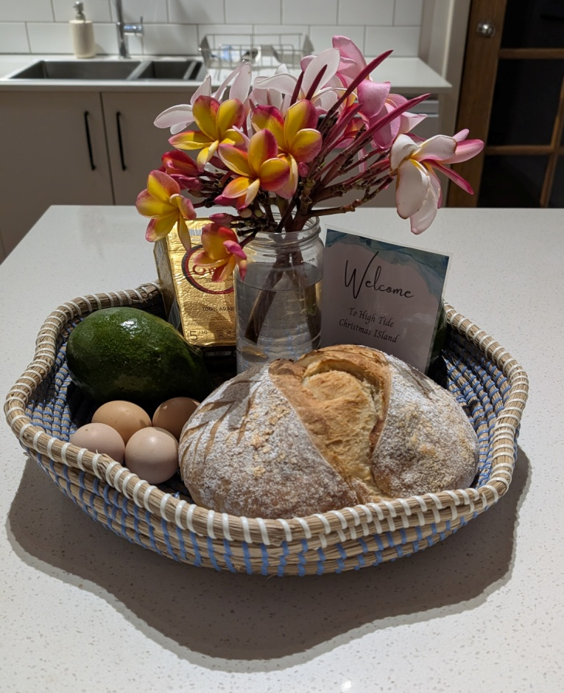
¹³ Now when Jesus heard this, he withdrew from there in a boat to a deserted place by himself. But when the crowds heard it, they followed him on foot from the towns. ¹⁴ When he went ashore, he saw a great crowd, and he had compassion for them and cured their sick. ¹⁵ When it was evening, the disciples came to him and said, “This is a deserted place, and the hour is now late; send the crowds away so that they may go into the villages and buy food for themselves.” ¹⁶ Jesus said to them, “They need not go away; you give them something to eat.” ¹⁷ They replied, “We have nothing here but five loaves and two fish.” ¹⁸ And he said, “Bring them here to me.” ¹⁹ Then he ordered the crowds to sit down on the grass. Taking the five loaves and the two fish, he looked up to heaven and blessed and broke the loaves and gave them to the disciples, and the disciples gave them to the crowds. ²⁰ And all ate and were filled, and they took up what was left over of the broken pieces, twelve baskets full. ²¹ And those who ate were about five thousand men, besides women and children.
From Rosslyn Bentley
The feeding of the five thousand is one of Jesus’ best-known miracles because it reveals something Matthew 14:13-21 recounts the miracle of the Feeding of the Five Thousand, where Jesus multiplies just five loaves of bread and two fish to satisfy a massive crowd.
The passage outlines this profound event in four clear stages:
The Withdrawal: Upon hearing about the death of John the Baptist, Jesus attempts to withdraw by boat to a solitary, deserted place. However, crowds follow Him on foot from nearby towns.
The Compassion: Seeing the massive multitude, Jesus is moved with compassion, puts aside His time for solitude, and spends the day healing the sick.
The Challenge: As evening approaches, the disciples urge Jesus to send the crowds away to buy food. Instead, Jesus tells them, "You give them something to eat," pointing out they only have five loaves and two fish among them.
The Multiplication: Jesus instructs the people to sit on the grass. He takes the food, blesses it, breaks it, and hands it to the disciples to distribute. Everyone eats and is fully satisfied, with twelve full baskets of leftovers gathered afterward.
Despite Jesus’ grief and wish to withdraw to reflect on the life of John the Baptist, he is driven by compassion showing how service to others can take precedence even over your own wishes and how this can then multiply blessings. Jesus is literally able to nurture the 5,000 even when he is feeling depleted through the gift of his own compassion.
Often just when I feel exhausted or overwhelmed, I see others suffering and I am overcome that my own small needs are nothing compared to the enormity of others circumstances: refugees who have lost their home, indigenous people deprived of their birthright, those with illnesses that deprive them of a comfortable life or the means to support themselves. While I have learned the hard way I am not indestructible and I cannot let compassion overcome my life, I also find with prayer and leaning on my faith I have so much capacity to give – often the more you give the more you have to give. When we live in a rich multicultural country we all have much bounty to share.
Contemplation and Conversation
How does Jesus’ compassion inspire you?
When have you exhibited compassion and found it feeds not only you but many others?
Prayer
Loving God, remind us that are called to share:
sharing the scarce resources of our planet with people who are affected by famine.
We know we are called to share:
sharing knowledge with those who have receiving hearts and receiving knowledge back from them.
We know we are called to share:
sharing compassion with those who are sick, troubled, and afraid.
We know we are called to share:
sharing hope with those whose freedom has been lost, whose confidence is shattered.
We know we are called to share:
sharing a vision of deep spirituality, bold discipleship, and daring justice.
—David Sparks, Called to Act: Prayers with Roots in the Gospel of Mark

Further Conversation … We would love to hear from you! Please consider sharing your thoughts on the Contemplation and Conversation question on our Rockwood Stone Facebook Page.

Our Rockwood Stone Family
If you missed today’s worship service, you can watch it here: https://youtu.be/sL54b5RWzsI
United Church of Canada
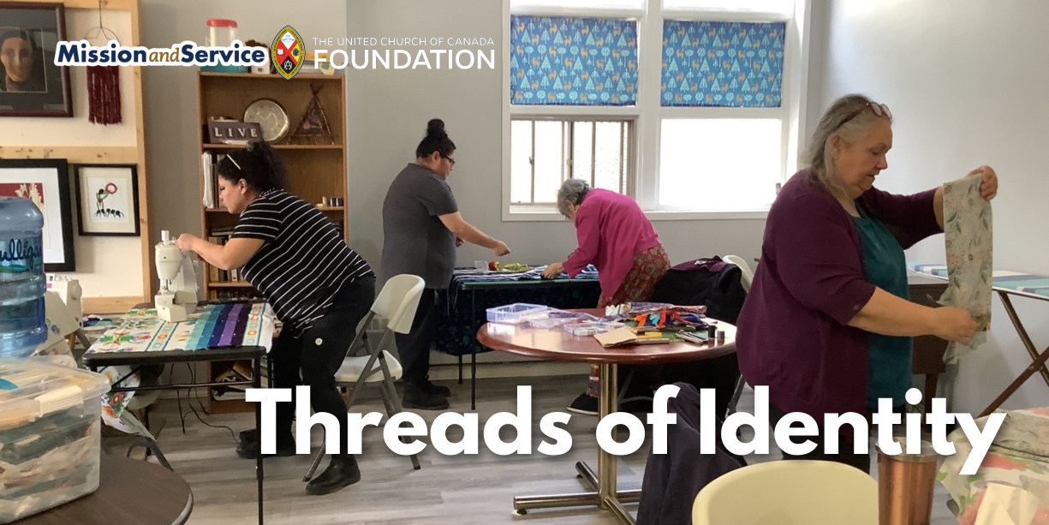

21 July 2026
Mission and Service Stories
Mission and Service Story – August 2: Threads of Identity
A ribbon skirt-making program in Saskatoon is helping Indigenous women and girls reconnect with culture, community, and identity. Here is the Mission and Service story for the week of August 2, 2026.
In Saskatoon, Saskatchewan, Mamohkamatowin Spiritual Community Inc. is helping Indigenous people reconnect with culture and community through a ribbon skirt-making program. Supported by Mission and Service, the program provides Indigenous participants living in Saskatoon’s core neighbourhoods with the materials, tools, and teachings needed to create their own ribbon skirts at no cost.
For many Indigenous women and girls, a ribbon skirt is more than a garment. It is an expression of identity, culture, and belonging, worn during ceremonies, celebrations, and other cultural and spiritual gatherings. For people living on low incomes, the cost of making or purchasing a ribbon skirt can place that expression of identity out of reach.
Participants learn how to use a sewing machine while making a skirt that reflects their own style and story. Alongside the practical sewing skills, they also receive teachings from an Elder, creating opportunities to deepen their understanding of the cultural and spiritual significance of ribbon skirts.
With support from Mission and Service, the program first started in 2024. Since then, community support has made it possible to purchase sewing machines and tables so participants have the tools they need to learn. Our support through Mission and Service helps provide fabric, ribbon, and other materials for each skirt, ensuring that cost to participants does not become a barrier.
The impact has been evident and ongoing. The women who completed the first sessions wear their ribbon skirts with great pride, knowing they had made them with their own hands while learning traditional teachings and connecting with community.
Programs like this reflect our commitment to supporting Indigenous leadership, strengthening community, and creating opportunities for people to reconnect with culture in meaningful ways. By combining practical skills with cultural teachings, Mamohkamatowin Spiritual Community Inc. is helping participants build confidence, celebrate their identities, and carry their traditions forward.
Our gifts through Mission and Service help support Indigenous-led ministries and community programs like this one. Together, we can help ensure more people have opportunities to learn, connect with culture, and participate fully in the traditions and communities that are meaningful to them. Let’s give generously.

A gift of belonging to a church is that the practice of gathering together for worship … to pray, sing, listen to scripture and share how God touches our lives – helps us grow in deeper relationship with God and each other. We are offering this practice of sharing beyond Sunday morning to deepen our connection. Each week you are offered a picture, a scripture and a question for contemplation, as well as a short reflection for you to contemplate, have conversation with people in your life and/or join an online conversation on our Rockwood Stone Facebook page.
Go to https://www.rockwoodstoneunitedchurches.com/ learn more about our churches.

