Contemplation and Conversation: 1st Sunday of Creation, September 13, 2026
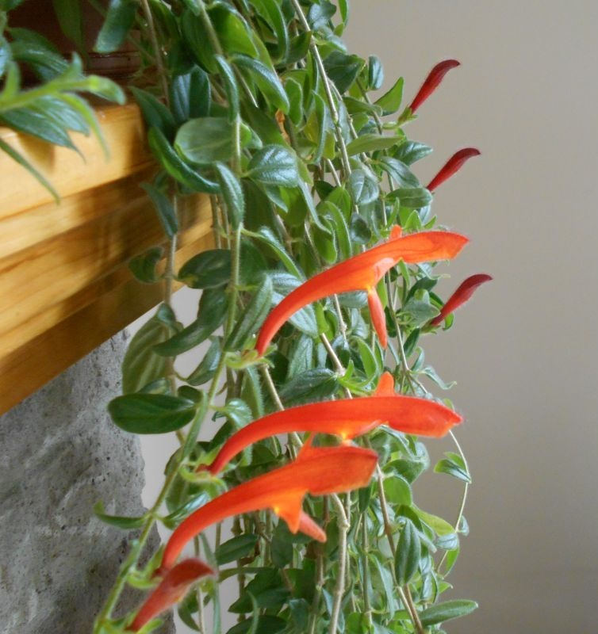
Scripture – Romans 14:1-12 NRSVUE
14 Welcome those who are weak in faith, but do not argue with them about their personal opinions. ² Some people's faith allows them to eat anything, but the person who is weak in the faith eats only vegetables. ³ The person who will eat anything is not to despise the one who doesn't; while the one who eats only vegetables is not to pass judgment on the one who will eat anything; for God has accepted that person. ⁴ Who are you to judge the servants of someone else? It is their own Master who will decide whether they succeed or fail. And they will succeed, because the Lord is able to make them succeed.
⁵ Some people think that a certain day is more important than other days, while others think that all days are the same. We each should firmly make up our own minds. ⁶ Those who think highly of a certain day do so in honor of the Lord; those who will eat anything do so in honor of the Lord, because they give thanks to God for the food. Those who refuse to eat certain things do so in honor of the Lord, and they give thanks to God. ⁷ We do not live for ourselves only, and we do not die for ourselves only. ⁸ If we live, it is for the Lord that we live, and if we die, it is for the Lord that we die. So whether we live or die, we belong to the Lord. ⁹ For Christ died and rose to life in order to be the Lord of the living and of the dead. ¹⁰ You then, who eat only vegetables—why do you pass judgment on others? And you who eat anything—why do you despise other believers? All of us will stand before God to be judged by him. ¹¹ For the scripture says,
“As surely as I am the living God, says the Lord,
everyone will kneel before me,
and everyone will confess that I am God.”
¹² Every one of us, then, will have to give an account to God.
From Karen Richardson
Years ago the church I was at decided we were going to fast every Friday of Lent and donate the money to World Development. One of the family’s had a 9- and 4-year-old. They decided the 9-year-old could fast for lunch, and the 4-year-old would fast for his morning treat at preschool. The young one came home one Friday, and mom knew right away that something was up. Giving the child that look he exclaimed “Well Jesus wouldn’t hate me for one lousy cookie.’
We do not all worship, pray, interpret scripture or enhance our spiritual lives in the same way at Rockwood Stone and that seems to be okay. We are free to express differences of opinions and to have others express theirs. We learn from one another whether it is from someone’s spiritual practices, someone’s interpretation of a scripture passage, or from someone’s doubts, questions or lack of faith. We often use the same words but one’s person perception of God or Holy Spirit or Jesus Christ might be quite different from another’s. It is only in conversation or small group gatherings that we are able to express this. I’m sure if we all reflected on a scripture, a hymn, a sermon we would all glom on to different things and that is a reflection of where we are at during that particular moment because maybe next year, next month, next week, tomorrow it would be quite different. While checking the commentaries on this passage there was a question Why is praying at 3 AM (called Quora) important – who knew! I had never heard of that and although I can agree with the concept of it being a time of quiet with no distractions, I can assure you that I won’t be setting an alarm for 3 AM to pray. Can I appreciate and even envy other’s commitment to their prayer time that they would awake at 3 AM to pray – absolutely but I certainly don’t judge those who do not and hope that I am not judged for this difference in a spiritual practise. I may be striving to be and do the best I can be as I believe God would want me to be, but I am stumbling and falling along the way and trying to trust in God’s grace.
Contemplation and Conversation
Are there practices that you reject but accept the people who follow them?
Are there practices that are important to you,
but you know others do not follow and you are okay with that?
Prayer
Holy mystery, wholly love, help us to listen and respect others’ opinions
as we would want them to respect ours.
Help us to learn and keep an open mind to hear your still small voice for our lives. Amen.

Further Conversation … We would love to hear from you! Please consider sharing your thoughts on the Contemplation and Conversation question on our Rockwood Stone Facebook Page.

Our Rockwood Stone Family
If you missed today’s worship service, you can watch it here: https://youtu.be/ge-f7Sajmfo

United Church of Canada
Sunday, September 13, 2026 is the first Sunday of the Season of Creation (also known as Creation Time) in the Revised Common Lectionary. This season runs through October 11.
The Season of Creation is a time in our liturgical calendar to come together in caring for Creation and in the building of a healthier, more just world that reflects God’s dream.
"Help to Reawaken Our Love for Creation"
Creating God,
You have called us to be in loving relations with all the Earth,
living with respect in creation,
choosing love and seeking justice at all times.
Instead, humankind has acted in hateful ways,
exploiting natural resources,
choosing power and seeking wealth in the present over future abundance.
We need your help to fight for a better future!
Help to reawaken our love for Creation,
that is so magnificent that we, with all our creativity and knowledge,
could never articulate it;
and so passionate that we, with the personal price and communal cost,
would still fight for it.
Help to deepen our relationships and love for each other:
Affirming the wisdom of both young and old activists,
so that we are not discouraged by empty platitudes and naysayers; and
Growing our community of allies,
so that we can create a sustainable and faithful response to the imminent climate crisis.
For the sake of your majestic creation, and
For the love of all our relations.
Help us to fight for a better future.
Amen.
—This prayer has been adapted from one originally written for the Fridays for Future Climate Strike movement by Alydia Smith
Visit our Worship section for more resources, prayers, and study material: https://united-church.ca/worship.../creation-time-week-1
#UCCan #SeasonofCreation #CreationTime #RevisedCommonLectionary 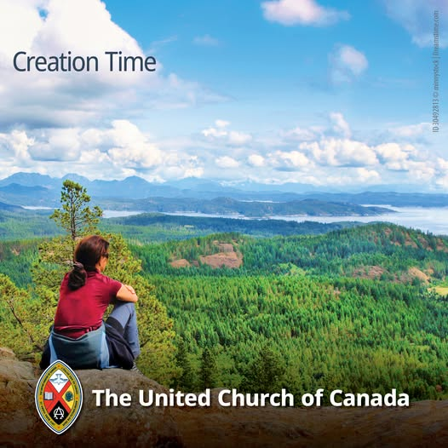
Pray for Peace. Act for Justice.
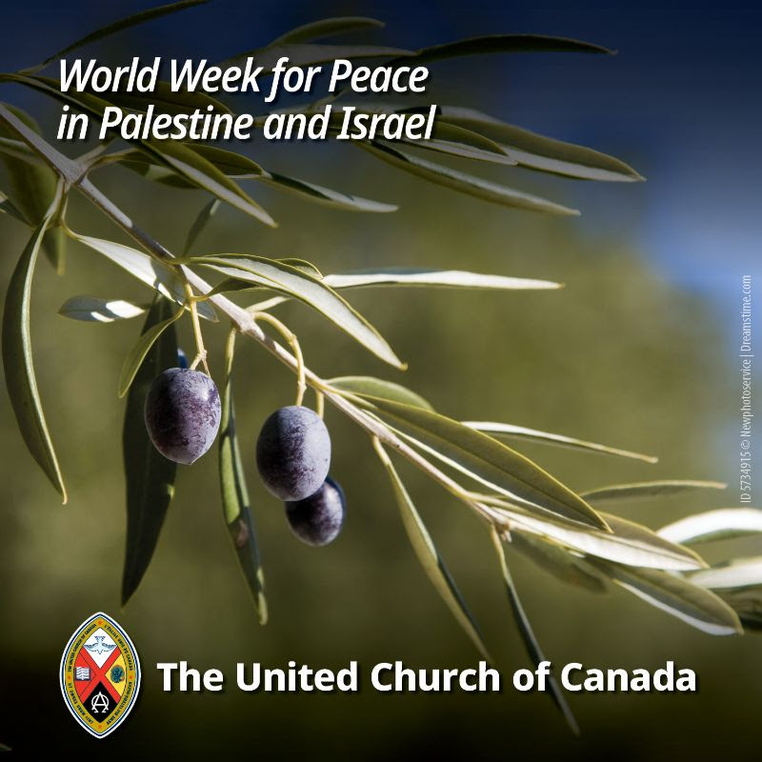
[Image credit: 5734915 Newphotoservice © Dreamstime]
As we mark the World Week for Peace in Palestine and Israel on September 20, invite your community of faith to turn prayer into action.
Write to your Member of Parliament urging Canada to support a lasting ceasefire, unhindered humanitarian aid, and a comprehensive two-way Canada–Israel arms embargo. Together, we can advocate for a just peace grounded in safety, dignity, and human rights for Palestinians and Israelis.
Find advocacy tools and a sample letter, and explore prayers and worship resources.

A gift of belonging to a church is that the practice of gathering together for worship … to pray, sing, listen to scripture and share how God touches our lives – helps us grow in deeper relationship with God and each other. We are offering this practice of sharing beyond Sunday morning to deepen our connection. Each week you are offered a picture, a scripture and a question for contemplation, as well as a short reflection for you to contemplate, have conversation with people in your life and/or join an online conversation on our Rockwood Stone Facebook page.
Go to https://www.rockwoodstoneunitedchurches.com/ learn more about our churches.

