Contemplation and Conversation: 21st Sunday after Pentecost, October 18, 2026


Scripture – 1 Thessalonians 1:1-10 NRSVUE
1 Paul, Silvanus, and Timothy,
To the church of the Thessalonians in God the Father and the Lord Jesus Christ:
Grace to you and peace.
² We always give thanks to God for all of you and mention you in our prayers, constantly ³ remembering before our God and Father your work of faith and labor of love and steadfastness of hope in our Lord Jesus Christ. ⁴ For we know, brothers and sisters beloved by God, that he has chosen you, ⁵ because our message of the gospel came to you not in word only but also in power and in the Holy Spirit and with full conviction; just as you know what kind of persons we proved to be among you for your sake. ⁶ And you became imitators of us and of the Lord, for in spite of persecution you received the word with joy from the Holy Spirit, ⁷ so that you became an example to all the believers in Macedonia and in Achaia. ⁸ For the word of the Lord has sounded forth from you not only in Macedonia and Achaia but in every place your faith in God has become known, so that we have no need to speak about it. ⁹ For they report about us what kind of welcome we had among you and how you turned to God from idols to serve a living and true God ¹⁰ and to wait for his Son from heaven, whom he raised from the dead—Jesus, who rescues us from the coming wrath.
From Brian Mack
The churches of Rockwood and Stone offer grace to you, Paul, Silas, and Timothy.
We give thanks to you for your writings which still guide us some one thousand nine hundred and sixty-five years since you wrote your letter of instruction to the Thessalonians. We know that you were writing to a specific people at a time when they were being persecuted. Forgive us if we misinterpret your intent.
You will be happy to know that we remain faithful to God. We know that our hope lies in Jesus Christ. Our work in our community is a labor of love. As humble servants, we try our best to serve God and imitate the love and kindness of Jesus Christ. As we go bout our daily lives, we remember that you focused on the need for a deep, trusting relationship with one another and that such a relationship can only flourish when God is at the center of our existence.
Paul, you taught that God’s self and his intention for us is revealed not just through word and song, but through active watching and listening on the part of believers. We are thankful to you for this insight. At a time of great change for us, we promise to return to these words of instruction again and again.
Your 2026 humble servants of Rockwood and Stone United churches
Contemplation and Conversation
How do you encourage others in our faith communities and in our wider community?
Prayer
Thank you for the teachings of Paul.
Help me to live out my faith joyfully.
May I be a model to others by encouraging and lifting up those around me. Amen.

Further Conversation … We would love to hear from you! Please consider sharing your thoughts on the Contemplation and Conversation question on our Rockwood Stone Facebook Page.

Our Rockwood Stone Family
If you missed today’s worship service, you can watch it here: https://youtu.be/BftVzIe0NYI

United Church of Canada
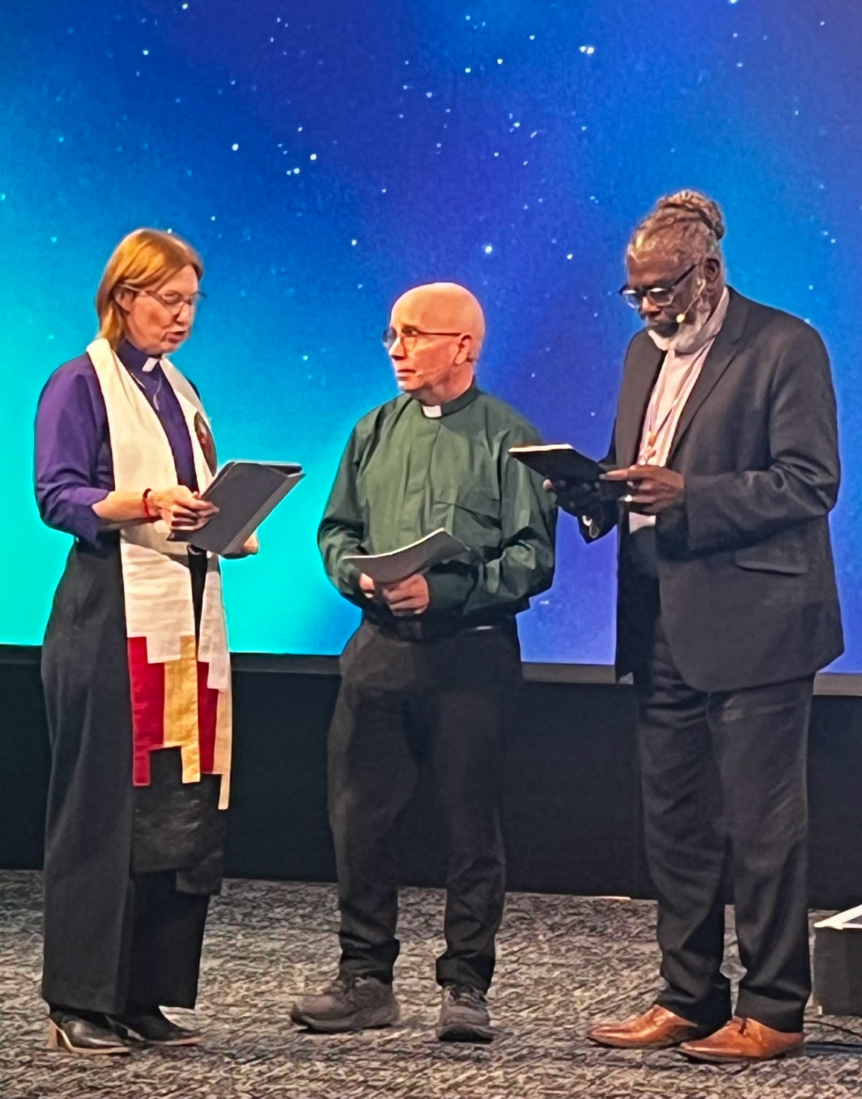
At the close of today’s Annual Meeting, the 45th General Council covenanted with the Rev. Éric Hébert-Daly as the next General Secretary of The United Church of Canada, effective January 1, 2027.
Éric affirmed his commitment to serving God, advancing the church’s mission and vision in partnership with the Moderator, and leading in the way of Jesus through deep spirituality, bold discipleship, and daring justice.
Rooted in our faith tradition, covenanting marks the formation of relationships and our mutual commitment to God and one another. Together, we seek to co-create a church that is evolving, connected, courageous, and diverse, united in its call and vision.
Today also marked the close of the General Council’s covenant with the Rev. Michael Blair, whose ministry as General Secretary concludes December 31, 2026. We give thanks for Michael’s faithful service, prophetic leadership, and dedication in helping the church navigate uncertain times and discern new ways of being God’s church. His leadership has left a lasting mark on our life together.
Find out more about Rev. Éric Hébert-Daly appointment as General Secretary: https://united-church.ca/.../rev-eric-hebert-daly...
[Photo, left to right: Moderator Rev. Dr. Kimberly Heath, Rev. Éric Hébert-Daly, General Secretary Rev. Michael Blair. Credit: Ronda Parkes.]

A gift of belonging to a church is that the practice of gathering together for worship … to pray, sing, listen to scripture and share how God touches our lives – helps us grow in deeper relationship with God and each other. We are offering this practice of sharing beyond Sunday morning to deepen our connection. Each week you are offered a picture, a scripture and a question for contemplation, as well as a short reflection for you to contemplate, have conversation with people in your life and/or join an online conversation on our Rockwood Stone Facebook page.
Go to https://www.rockwoodstoneunitedchurches.com/ learn more about our churches.

