Contemplation and Conversation: 2nd Sunday of Advent, December 6, 2020
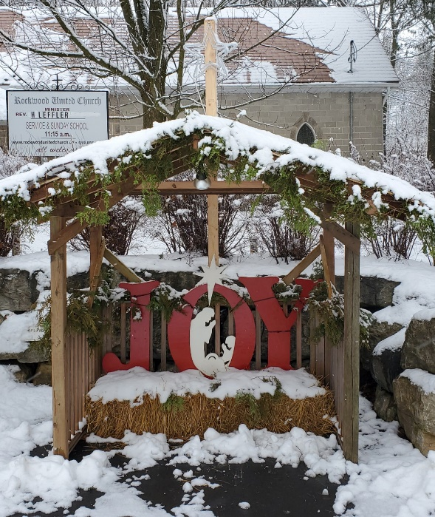
Scripture: Mark 1:1-8 (NRSV) https://www.biblegateway.com/passage/?search=mark+1%3A1-8&version=NRSV
Contemplation and Conversation: How are you preparing for the birth of the prince of peace?
From Rev. Heather Leffler:
Often in Advent we read the story of John the Baptist preaching the Good News of Jesus’ coming. John is not heralding the birth of Jesus but the beginning of Jesus’ ministry. He is asking people to prepare their hearts for the One whom God has sent to show us a new path to peace.
Often for us Advent is much more about decorating, shopping, cooking and preparing to welcome family and friends into our homes. Even our church activities often focus on coming together for special meals and parties. In all the busyness, it is easy to lose sight of Jesus and peace.
This year when we are asked to keep physically distanced from one another and sharing meals and opening gifts will mostly be relegated to online, might the Holy One be inviting us to pause and prepare in a deeper way? How would our Christmas change if instead of gathering in large groups we called individual family members and friends to catch up with them? Might we take the time we would have spent driving to special events to pray for the people we will not see in person? Might you have time this Christmas to add a spiritual practice? Consider meditating on different character in your nativity each day and imagine how Mary, Joseph, the shepherd, angels and wisemen felt on that holy night. May you find peace in this challenging time.

Whether you are at home trying to help slow the spread of the virus,
working to help care for those who are impacted most by COVID-19
or working to keep some normalcy in this time,
may you know God’s deep and abiding love in your life.
Know you are a valued part of our Rockwood and Stone United Church families.

Further Conversation … Would you like to talk more about today’s reflection? Email Heather at hleffler@rogers.com. Following worship next Sunday, she will invite others to join you in a Zoom break out room to share in further conversation.

From our Rockwood Stone Affirming Discernment Circle
An article was shared this week with the Affirming Church Discernment Circle about “deadnaming”. If like me, you have never heard of deadnaming before it can feel like just one more thing to learn but this article helps explain the importance of using a person's correct name and gender.
https://www.cbc.ca/kidsnews/post/transgender-teen-on-why-deadnaming-elliot-page-is-harmful. The video included in the article can be found at https://www.youtube.com/watch?v=PzGauky20tc .

United Church of Canada
From Moderator Richard Bott
Today, as I wake, I remember the names of 14 women.
Geneviève Bergeron.
Hélène Colgan.
Nathalie Croteau.
Barbara Daigneault.
Anne-Marie Edward.
Maud Haviernick.
Maryse Laganière.
Maryse Leclair.
Anne-Marie Lemay.
Sonia Pelletier.
Michèle Richard.
Annie St-Arneault.
Annie Turcotte.
Barbara Klucznik-Widajewicz.
Fourteen women, killed by a man's hatred of women.
As I remember their names, I also remember the thousands of missing and murdered Indigenous women and girls across this land.
As I remember their names, I also remember the trans women who have been killed at the hands of men's hatred and fear.
As I remember their names, I also remember the women the world around who have been killed by men's violence and power.
In remembering these women, and the fact that their lives were cut short by man's violence, I commit myself again to be a person who works against men's violence against women, and a man who calls and challenges other men to do the same.
Geneviève Bergeron.
Hélène Colgan.
Nathalie Croteau.
Barbara Daigneault.
Anne-Marie Edward.
Maud Haviernick.
Maryse Laganière.
Maryse Leclair.
Anne-Marie Lemay.
Sonia Pelletier.
Michèle Richard.
Annie St-Arneault.
Annie Turcotte.
Barbara Klucznik-Widajewicz.
14 women who I can remember, who also remind me of all the women whose names I do not know.
May their memory change the world.

The Moderator of The United Church of Canada is offering a Blue Christmas service for anyone who is interested on December 9 at 6:30 pm; the link for the service can be found at https://www.united-in-learning.com/index.php/webinars/367-blue-christmas-service-december-2020?fbclid=IwAR3YSG27SQuDKGL_mzbwOPeEz‌VlxZW6TWozD09tO2ddFCbCficqSK2Jvck8.x
A gift of belonging to a church is that the practice of gathering together for worship … to pray, sing, listen to scripture and share how God touches our lives – helps us grow in deeper relationship to God and each other. With COVID-19 keeping us at home and physically distant from our Stone or Rockwood families, we are missing each other. We are offering this practice of sharing beyond Sunday morning to deepen our connection. Each week you will be offered a picture, a scripture and a question for contemplation, as well as a short reflection for you to contemplate, have conversation with people in your life and/or join an online conversation on our Rockwood Stone Facebook page.

