Contemplation and Conversation: 25th Sunday after Pentecost, November 14, 2021
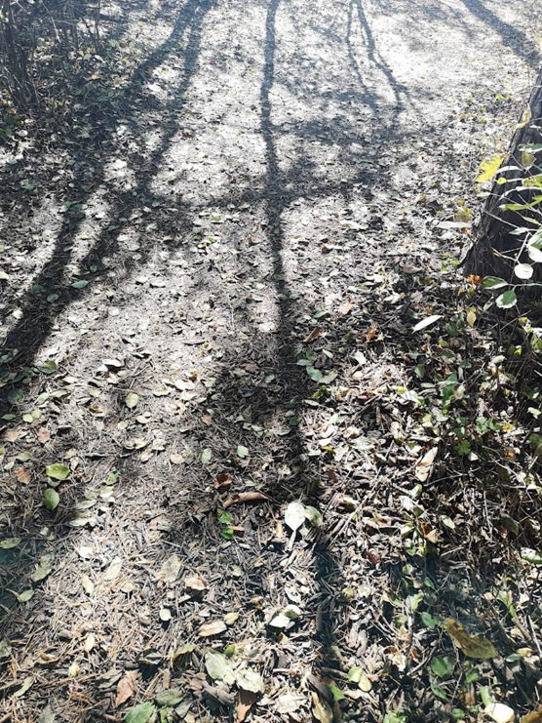
Scripture: Hebrews 10:11-14, 19-25 https://www.biblegateway.com/passage/?search=Hebrews+10%3A11-14%2C+Hebrews+10%3A19-25&version=NRSV
Contemplation and Conversation:
Is there something you could confess to God today that would lift your spirit?
From Rev. Heather Leffler:
Growing up the only prayers of confession I remember were on communion Sundays. If you had asked me, I would have probably said that it was a Catholic practice to offer confession.
Over time Protestant churches came to appreciate the significance of confessing our sins. Acknowledging out loud or in the silence of our hearts those things that separate us from God or from another person and seeking forgiveness is not a once and for all action. Jesus indeed made a once and for all sacrifice so that we would know we are loved and forgiven. As we journey into deeper relationship with God and our siblings in faith, we recognize those places in our lives where through our actions or inactions we are hurting someone else, ourselves or creation. Confessing and seeking forgiveness can help us let go and move on, lifting our spirits and strengthening our relationships.
May we trust in God’s forgiving love enough to confess those actions or inactions that separate us from others. Amen.
Whether you are at home trying to help slow the spread of the virus,
working to help care for those who are impacted most by COVID-19
or working to keep some normalcy in this time,
may you know God’s deep and abiding love in your life.
Know you are a valued part of our Rockwood and Stone United Church families.

Further Conversation … Would you like to talk more about today’s reflection? Email Heather at hleffler@rogers.com. Following worship next Sunday, she will invite others to join you in a Zoom break out room to share in further conversation.

From Worship
Diane Matheson-Jimenez Minister for Social Justice for Western Ontario Waterways invites us to be brave when we engage each other.
- B eing accountable for the impact of both our words and our silence
- R eflecting on and naming our own biases
- A ctively listening
- V ocalizing questions that arise from our learning
- E ncountering new ideas with curiosity and wonder

United Church of Canada From Moderator Richard BottPublished On: November 13, 2021
Why bother?
Oh, friend!
It's not for some future legacy
that I bother.
It's not so that my name gets written
on some eternal book;
or my words are saved in the spin states of quarks,
to be embedded into the fabric of the universe
until the end of time;
or my actions are turned into
an epic worthy of Gilgamesh and Enkidu,
that I bother.
Another minister, a guy named Paul, said,
"Prophecies? They'll end!
Languages? They'll go silent.
Knowledge? Naa, it won't last!"
I don't bother for some future memory.
I bother because
this moment is the only moment
that I can do anything about,
in an instant, it will be gone -
but in this instant
I can live the best me that is possible;
I can love, not just to the best of my ability,
but, knowing that Divine love fills
the spaces in-between,
I can love, tangibly, beyond my ability,
I bother because, perhaps,
just perhaps,
if I live that love in the moments you can't,
and you live the love in the moments I can't,
and they live the love in the moments we can't,
then, maybe,
just maybe,
this world will be changed.
I don't bother for a future,
as hopeful as I am about it.
I bother because
that's what needs to happen
now.

A gift of belonging to a church is that the practice of gathering together for worship … to pray, sing, listen to scripture and share how God touches our lives – helps us grow in deeper relationship to God and each other. With COVID-19 keeping us at home and physically distant from our Stone or Rockwood families, we are missing each other. We are offering this practice of sharing beyond Sunday morning to deepen our connection. Each week you will be offered a picture, a scripture and a question for contemplation, as well as a short reflection for you to contemplate, have conversation with people in your life and/or join an online conversation on our Rockwood Stone Facebook page.

