Contemplation and Conversation: Pentecost Sunday, May 23, 2021
Scripture: Romans 8:22-27 NRSV https://www.biblegateway.com/passage/?search=Romans%208%3A22-27&version=NRSV
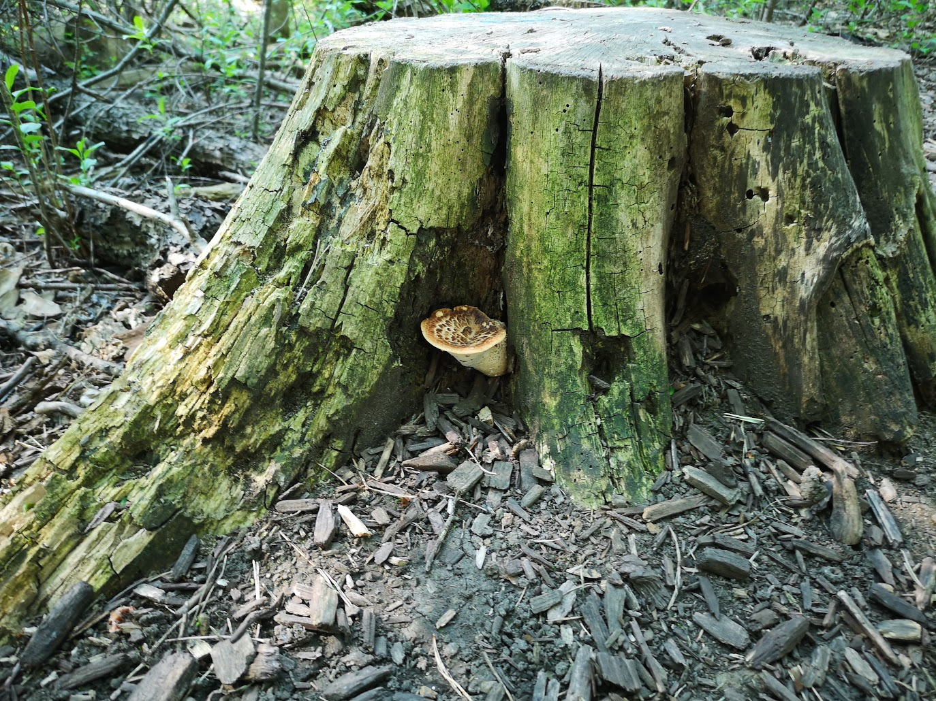
Contemplation and Conversation: For who or what might the Spirit be praying through you?
From Rev. Heather Leffler:
Have you ever found yourself thinking about someone you haven’t seen in a long time – an old friend from school or work, a distant cousin, a church friend? I have come to trust that this is the Spirit praying through us. The Spirit, knowing the person needs prayer, raises them up in our hearts and minds. We can respond by giving thanks to God for the times we shared, pray for their wellbeing, or even send a note or give them a call.
The more I have learned to trust these are prayers, the more I recognize other prayers the Spirit invites me to lift to God. The nudge to pray for people impacted by COVID-19, especially migrant workers, refugees and those who live on the streets … for children, teachers and parents to find blessings amidst the challenges of online school … for a just and lasting peace in Israel and Palestine … a world where people are accepted as God created them and we recognize the gift in diversity.
May you recognize the Spirit praying through you today.

Whether you are at home trying to help slow the spread of the virus,
working to help care for those who are impacted most by COVID-19
or working to keep some normalcy in this time,
may you know God’s deep and abiding love in your life.
Know you are a valued part of our Rockwood and Stone United Church families.

Further Conversation … Would you like to talk more about today’s reflection? Email Heather at hleffler@rogers.com. Following worship next Sunday, she will invite others to join you in a Zoom break out room to share in further conversation.

From Worship
This morning we listened to Douglas Wood’s Old Turtle and the Broken Truth. To hear Douglas read his book and hear his hope for our world, go to https://www.youtube.com/watch?v=26byBtwjpy4 . The reading shared in worship can be found at https://www.youtube.com/watch?v=3GTYbsI6UYE .

United Church of Canada – Published On: May 28, 2019
In his Pentecost 2019 reflection, Moderator Richard Bott reflects on the movement of the Holy Spirit in our lives. https://united-church.ca/news/moderators-pentecost-message-2019
As a denomination, The United Church of Canada believes that the Holy Spirit continues to move in the world. As we say in the New Creed, God “works in us, and others, by the Spirit.” Where we recognize movements in the world that bring healing, hope, life, and abundant life for all creation, there’s a pretty good chance that we’ve met the movement of the Holy Spirit.
A gift of belonging to a church is that the practice of gathering together for worship … to pray, sing, listen to scripture and share how God touches our lives – helps us grow in deeper relationship to God and each other. With COVID-19 keeping us at home and physically distant from our Stone or Rockwood families, we are missing each other. We are offering this practice of sharing beyond Sunday morning to deepen our connection. Each week you will be offered a picture, a scripture and a question for contemplation, as well as a short reflection for you to contemplate, have conversation with people in your life and/or join an online conversation on our Rockwood Stone Facebook page.

