Contemplation and Conversation: 21st after Pentecost
Sunday, October 25, 2020

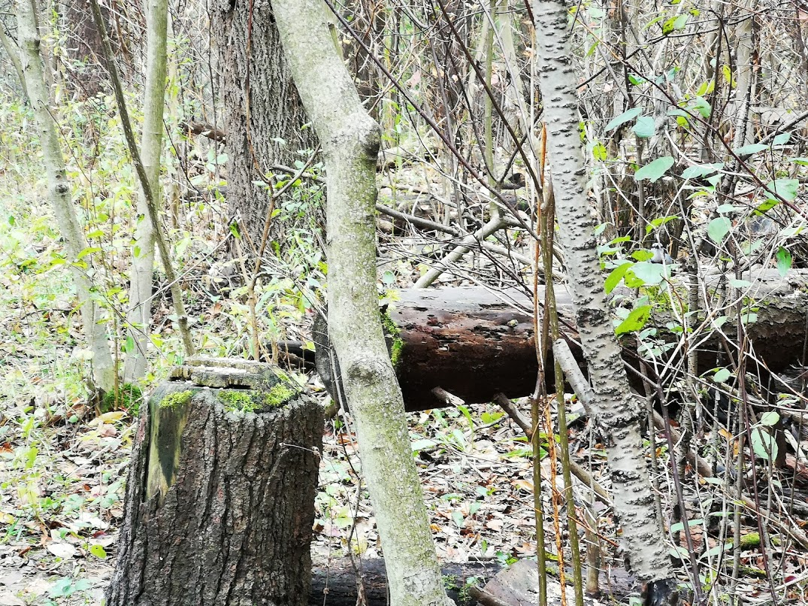
Scripture: Matthew 22:34-40 https://www.biblegateway.com/passage/?search=Matthew+22%3A34-40&version=NRSV
Contemplation and Conversation: Who do you find it challenging to love?
What might help you respond to them in new way?
From Rev. Heather Leffler:
These few verses are the very essence of the good news or gospel of Jesus. These two laws sum up the Ten Commandments and are truly the basis for all just laws. If we love God first and love our neighbour and ourselves, we will experience a taste of God’s kingdom in our lives.
The Canadian Department of Justice says, “Laws help to ensure a safe and peaceful society. The Canadian legal system respects individual rights and ensures that our society is orderly. It applies the same law to everybody.” We know that not all our laws are just. Systemic racism, lobbies, politics, economics and even religions have influenced our laws to benefit particular groups. Together we are called to name and dismantle those laws that advantage one group of people over another.
The challenge of Jesus’ call to love is that not everyone is seems loveable. It is far easier to look for justice than to respond in love to those who hurt us or people we care about, steal or damage property. Stephen Jackson from Anishnabeg Outreach shared his belief that we need to work for reconciliation and healing instead of justice. When someone has offended and they are brought to justice, the victim may find some peace but often the offender is then left angry. When we seek understanding and reconciliation – when we love – those who hurt us, we open the door to finding common ground and we can move forward together.
Love God and love your neighbour as you love yourself sounds simple but it is one of the hardest things God asks of us and it is the spiritual practice that has the most potential to change the world. May it be so.

Whether you are at home trying to help slow the spread of the virus,
working to help care for those who are impacted most by COVID-19
or working to keep some normalcy in this time,
may you know God’s deep and abiding love in your life.
Know you are a valued part of our Rockwood and Stone United Church families.

Further Conversation … Would you like to talk more about today’s reflection? Email Heather at hleffler@rogers.com. Following worship next Sunday, she will invite others to join you in a Zoom break out room to share in further conversation.

Our Church Family – Please pray for Lou Darcie who is in Guelph General Hospital and will have tests in Kitchener this week.
Mabel Parker is transitioning into life at Eden House Retirement Home 5016 Wellington Rd. 29, Guelph/Eramosa, ON N1H 6H8 519-856-4095 and Marion Osborne is transitioning into life at Riverside Glen 190-60 Woodlawn Road East, Guelph, Ontario, N1H 8M8 519-265-1707. During this time of change and the isolation period, phone calls, notes and cards would be greatly appreciated.

United Church of Canada
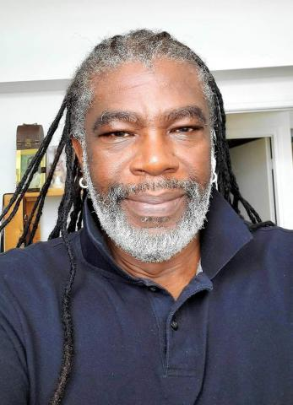
The United Church of Canada is pleased to announce the appointment of the Rev. Michael Blair as its new General Secretary beginning November 1, 2020. The role of General Secretary, General Council is a permanent position, providing leadership in the direction, management, and coordination of the affairs of the church working in close collaboration with the Moderator, who is elected every three years as the church’s spiritual leader and spokesperson.
The Rev. Blair is currently serving in the General Council Office, Toronto, as the Executive Minister, Church in Mission Unit, which maintains the relationships with overseas partners, develops faith formation resources for the church and initiates advocacy campaigns for the denomination. He has been in that role for eight years. Born in Jamaica, his faith journey began in the Anglican Church. He came to Canada as a young adult with his family, was ordained in the Convention Baptist Church, and in 2010 was admitted to the United Church’s order of ministry.
The Rev. Blair replaces Nora Sanders, who is retiring after almost 14 years as General Secretary. The Rev. Blair was appointed by the church’s General Council Executive during their online meeting August 27 after a search process that lasted 10 months. Sanders says, “I have worked with Michael for 12 years. I know his deep faith and sense of call to continue the life and work of the United Church in this time, with all its complexities. He is also well known in ecumenical circles and to many of our international partners, so he brings a broad horizon of expertise to the role.”
From Stephen Jackson, CEO of Anishnabeg Outreach
Hi All,
AO is growing again and our Indigenous centre of healing is finally functionally complete enough to be considered a true centre for healing which means it is delivering on true reconciliation. I know I have had a number of reconciliation-based conversations with many of you.
I am not sure if any of you heard my SVP speech last November. I was part of their Perfect Pitch contest. We lost by a massive margin. The concept was a bit too large for most but Dave Caputo (chair of Communitech) was in the audience that night and he saw the vision and eventually partnered with us. I was looking for $1 million support to finish building our centre of healing and talked about their impact if they were across the country. The impacts we are trying to disrupt are 30% Indigenous people making up prison populations nationally, 50% of homeless population is Indigenous, 75% of our children in care are Indigenous and Indigenous students have a 500% higher drop out rate in school. There are also huge issues with addictions, mental health, health and suicide. I am thrilled to announce that we have completed our proof of concept Indigenous Centre of Healing. I am thrilled that Communitech and the University of Waterloo is now part of our healing process. We recently partnered with LHIN, Carizon, Guelph Counselling and OFIFC to secure funding and program resources / mentoring to build the region’s first Indigenous Mental Health unit. I am so excited, we finally have the resources to begin the much needed counselling aspect of healing. This is going to have such a huge impact for the Indigenous community which is afraid to go to colonial service providers for fear of negative consequences. This will have an incredible impact for children. This was one of the last missing pieces. We now have our Healing lodge, Teaching lodge and medicine gardens. We have our Indigenous EarlyON site, a new national Math Tutoring program, a new national Mentoring program and Employment agency. We support families and children through our spirit bundles (food, clothes, furniture, pet food, bikes, cleaning supplies and sanitary and baby supplies, back to school backpacks, masks, etc.). We have partnered with another Indigenous organization who secured a $50,000 grant to purchase traditional foods for Indigenous people (game, fish, rice, corn, etc.) and we will be the distributors through our spirit bundles. The spirit bundle program has been simply amazing. It is all donation-based. So mostly supplies and some start up funding. This really means we have a micro Walmart warehouse in our great room. We have already delivered more than 50,000 pounds of supplies totalling more than $250,000 to families in desperate need and now we will be able to offer traditional foods over the winter. In the past, food was a weapon used against Indigenous people throughout colonial history. For us, food is often considered medicine and traditional diets can positively impact medical conditions. By the end of winter, we will have delivered more than $500,000 in much needed pandemic related supplies. Simply put, this is an incredible return on your pandemic investment. We have also recently partnered with Police to create a signature program for them. Thanks so much to Bryan Larkin and his Leadership team for supporting our proposal. This program capitalizes on the good will of people in the community and their interest in helping those in need during the pandemic. I saw an opportunity, when Police’s backpack program was over subscribed. Beginning in November, they will begin collecting winter clothes (boots, hats, mitts, coats and snow pants) for children, youth and adults. I designed this program not to help just us and the other Indigenous organizations who we will distribute to but rather to help all organizations in the region who support families or people in need. So newcomers to Canada, community centres, homeless shelters, etc. This means all agencies will have warm winter wear for their clients in need. This is incredibly needed for families to help with social isolation. The land will heal and now people will be able to go on the land this winter. We now have multiples services that help each age group, provide hands up, not hand outs and move the needle on healing which is true reconciliation. Personally, I think the true reconciliation is actually the partnerships that enable the healing. That is our way of being. Needless to say, it took me a year but we now have the country’s first centre of Indigenous healing: our proof of concept. And thanks to all of our partnerships and support from so many, it worked out way better than expected.
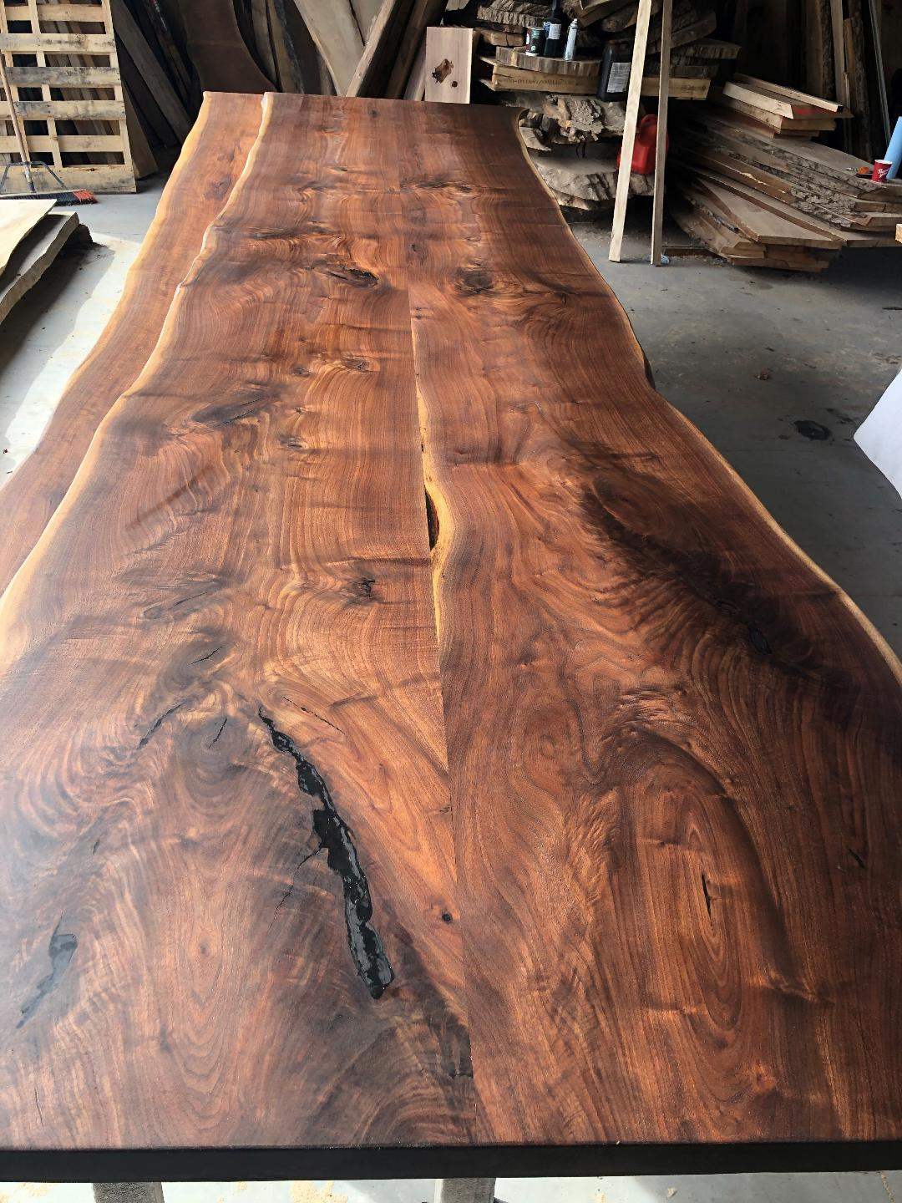
Things are also progressing extremely well for us on the new national Indigenous mentoring program we are building in partnership with Communitech. We now have a couple of introductory web-based and self-directed computer courses for mentees and we have approximately 50 tutors (profs and grad students) to provide 1on1 support for the mentees all thanks to our evolving and expanding partnership with U of W. We are looking at what courses we will need to develop next. In essence, we are creating a process for rapid remote development of programmers capable of filling entry level jobs in AI applications or mobile app development. This means we will create a talent pool for back-shoring or reshoring tech jobs to Canada and for the ever expanding tech community. We also now have similar courses to support math in case math skills need to be augmented. Our new math courses begin in grade four and progress through grade 12. These courses will also enable us to begin a new national math tutoring program to help prepare future generations of programmers. We also have our first cohort of mentees for the pilot. We have approximately 18-20 of them. Some are from remote reserves and some are from urban centres. Some are younger and some older. It will be a good mix to find out what other supports will be needed for them. We have partnered with University College of the North for the northern participants and therefore, will be able to have lots of supports in place for them in their home communities. University College of the North recognizes how impactful our program will be for their clientele and can’t wait for us to expand our offerings. They are redesigning their entire program and have actually launched it immediately to fit with our program. They were planning on launching in January as a call centre support. We should have everyone registered as a mentee next week and enrolled in the computer courses. Once they are progressing, we will be ready for some mentors for them from the Communitech Community of companies which includes Google. We should be ready to start enrolling mentors in a couple of weeks and then on to matching. Once our pilot is complete, we should be able to scale up and begin helping thousands of Indigenous people from across the country. This is such and exciting and impactful program for us. With support, the potential of this program is limitless for Indigenous people living on reserves or urban centres. This program will change the world for them and thanks to the pandemic, computer work is now remote and may never move back to offices.
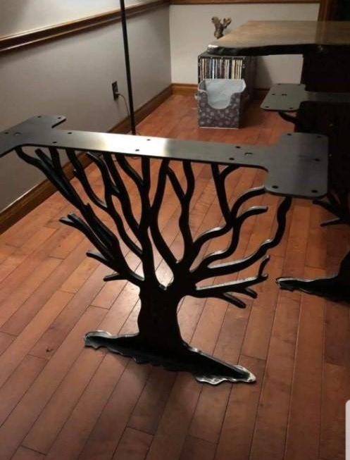
In other less important news, our 2 new 16 foot great room tables are ready. The bases I am having made will be another week or so. Combined with our new board room table we will have over 40 feet of very beautiful walnut tables for organizations that want to utilize our meeting space in the great room. When not in use for big meetings they will be part of the technology hub we have built to support the mentoring program. And we were sponsored by a beer company. We were chosen as their fall charity. We will receive $2500 to help support our Healing lodge. Really, Honorarium for our elder to help heal people. To be honest, I never expected AO to ever be on a beer can label but we value every dollar as it helps us move the needle on healing. As many of you know, we pretty much spin straw to gold.
I am still working on more partnerships that will continue to move the needle on reconciliation and healing. I am extremely thankful for all we have been able to accomplish since the pandemic began and for all of your support. I will keep you informed as things develop and evolve at AO.
Stone United Church’s 158 Anniversary Quiz
- How many ministers have served Stone UC over the past 158 years (1862-2020)?
- What year was the basement dug out/floor raised?
- Where did the congregation meet when these renovations were taking place?
- What year was the Christian Education/Kitchen/Washroom addition built?
- How many burial plots are in the cemetery?
- What year was the first burial? Bonus Q: what was surname?
- What factor contributed to the greatest number of people facing hunger in 2019?
- What factor is contributing to the greatest number of people facing hunger in 2020?
- Last year, Foodgrains projects trained 65,700 farmers in this type of agriculture.
- In millions of dollars, how much did the Canadian Foodgrains Bank contribute in assistance in 2018-19?
- How many dollars does the Canadian International Development agency match for every dollar raised by Foodgrains Projects?
Watch next week’s announcements or email hleffler@rogers.com for the answers.

A gift of belonging to a church is that the practice of gathering together for worship … to pray, sing, listen to scripture and share how God touches our lives – helps us grow in deeper relationship to God and each other. With COVID-19 keeping us at home and physically distant from our Stone or Rockwood families, we are missing each other. We are offering this practice of sharing beyond Sunday morning to deepen our connection. Each week you will be offered a picture, a scripture and a question for contemplation, as well as a short reflection for you to contemplate, have conversation with people in your life and/or join an online conversation on our Facebook page or on Zoom following worship.

