Contemplation and Conversation: 3rd Sunday of Easter 2020
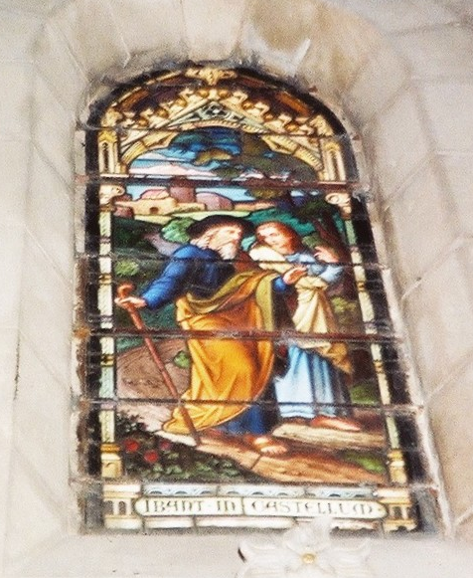
Scripture: Luke 24:28-35 NRSV https://www.biblegateway.com/passage/?search=Luke+24%3A28-35&version=NRSV
²⁸As they came near the village to which they were going, he walked ahead as if he were going on. ²⁹But they urged him strongly, saying, “Stay with us, because it is almost evening and the day is now nearly over.” So he went in to stay with them. ³⁰When he was at the table with them, he took bread, blessed and broke it, and gave it to them. ³¹Then their eyes were opened, and they recognized him; and he vanished from their sight. ³²They said to each other, “Were not our hearts burning within us while he was talking to us on the road, while he was opening the scriptures to us?” ³³That same hour they got up and returned to Jerusalem; and they found the eleven and their companions gathered together. ³⁴They were saying, “The Lord has risen indeed, and he has appeared to Simon!” ³⁵Then they told what had happened on the road, and how he had been made known to them in the breaking of the bread.
Consider taking time to read the full Emmaus Road story Luke 24:13-35 https://www.biblegateway.com/passage/?search=luke+14%3A13-35&version=NRSV

Contemplation and Conversation: When have you recognized the face of Christ in another?

From Rev. Heather Leffler:
May the Christ who walks on wounded feet walk with you on the road.
May the Christ who serves with wounded hands, teach you to serve each other.
When you go out, may you see the face of Jesus in everyone you meet,
and may everyone you meet see the face of Jesus in you. – A Celtic Blessing
Cleopas and his wife invited Jesus into their home as they would have any stranger needing shelter for the night. On the walk home and all the while they were preparing dinner, their grief, sadness and fear kept them from recognizing Jesus. In the simple act of blessing their meal and sharing it with them their eyes were opened. In that moment, their grief turned to joy when they recognized Jesus their Lord, risen from the dead. In this strange time of social distancing, look for the places you can reach out with your prayers, words and actions and make a difference. In that reaching out may you find the joy of seeing Jesus in another.

Whether you are at home trying to help slow the spread of the virus,
working to help care for those who are impacted most by COVID-19
or working to keep some normalcy in this time,
may you know God’s deep and abiding love in your life.
Know you are a valued part of our Rockwood and Stone United Church families.

Thanks to Brent Stiles for his gift of music today. https://www.youtube.com/watch?v=S0xlGiqQLv4
For the people of Portapique,
neighbours and community,
grieving today,
I pray.
Good morning, Heather.

On behalf of Anishnabeg Outreach, I wish to express my gratitude to our funders, donors and friends from the local region. This appreciation is such a small token and doesn’t seem to suffice for the outpouring of support. In my work email signature, I use a quote from Chief Seattle that “Humankind has not woven the web of life. We are but one thread within it. Whatever we do to the web, we do to ourselves. All things are bound together. All things connect.” And in these moments of our histories, we have come together to help one another. Together we are stronger. As a First Nations woman, there are many teachings on the role and purpose of braids – whether it is hair or sweetgrass or spiderwebs. A fundamental understanding is that the individual strands are stronger when they come together and are able to naturally weave beauty in front of our eyes. In my language, chi meegwetch is roughly translated to “huge amounts of thanks that are from my heart”. So. Chi meegwetch to everyone who has contributed, donated and offered help … to be part of the braid we call community.

Tammy Webster, AO Board President
I would like to acknowledge that the land on which we gather today is the land traditionally used by the Haudenosaunee, Anishnaabe and Neutral people. I also acknowledge the enduring presence and deep traditional knowledge, laws and philosophies of the Indigenous people with whom we share this land today.
For the victims of the shooting,
though I don’t know name or number,
I pray.
For their pain and their loss,
for their shock and confusion,
for all that has happened because of
this violence,
I pray your grace,
your compassion,
your strong presence,
your overwhelming love,
God of all creation.
In Jesus’ name...
—A prayer for the people of Nova Scotia affected by the shootings of April 18‒19,
by the Right Rev. Richard Bott. Moderator Bott encourages the sharing of prayers he posts throughout his term.

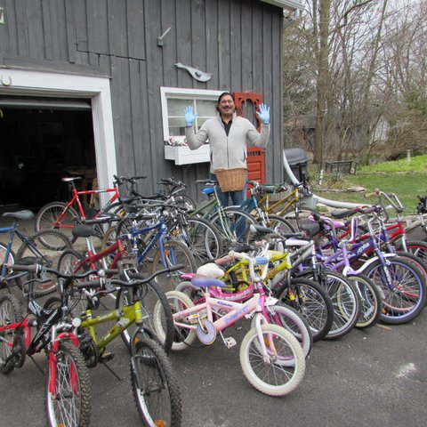
Moderator's Online Worship – Sunday, April 26, 2020 During the COVID-19 pandemic, Moderator Richard Bott offers an online service for those looking to gather with others, pray, and worship together. https://www.united-church.ca/blogs/round-table
Thanks to everyone who donated bikes and masks. Stephen Jackson picked up 21 bikes and 50 face masks this week. So far we have collected 50 bikes.

A gift of belonging to a church is that gathering together for worship … to pray, sing, listen to scripture and share how God touches our lives – helps us grow in deeper relationship to God and each other. With COVID-19 keeping us at home and physically distant from our Stone or Rockwood families, we are missing each other. We are offering this practice of sharing beyond Sunday morning to deepen our connection. Each week you will be offered a picture, a scripture and a question for contemplation, as well as a short reflection for you to contemplate, have conversation with people in your life and/or join an online conversation on our Rockwood Stone Facebook page.

