Contemplation and Conversation: Easter Sunday, April 4, 2021
Scripture: Mark 16:1-8 NRSV https://www.biblegateway.com/passage/?search=Mark+16%3A1-8&version=NRSV
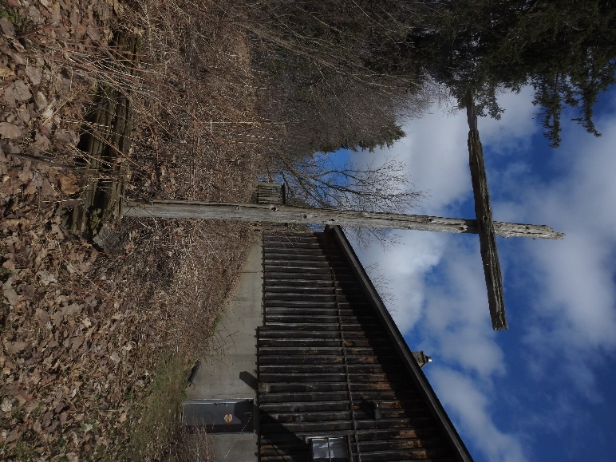
Go to https://www.youtube.com/watch?v=MYOXK3CV_wo for the Moderator’s Easter Message based Mark 16:1-8.
Contemplation and Conversation: When have you been surprised by good news?
From Rev. Heather Leffler:
Mary, Mary and Salome went to the tomb to be near Jesus one last time. Their tradition said that a person’s spirit stayed near their grave for three days until it could no longer recognize its body. I imagine the women hoping they might sense Jesus’ presence one last time.
When the tomb was open, they were confused, even though they brought spices to put on Jesus’ body. When they entered and saw a young man, they were alarmed. They couldn’t take in his words. They couldn’t imagine sharing them. They fled in terror and amazement. How long did it take before they were able to share what they had heard? How long was it until they could believe?
Sharing good news isn’t always easy. Sometimes we worry it is too good to be true. Sometimes we are anxious that sharing it might keep it from happening. Sometimes we are afraid to share because the person hearing our news won’t be as excited as we are.
Knowing God through Jesus hasn’t been something I have shared with everyone I have met. If someone asked about my church or faith, I was glad to talk but I often hid behind not wanting to impose my beliefs on others. During this pandemic, our churches have been guided by the Spirit to connect in creative ways. I sense we are finding gift and hope in places where others are only seeing struggles and despair. My prayer is that we continue to feel the comforting presence of the risen Christ with us and that we risk sharing that Good News with others. Don’t hesitate to share our Zoom link if you know someone who would like to be part of our community of faith.

Whether you are at home trying to help slow the spread of the virus,
working to help care for those who are impacted most by COVID-19
or working to keep some normalcy in this time,
may you know God’s deep and abiding love in your life.
Know you are a valued part of our Rockwood and Stone United Church families.

Further Conversation … Would you like to talk more about today’s reflection? Email Heather at hleffler@rogers.com. Following worship next Sunday, she will invite others to join you in a Zoom break out room to share in further conversation.

United Church of Canada – From Moderator Richard Bott
Many feel that Jesus' redemption of creation
was in his crucifixion,
in his acceptance of a death sentence,
imposed by humankind's fear,
a sacrifice on the altar of
our worst impulse.
That may be true.
But, for me, it is Christ's Resurrection,
rather than the Crucifixion,
that is the timeless time of amazing grace,
the healing moment
that pours divine gold into Creation's cracks,
that binds everything together
in a way that no human being could ever
take apart.
It is the Resurrection that screams,
"Death has no dominion,"
that shouts,
"I came that they might have life,
and have it in abundance,"
that cries out,
"The Kingdom of heaven is here!"
The silence of the tomb
is not the quiet of a heart stopped,
but that moment of stillness
before God's storm of transformation
bursts out
into the world.
A gift of belonging to a church is that the practice of gathering together for worship … to pray, sing, listen to scripture and share how God touches our lives – helps us grow in deeper relationship to God and each other. With COVID-19 keeping us at home and physically distant from our Stone or Rockwood families, we are missing each other. We are offering this practice of sharing beyond Sunday morning to deepen our connection. Each week you will be offered a picture, a scripture and a question for contemplation, as well as a short reflection for you to contemplate, have conversation with people in your life and/or join an online conversation on our Rockwood Stone Facebook page.

