Contemplation and Conversation: Transfiguration Sunday 2020
Scripture: Matthew 17:1-9 https://www.biblegateway.com/passage/?search=mathew+17%3A1-9&version=NRSV
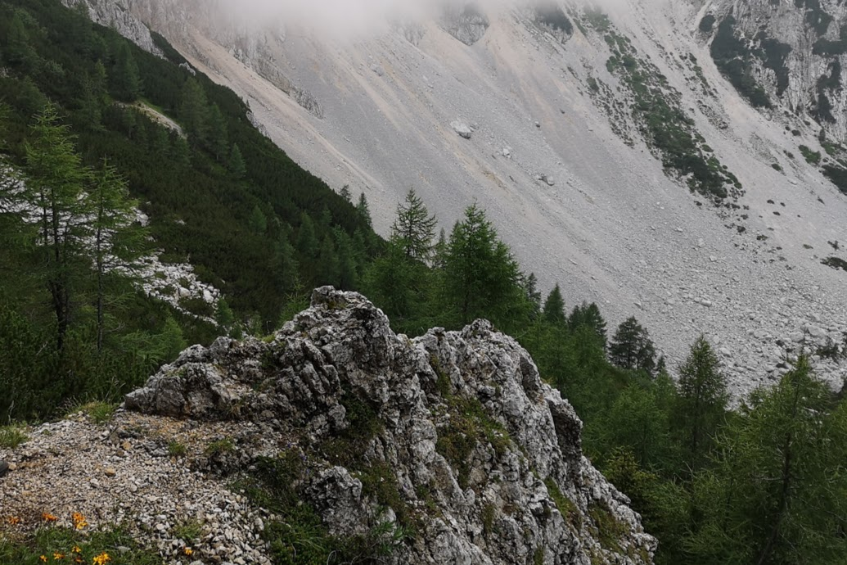
Contemplation and Conversation: What mountain top experience assures you of God’s presence with you when life is most challenging?
From Rev. Heather Leffler:
When Peter was struggling to remind early Christians what it meant to be followers of Jesus, he remembered his mountain top experience. Seeing Moses and Elijah, and hearing God’s voice saying, “This is my son, the beloved”, Peter had no doubt God was with Jesus then, and was with him as he tried to steer the new church away from false teachers. He shared his mountain top moment to remind them and us that God is always with us no matter what is happening in our lives. As a young cub leader nervously gathering a group of 16 to 18 year-olds for worship one wintry day in the Everton Scout Forest; the sun breaking through the trees calmed me and assured me God was with us. That memory continues to warm my heart in times of struggle.
May your mountain top memories bring you comfort and peace in times of struggle.
Know you are a valued part of our Rockwood and Stone United Church families.

A gift of belonging to a church is that the practice of gathering together for worship … to pray, sing, listen to scripture and share how God touches our lives – helps us grow in deeper relationship to God and each other. When life keeps you from being physically present at Stone or Rockwood, you are missed. We are offering this practice of sharing beyond Sunday morning to deepen our connection. Each week you will be offered a picture, a scripture and a question for contemplation, as well as a short reflection for you to contemplate, have conversation with people in your life and/or join an online conversation on our Rockwood Stone Facebook page.

