Contemplation and Conversation: 7th Sunday after Epiphany, February 20, 2022
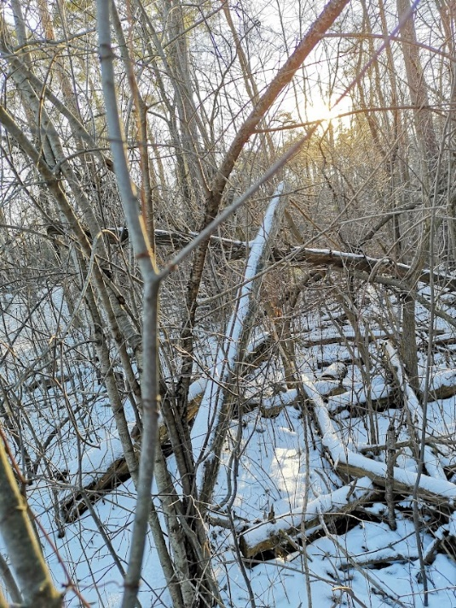
Scripture: Luke 6:27-38 NRSV https://www.biblegateway.com/passage/?search=Luke%206%3A27-38&version=NRSV
Contemplation and Conversation: Who do you find it hard to love?
From Rev. Heather Leffler:
It sounds so right and good when Jesus tells us to love our enemies, even those who hate us. We know he did. From the cross he asked God to forgive the people who condemned him to death. Yet it is not easy to love people who frighten us or make us angry.
Sometimes its hard to love the people who are closest to us. Not just when they say and do things that hurt us or don’t do the things, we asked them to do, but when we aren’t feel well or are angry at ourselves it is hard to be loving.
At the same time, I trust that God is asking us to do the very thing that will change the world. If we can respond to people who we struggle with by praying for them and respecting our differences, we will make space to come to know each other and love one another. May we love as we are loved. Amen.
Whether you are at home trying to help slow the spread of the virus,
working to help care for those who are impacted most by COVID-19
or working to keep some normalcy in this time,
may you know God’s deep and abiding love in your life.
Know you are a valued part of our Rockwood and Stone United Church families.

Further Conversation … Would you like to talk more about today’s reflection? Email Heather at hleffler@rogers.com. Following worship next Sunday, she will invite others to join you in a Zoom break out room to share in further conversation.

Our Rockwood Stone Family
If you missed today’s worship service, email rockwoodstoneuc@gmail.com for a link.
United Church of Canada From Moderator Richard Bott, February 18, 2022 at 12:09
As I watch the police enforcing the laws
and the bylaws, preparing to move the trucks
that have blocked the roads in Ottawa;
as I have watched the images of the blockades
being closed down at border crossings,
I find myself called to prayer...
God, whose love surrounds all,
is in all, is with all,
I pray for all my neighbours -
for all who are afraid,
for all who are frustrated,
for all who are burdened,
for all who are lost,
for all who have come to a place
where they feel they cannot trust
their neighbours,
their communities,
their leaders...
I pray for all who are afraid,
for all who have been working,
and are continuing to work,
for the safety and health and well-being
of all of us - here in Canada
and around the world -
for the health care workers
who continue to care for those people
whose bodies have fallen to the worst
of Covid-19.
I pray that you will help us
to find ways of dealing with one another
that help to calm fears,
that help to face the future,
that help us to move together,
for the healing of all
your creation.
Open our hearts to the wisdom
that will lead us into places
of unity and hope,
loving God.
In Christ's name...
Amen.

Black History Month
For Black History Month, Demanya Kofi Akoussah shares stories of anti-Black racism and prays for a better future. Demanya is the minister of Saint-Marc United Church, a Francophone congregation in Ottawa. Previous to becoming a United Church minister, his work has been focused on peace, non-violence, interculturalism, and inter-religious dialogue. He was the director of Human Resources of his denomination before coming to Canada to serve in The United Church of Canada.
https://united-church.ca/blogs/round-table/my-fault-having-been-created-black

A gift of belonging to a church is that the practice of gathering together for worship … to pray, sing, listen to scripture and share how God touches our lives – helps us grow in deeper relationship to God and each other. With COVID-19 keeping us at home and physically distant from our Stone or Rockwood families, we are missing each other. We are offering this practice of sharing beyond Sunday morning to deepen our connection. Each week you will be offered a picture, a scripture and a question for contemplation, as well as a short reflection for you to contemplate, have conversation with people in your life and/or join an online conversation on our Rockwood Stone Facebook page.

