Contemplation and Conversation: 3rd Sunday of Lent 2020
Scripture: John 4:5-15 https://www.biblegateway.com/passage/?search=John+4%3A5-15&version=NRSV
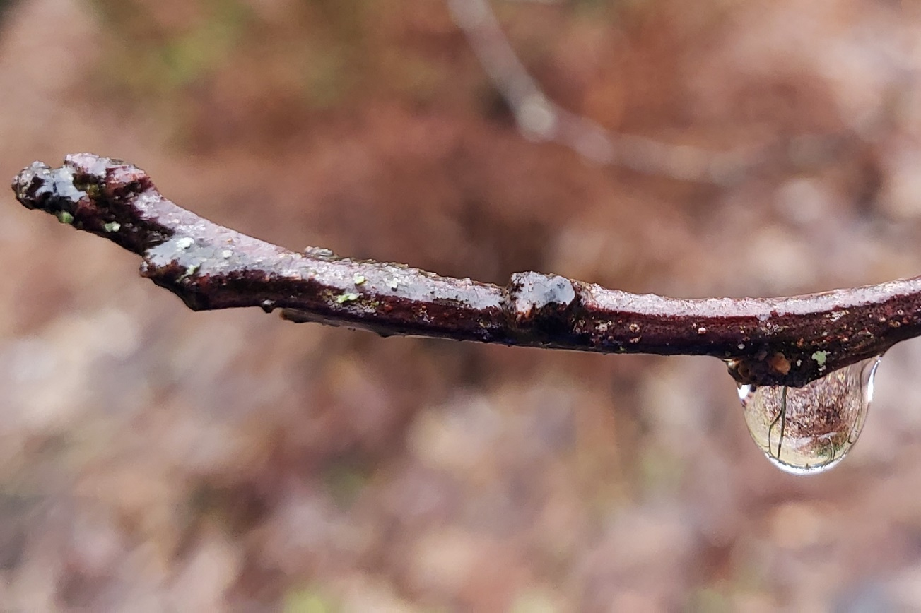
(Consider taking time to read the whole story of the Woman at the Well with Jesus John 4:5-42 https://www.biblegateway.com/passage/?search=John+4%3A5-42&version=NRSV.)
Living Water
Photo by L Leffler
Contemplation and Conversation:
What do you need to feel connected to community in this time of social distancing?
From Rev. Heather Leffler:
Jesus was at the well in Samaria at noon. Hot, thirsty and tired, he had no way to draw water. The women of the community would have been there earlier in the morning or would return in the cool of the evening in groups, enjoying one another’s company. The woman who came to the well in the heat of the day was alone – isolated from her community. Jesus acceptance of her gave her the confidence to face the people she believed were critical of her way of life. Sharing the gift of meeting Jesus with her neighbours and urging them to come and hear his words of life, restored her to community. In this new time when we are asked to keep physically apart from each other, I pray that we will take the time to pray for one another and connect through phone, online or even letters so that the people in our lives continue to experience community and through it the deep and abiding love of God.
May you trust the nudging of the Spirit when you are called to reach out to others virtually.
Know that as we hold each other we are held in God’s love.

A gift of belonging to a church is that the practice of gathering together for worship … to pray, sing, listen to scripture and share how God touches our lives – helps us grow in deeper relationship to God and each other. When life keeps you from being physically present at Stone or Rockwood, you are missed. We are offering this practice of sharing beyond Sunday morning to deepen our connection. Each week you will be offered a picture, a scripture and a question for contemplation, as well as a short reflection for you to contemplate, have conversation with people in your life and/or join an online conversation on our Rockwood Stone Facebook page.

