Contemplation and Conversation: 2nd Sunday after Pentecost, June 19, 2022
Scripture: Galatians 3:23-29 NRSVUE https://www.biblegateway.com/passage/?search=Galatians%203%3A23-29&version=NRSVUE
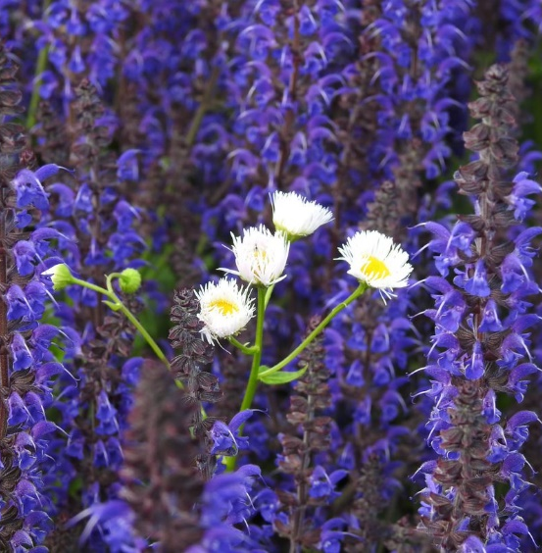
From Rev. Heather Leffler:
God gave the people of Israel the law so that they would love God, love each other and care for the earth. Two laws – love the Lord with all your heart, mind, soul and strength and love your neighbour as yourself – became ten commandments, which became 613 laws. Then the rabbis filled books with commentary trying to help people follow God’s way. Instead of bringing people together, there were times when the laws set people apart from each other and were used to do harm.
The Holy One saw that we needed a new way. Through Jesus, Emmanuel, God with us we were offered a new way. Jesus came to assure us of God’s grace, forgiveness and love for all people. While Paul named gender, religion and social or economic status, what he was telling the Galatians and us was that Jesus came to reconcile all people to God, no exceptions.
This month when our country is marking Pride season, Indigenous History Month, National Indigenous Peoples Day, Saint Jean Baptiste day, Italian Heritage Month, Filipino Heritage Month, Portuguese Heritage Month and Canadian Multiculturalism Day, my prayer is that we can take Paul’s words to heart and celebrate each other’s uniqueness even as we embrace one another’s common humanity. For me being adopted into the family of Abraham through our saviour, invites me to seek reconciliation and relationship with all people so that God’s kingdom can come on earth as it is in heaven.
Contemplation and Conversation
What does belonging to Christ mean to you?
Prayer
God of all people, times and places, help us to truly be siblings
who care for each other, your creatures and the earth. Amen.
Know you are a valued part of our Rockwood and Stone United Church families.

Further Conversation … Would you like to talk more about today’s reflection? Email Heather at hleffler@rogers.com. Following worship next Sunday, she will invite others to join you in a Zoom break out room to share in further conversation.

Our Rockwood Stone Family
From Heather … Thank you so much for the beautiful flowers, delightful books, cards, emails, texts, video and picnic at Stone celebrating my 10th Anniversary with you. The choir’s anthem “Here I Am Lord” was sung at my ordination and brought back lovely memories as did all the pictures of worship and activities we have done together. Sharing in ministry with you is a blessing.
If you missed today’s worship service, email rockwoodstoneuc@gmail.com for a YouTube link.

With Sympathy
Our sympathy to the Miller family on the death of Amy’s mother, Karen Danks and to the McPhedran family on the death of Darlene’s brother-in-law, William Prentice.
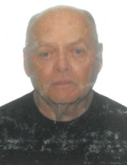
William Wayne “Bill” Prentice passed away unexpectedly with his loving family by his side at the Grey Bruce Health Services in Owen Sound on Thursday, June 9, 2022. Dearly loved husband of “Donna” Marie Helen Prentice (nee Hawkes) for 61 years. Loving father of Tracy Lynn Prentice of Guelph and Troy Prentice (Angela), of Owen Sound. Proud grandfather of Reanna (Cody), Reline, Cory (Yoanne), Trevor (Becky), Nicole (Evan) and Jason and great-grandfather of 6 great-grandkids and excited for another one on the way. His nieces, nephews and friends will miss him dearly. Predeceased by his extra special grandson Bryan whom he will now reunite with, his parents, Hugh and Mildred Prentice, his 3 brothers and 3 sisters.
Bill was the loving son in law of Roy and Edna Hawkes, (predeceased). Loved brother-in-law of David Hawkes (predeceased), his wife Cheryl and their family, and Darlene (Hawkes) and Sandy McPhedran and their family.
We have had many memories of our wonderful family gatherings together at Mom and Dads and at Darlene’s and Sandy’s farm over many, many years. https://www.tributearchive.com/obituaries/25122257/william-prentice/owen-sound/ontario/brian-e-wood-funeral-home-ltd
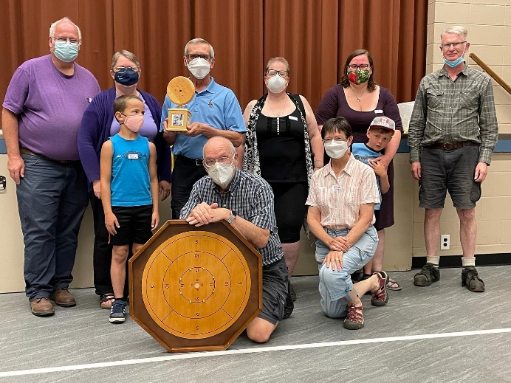
United Church of Canada
From Ecumenical Campus Ministry:
Congratulations to the combined team of Trinity, Church of the Apostles, and Rockwood-Stone United for their victory at today’s Spring Crokinole tournament.
It was a load of fun and so good to be together again. And we raised $600 for programming with the Ecumenical Campus Ministry at the UofG.
Thanks to everyone who took part!
If you were not able to attend the Crokinole Tournament but you would like to support the work of the Ecumenical Campus Ministry at the University of Guelph you can make a donation at https://www.ecmguelph.org/donate

A gift of belonging to a church is that the practice of gathering together for worship … to pray, sing, listen to scripture and share how God touches our lives – helps us grow in deeper relationship with God and each other. We are offering this practice of sharing beyond Sunday morning to deepen our connection. Each week you are offered a picture, a scripture and a question for contemplation, as well as a short reflection for you to contemplate, have conversation with people in your life and/or join an online conversation on our Rockwood Stone Facebook page.

