Contemplation and Conversation: 5th Sunday of Lent, March 21, 2021
Scripture: John 12:20-33 https://www.biblegateway.com/passage/?search=John%2012%3A20- 33&version=NRSV
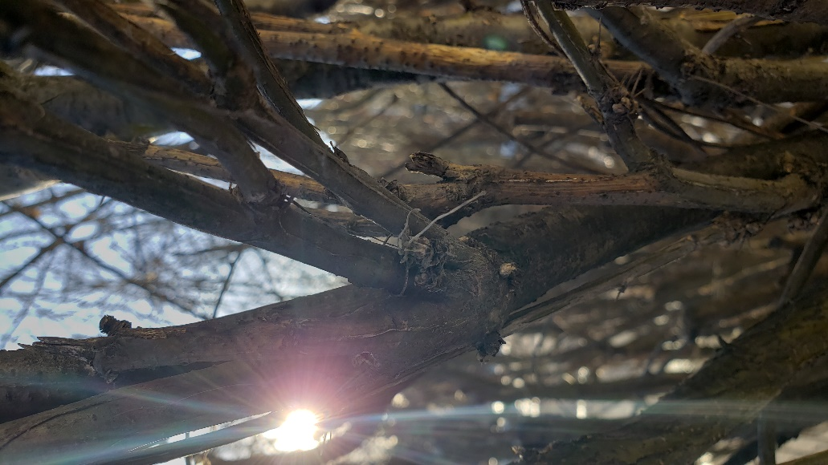
Contemplation and Conversation: What words would you like to hear from God today?
From Rev. Heather Leffler:
Jesus was preparing himself and his disciples for what was to come. He could have chosen to turn back to Galilee. He didn’t have to face the leaders who wanted his ministry to end. What Jesus knew was that if he didn’t move forward his ministry would be forgotten.
It would be his suffering and death and God’s power over death that would signal God’s kingdom truly coming on earth. After reminding his disciples that a grain can only grow, if it is buried in the ground, he gave those around him an insight into his personal struggle. It wasn’t easy for him to face his future, but he called out in prayer to God to glorify God’s name.
The voice from heaven – God’s voice – assured him that what he was choosing would bring glory to God. While I trust Jesus would have been grateful for those words and found strength in them, he knew they would be an even more important touchstone for his followers after his death.
One of the gifts of our faith is that we know Jesus experienced the challenges and joys of life in the same way we do. His words and the words of scripture continue to speak in times of fear and struggle.
Do not fear for I am with you … I will strengthen you and help you.
I am with you always, to the end of the age.
And we know that in all things God works for the good of those who love him.
May you hear the word of God that you need today. Amen.

Whether you are at home trying to help slow the spread of the virus,
working to help care for those who are impacted most by COVID-19
or working to keep some normalcy in this time,
may you know God’s deep and abiding love in your life.
Know you are a valued part of our Rockwood and Stone United Church families.

Further Conversation … Would you like to talk more about today’s reflection? Email Heather at hleffler@rogers.com. Following worship next Sunday, she will invite others to join you in a Zoom break out room to share in further conversation.

From Worship
Today is the International Day for the Elimination of Racism. If you missed the video in worship or would like to see it again it can be found at https://youtu.be/dpu_6sFk_78 .

United Church of Canada
A prayer inspired by Psalm 51:1-12 in response to the Atlanta shootings on March 16, 2021.
Have mercy on us, O God,
according to your steadfast love;
for the weight of escalating anti-Asian racism,
revealed in hateful and misogynistic violence,
is too much to bear alone.
We call to you for help,
recognizing that many of us are at fault.
As a society, we have failed to value and cherish all your peoples.
We have wrongly “othered” and rejected your glorious design in Asian people.
We have enabled domestic terrorism, and White supremacy to fester and flourish.
We have hidden violence against women by ignoring, dismissing, and normalizing complex interconnected systems that work to oppress.
Have mercy on us, O God,
and in your abundant compassion,
receive our broken hearts—
as we cry with all who grieve lives devastated by the misogynistic violence of anti-Asian racism;
we mourn the recent deaths of:
Dauyou Feng
Hyun Jung Grant
Suncha Kim
Paul Andre Michels
Soon C. Park
Xiaojie Tan
Delania Ashley Yaun
Yung A. Yue
in the March 16, Atlanta shooting;
and we lament our failure to protect the rights of sex and migrant workers.
Reveal to us the often-hidden violence experienced by Asian peoples,
make us attentive to those among us who feel that they are struggling alone,
so that we can begin to heal together.
Have mercy on us, O God,
according to your steadfast love,
and in your abundant compassion
put a reconciling spirit within us;
teach us deep in our hearts that we are one in you,
and help us to find ways to live out this wisdom in our words and our actions,
naming and calling out anti-Asian racism and sexism,
until we are able to celebrate with gladness our future reconciliation
where all people are protected and beloved. Amen.

A gift of belonging to a church is that the practice of gathering together for worship … to pray, sing, listen to scripture and share how God touches our lives – helps us grow in deeper relationship to God and each other. With COVID-19 keeping us at home and physically distant from our Stone or Rockwood families, we are missing each other. We are offering this practice of sharing beyond Sunday morning to deepen our connection. Each week you will be offered a picture, a scripture and a question for contemplation, as well as a short reflection for you to contemplate, have conversation with people in your life and/or join an online conversation on our Rockwood Stone Facebook page.

