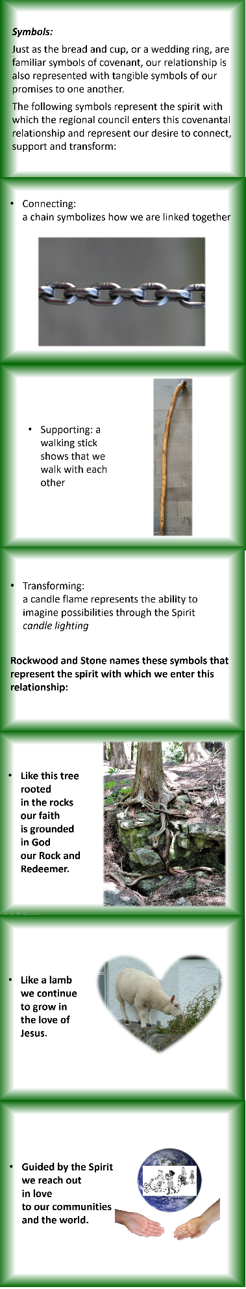
Contemplation and Conversation: 2nd Sunday after Pentecost, June 6, 2021
Scripture: Mark 3 :20-35 https://www.biblegateway.com/passage/?search=Mark+3%3A20-35&version=NRSV
Contemplation and Conversation: Who are your siblings in faith?
From Rev. Heather Leffler:
Jesus confused his community and his family. Jewish tradition taught that to be in relationship with God you needed to follow the laws of Moses. Those laws governed all aspects of human life including what you ate and who you associated with. The Jewish leaders could not understand how he could eat with sinners, tax collectors and prostitutes.
Jesus was faithful to the spirit of the law. God had given the law to the Israelites so they could be a light to all people bringing others into relationship with the one who is Holy Mystery and Wholly Love. Where the Jewish leaders had separated themselves from others to remain pure, Jesus broke down the laws to draw people together. His actions created new communities where people could receive forgiveness and respond in love.
Today in worship we celebrated the covenant we have with The United Church of Canada through Western Ontario Waterways Regional Council. Through Jesus, we are blessed to belong to the family that includes Rockwood and Stone, the United Church, the Christian Church and all God’s people. For that I am deeply grateful.

Whether you are at home trying to help slow the spread of the virus,
working to help care for those who are impacted most by COVID-19
or working to keep some normalcy in this time,
may you know God’s deep and abiding love in your life.
Know you are a valued part of our Rockwood and Stone United Church families.

Further Conversation … Would you like to talk more about today’s reflection? Email Heather at hleffler@rogers.com. Following worship next Sunday, she will invite others to join you in a Zoom break out room to share in further conversation.

From our Rockwood Stone Affirming Discernment Circle
Celebrate the Affirming Designations of Antler River Watershed, Horseshoe Falls and Western Ontario Waterways Regional Councils today, Sunday, June 6 at 2:00 to 3:00 pm.
Join Zoom Meeting link: https://united-church.zoom.us/j/92162978931 Meeting ID: 921 6297 8931
To phone in, dial 1 855-703-8985, with meeting ID Meeting ID: 921 6297 8931
Please have a candle handy (virtual…or not!) to help us light the Christ Candle together
We Are One, We Are Many

United Church of Canada from Moderator Richard Bott
Many questions have come to the General Council office, in the wake of the finding of the children's remains at the Kamloops Residential School site.
We hope that the link below will help folks in the United Church with some of their questions.
https://united-church.ca/.../response-kamloops...
A gift of belonging to a church is that the practice of gathering together for worship … to pray, sing, listen to scripture and share how God touches our lives – helps us grow in deeper relationship to God and each other. With COVID-19 keeping us at home and physically distant from our Stone or Rockwood families, we are missing each other. We are offering this practice of sharing beyond Sunday morning to deepen our connection. Each week you will be offered a picture, a scripture and a question for contemplation, as well as a short reflection for you to contemplate, have conversation with people in your life and/or join an online conversation on our Rockwood Stone Facebook page.

