Contemplation and Conversation: 5th Sunday after Epiphany 2020
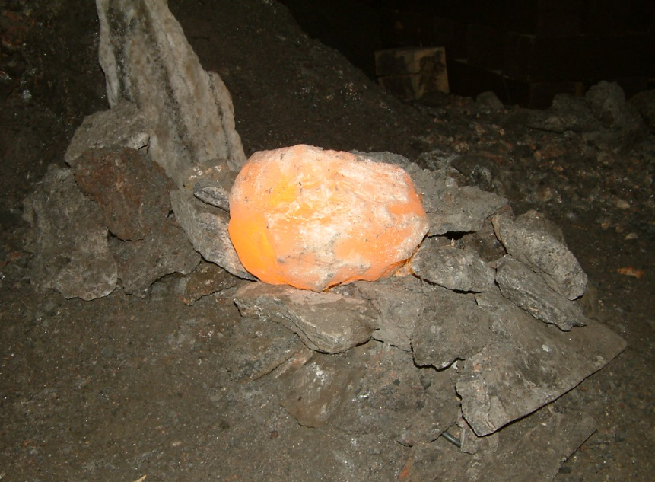
A gift of belonging to a church is that the practice of gathering together for worship … to pray, sing, listen to scripture and share how God touches our lives – helps us grow in deeper relationship to God and each other. When life keeps you from being physically present at Stone or Rockwood, you are missed. We are offering a practice of sharing beyond Sunday morning to deepen our connection. Each week you will be offered a picture, a scripture and a question for contemplation, as well as a short reflection for you to contemplate, have conversation with people in your life and/or join an online conversation on our Rockwood Stone Facebook page.
Matthew 5:13-16 https://www.biblegateway.com/passage/?search=Matthew+5%3A13-16&version=NRSV
Contemplation and Conversation: Where might the Holy One be asking you to be like salt or light to someone in your life? Where are you being asked to step back so you don’t overwhelm someone?
From Rev. Heather Leffler:
We need salt and light to live. A small amount of salt enhances the taste of food and we need it for our health. Sunshine brightens our day improving our physical and mental health. Light allows us to extend our day letting us work, study and play at night. Our health suffers when we are deprived of either.
Too much salt or light can harm us too. Too much salt makes food inedible and negatively impacts our blood pressure and health. Too much light – looking into an eclipse or light reflecting off the snow; or excessive light when we are trying to sleep – can damage our health.
When Jesus calls us salt and light, he is inviting us to be a blessing to others, while being mindful that our presence, advice or help does not overwhelm them.
May you be salt and light to others.
Know you are a valued part of our Rockwood and Stone United Church families.

