Contemplation and Conversation: 4th Sunday after Lent, March 14, 2020
Scripture: Psalm 107:1-3, 17-22 https://www.biblegateway.com/passage/?search=Psalm%20107%3A1-3%2CPsalm%20107%3A17-22&version=NRSV
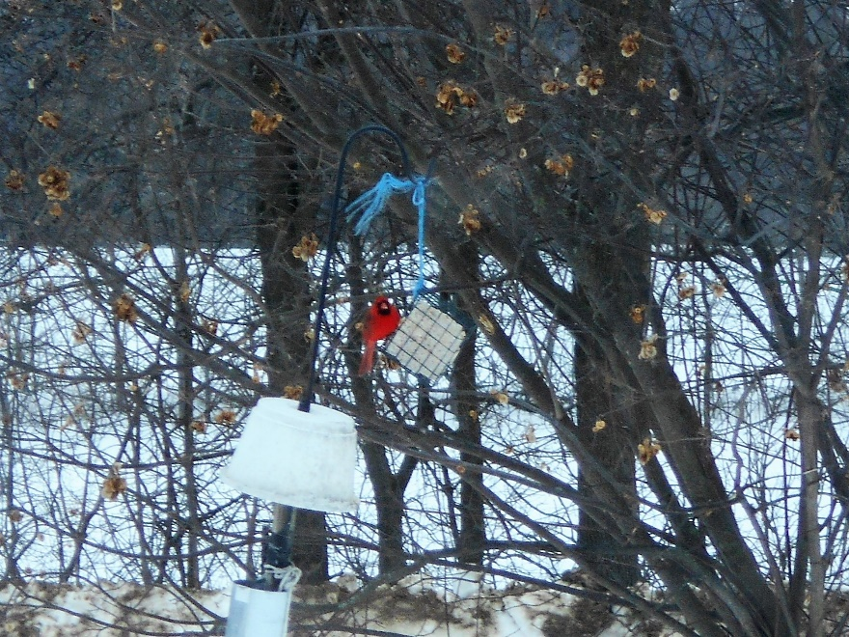
Contemplation and Conversation:
Grace
From Karen Richardson:
I chose this scripture because it spoke to me of grace that was offered in the Old Testament. Every morning for the past months in COVID, the second last prayer on my pray list has been for grace. Grace is one of those things that as Heather said last Sunday is a stumbling block to my faith.
On the one hand I am not at all comfortable with the premise that only those who profess faith in Christ can be given God’s grace. That entitled and exclusive view just does not resonate with the God of my understanding. On the other hand, there is no doubt in my mind that when I think about the teachings, healings and life of Jesus it is all about restoring people and giving them new life, both physically and spiritually which to me is what grace is all about.
This psalm talks about the angst of those who have done wrong and can’t believe that they are still loved and cherished. That it brings them sickness and close to death - a living death. Grace for me is all about letting go of our wrongs not to excuse them but to be able to enter each new day with a heart full of love and openness “for his wonderful works to humankind” instead of being rooted in a past which cannot be changed. On a light-hearted note it reminds me of the prayer by John Maxwell
Dear Lord, So far I've done all right.
I haven't gossiped,
haven't lost my temper,
haven't been greedy, grumpy, nasty, selfish, or overindulgent.
I'm really glad about that.
But in a few minutes, God,
I'm going to get out of bed.
And from then on,
I'm going to need a lot more help.
The last part of my prayers is to be aware of my blessings and try to live out my life in that gratitude. If I am stuck in the past it is hard to look forward in thankfulness ‘with songs of joy’ which resonates with what I believe God wants for each one of us.
The picture of the cardinal is in loving memory of my mom on the 30th anniversary of her passing.

Whether you are at home trying to help slow the spread of the virus,
working to help care for those who are impacted most by COVID-19
or working to keep some normalcy in this time,
may you know God’s deep and abiding love in your life.
Know you are a valued part of our Rockwood and Stone United Church families.

Further Conversation … Would you like to talk more about today’s reflection? Email Heather at hleffler@rogers.com. Following worship next Sunday, she will invite others to join you in a Zoom breakout room to share in further conversation.

From our Rockwood Stone Affirming Discernment Circle
You are invited to watch the PIE Day video from this morning’s worship again https://vimeo.com/386554880?fbclid=IwAR0ncK2O4cEkGlbb05f1xwx0v3L1-L-KtsKe-Ycs1nGY_vlZlbZR9‌eKR4xY. If you missed it our Moderator Richard Bott also shared reflections on Pie Day https://www. ‌youtube.com/watch?v=dX-w46NSfH0 .

United Church of Canada
Moderator Richard Bott’s Affirming PIE Recipe
One cup of story sharing
Two cups of careful listening
One tbsp of hope
One handful of wonder
Just enough salt from tears of remembering and celebration to make it real
Top it with the Fruits of the Spirit
Sweet, sweet crust of God’s grace

A gift of belonging to a church is that the practice of gathering together for worship … to pray, sing, listen to scripture and share how God touches our lives – helps us grow in deeper relationship to God and each other. With COVID-19 keeping us at home and physically distant from our Stone or Rockwood families, we are missing each other. We are offering this practice of sharing beyond Sunday morning to deepen our connection. Each week you will be offered a picture, a scripture and a question for contemplation, as well as a short reflection for you to contemplate, have conversation with people in your life and/or join an online conversation on our Rockwood Stone Facebook page.

