Contemplation and Conversation: 2nd Sunday after Epiphany, January 16, 2022
Scripture: John 2:1-11 https://www.biblegateway.com/passage/?search=John%202%3A1-11&version=NRSV
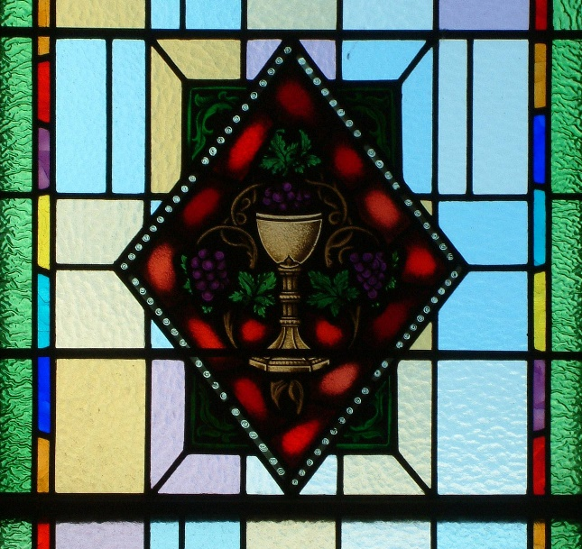
Contemplation and Conversation:
When has someone encouraged you to share your gift?
Is there someone you could encourage to share their gift?
From Rev. Heather Leffler:
Mary knew from before Jesus’ birth that he was the Chosen One, the son of God. In her heart, she had treasured Gabriel’s message, the words of the angels shared by the shepherds, the gifts and visit of the wise ones and the memory of Jesus speaking with the elders in the temple. She had watched her son learn from Joseph and share in caring for their family. I imagine her mother’s heart longed to keep him close forever.
Mary knew Jesus had a purpose to fulfill. He had been baptized by his cousin John and chosen his followers. They were with him at the wedding feast in Cana. It was time. Her son needed to be about what God had called him to do.
When the wine ran low, Mary knew that Jesus could help their host. Jesus didn’t think he was ready, but she knew. She told the servants to do whatever he said. With his mother’s nudge, Jesus began his ministry by turning six stone jars of water into the best wine of the evening and his disciples believed in him.
May we be open to nudges from others and may we encourage others to share their gifts so we can do God’s work in the world. Amen.
Whether you are at home trying to help slow the spread of the virus,
working to help care for those who are impacted most by COVID-19
or working to keep some normalcy in this time,
may you know God’s deep and abiding love in your life.
Know you are a valued part of our Rockwood and Stone United Church families.

Our Rockwood Stone Family
If you missed today’s worship service, email hleffler@rogers.com for the link.
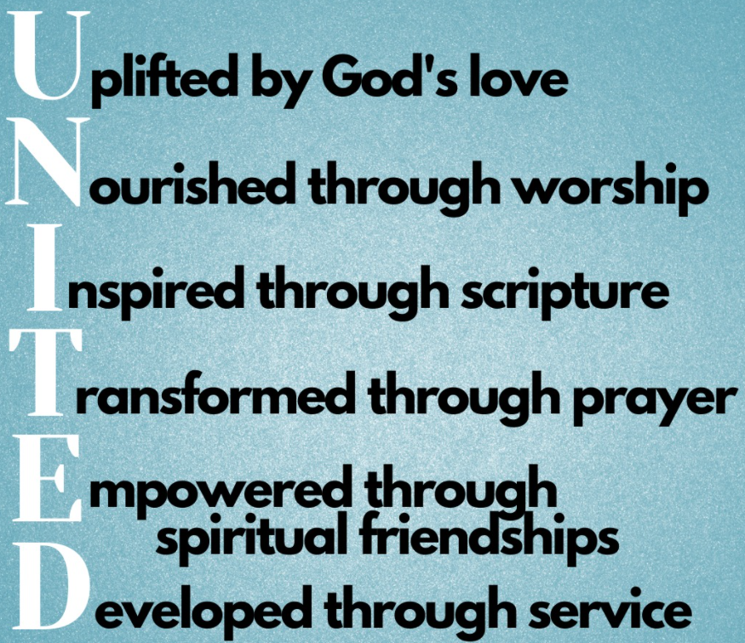
United Church of Canada from Moderator Richard Bott, December 29, 2021
As I contemplate the coming year, I'm wondering what I might do that would help me to live more deeply into my discipleship practices?
What about you? Is there something that you'd like to try? Something that's helped you in the past, that might help others?
I'm working to be U.N.I.T.E.D. as a disciple of Jesus!
(image: rb)

A gift of belonging to a church is that the practice of gathering together for worship … to pray, sing, listen to scripture and share how God touches our lives – helps us grow in deeper relationship to God and each other. With COVID-19 keeping us at home and physically distant from our Stone or Rockwood families, we are missing each other. We are offering this practice of sharing beyond Sunday morning to deepen our connection. Each week you will be offered a picture, a scripture and a question for contemplation, as well as a short reflection for you to contemplate, have conversation with people in your life and/or join an online conversation on our Rockwood Stone Facebook page.

