Contemplation and Conversation:
14th Sunday after Pentecost, September 6, 2020
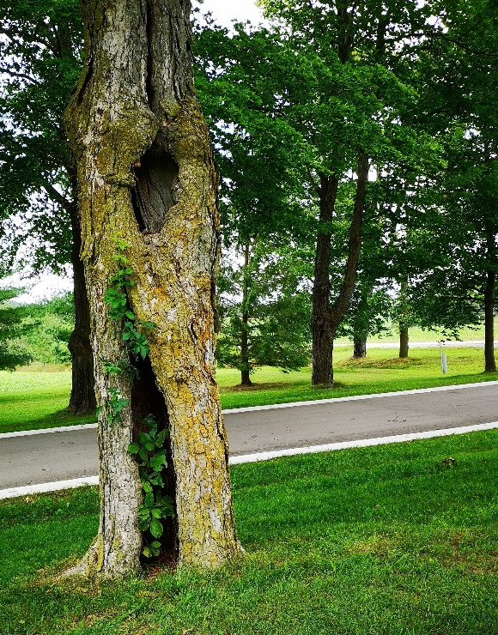
Scripture: Romans 13:8-14
⁸Owe no one anything, except to love one another; for the one who loves another has fulfilled the law. ⁹The commandments, “You shall not commit adultery; You shall not murder; You shall not steal; You shall not covet”; and any other commandment, are summed up in this word, “Love your neighbor as yourself.” ¹⁰Love does no wrong to a neighbor; therefore, love is the fulfilling of the law.
¹¹Besides this, you know what time it is, how it is now the moment for you to wake from sleep. For salvation is nearer to us now than when we became believers; ¹²the night is far gone, the day is near. Let us then lay aside the works of darkness and put on the armor of light; ¹³let us live honorably as in the day, not in reveling and drunkenness, not in debauchery and licentiousness, not in quarreling and jealousy. ¹⁴Instead, put on the Lord Jesus Christ, and make no provision for the flesh, to gratify its desires.
Contemplation and Conversation: How has God shown love to me? How have others been instruments of love in my life? How will I show love to others this week?
From Brian Mack:
Participation in Spiritual Saturdays and at various times in the Week of Guided Prayer has convinced me that it is good to escape from the busyness of everyday life once in a while and to reflect on scripture in a quiet atmosphere. I have come to the conclusion that scripture is most meaningful to me when it is savored slowly, pondered over in an atmosphere free from pressure, and regarded as the beginning point of a conversation with God. That conversation can take an endless variety of forms. In my case, I often find myself doodling, creating word webs, or making lists of random thoughts that have been evoked by a passage. I am free to interpret the passage in my own way as the Spirit leads me. There is no Biblical commentary to color my thoughts. There are no restrictions imposed on me by the culture in which I live. I am free to confront the ups and downs of my own life.
When I read this passage from Romans, my jot notes took the form of a series of imaginings or “what ifs”. What if I was less judgmental and more forgiving? What if I spent more time blessing others rather than cursing them? What if I inflicted less pain through my actions and more time binding up the wounds of my fellow humans? What if I offered more words of encouragement rather than words of condemnation? What if I consciously looked for the good in others rather than focusing on their faults? What if I gave of my time and resources more freely and without reservation to help those marginalized in society? What if I moved beyond saying the right things to actually confronting social justice issues through actions of protest? What if I allowed my heart to be more open to all people of the world so that I might truly be a “channel of God’s peace”? What if I loved others as much as I love myself? As these “what if” questions demonstrate, there are so many ways in which I can improve upon how I love others and thus fulfil the demands contained in the Law.
As I continue to wrestle with how to best show love in my own life and to encourage others to do likewise, I am comforted, strengthened, and reassured by the unconditional and everlasting love offered to all of us by the One we call both Holy Mystery and Wholly Love.

Whether you are at home trying to help slow the spread of the virus,
working to help care for those who are impacted most by COVID-19
or working to keep some normalcy in this time,
may you know God’s deep and abiding love in your life.
Know you are a valued part of our Rockwood and Stone United Church families.

A gift of belonging to a church is that the practice of gathering together for worship … to pray, sing, listen to scripture and share how God touches our lives – helps us grow in deeper relationship to God and each other. With COVID-19 keeping us at home and physically distant from our Stone or Rockwood families, we are missing each other. We are offering this practice of sharing beyond Sunday morning to deepen our connection. Each week you will be offered a picture, a scripture and a question for contemplation, as well as a short reflection for you to contemplate, have conversation with people in your life and/or join an online conversation on our Rockwood Stone Facebook page.

